AP Biology 12
Genome Evolution: Chapter 21

Genome evolution is the process by which a genome changes in structure (sequence) or size over time
Concept 4: Analyzing genomes and their evolution: retrotransposons, evo-devo, homeoboxes

You Must Know
- How prokaryotic genomes compared to eukaryotic genomes
- The activity and role of transposable elements and retrotransposons.
- How evo-devo relates to our understanding of the evolution of genomes.
- The role homeotic genes and homeoboxes

How could so many proteins be made with so few genes?
Only 1.5% of the human genome codes for proteins or is transcribed into rRNAs or tRNAs. Much of the rest is___________________, sequences that are present in multiple copies in the genome.
___________________________makeup much of the repetitive DNA.
Stretches of DNA that moves from one location to another in the genome with the aid of an enzyme,____________________.

Two types
_________________move by means of a DNA intermediate
_________________move by means of a RNA intermediate and leave a copy at the original site. The process involves reverse transcriptase (remember this guy? Retroviruses!)
Jumping Genes!
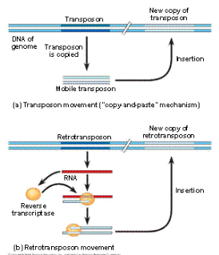

What’s the point of transposable elements?
Transposons can ____________________________function if inserted in the middle of a functional gene, or alter gene expression if inserted into a regulatory element.
While this may be harmful, over many generations some may have small beneficial effects, resulting in __________________________.
_____________________are collections of 2 or more identical or very similar genes.
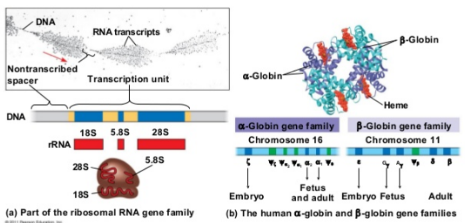
Evo-devo
→ a field of biology that compares _________________processes to understand how they may have evolved and how changes can modify existing organismal features or lead to new ones.
Homeotic genes
Master regulatory genes that control ______________and _____________________of body parts by controlling the developmental fate of groups of cells.
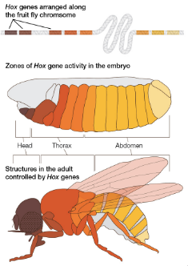
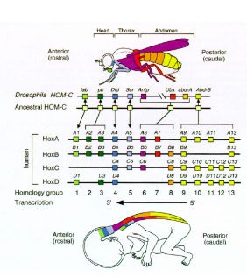
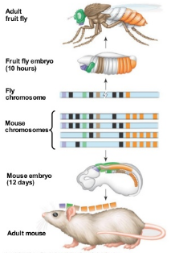

hox genes
homeotic genes in animal were named hox genes, short form for homeobox containing genes.
A homeobox is a widely conserved 180-nucleotide sequence found in homeotic genes. The sequence is _______________________since it is found in many groups (e.g. fungi, animals, and plants) with very few differences. This hints at the _______________________________of all life-forms.

