

Name:

Block:

**What Does Math Sound Like?**

Every time I’m reading music, I am reading math. Here’s the code. Here’s what I mean:

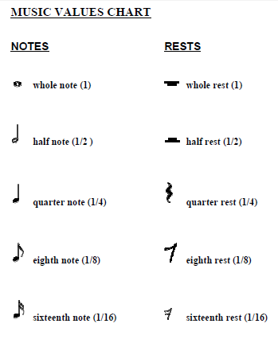

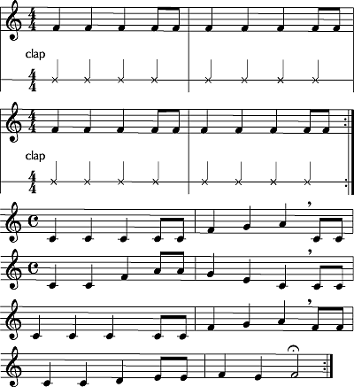



Your Mission is to find the math in your music. Here’s how.

* Find the written music for any school appropriate song you choose
* Write the corresponding math equation below the music like above (you can write it on the original music you find or transfer it over to manuscript paper below – only 8 bars!)
* complete the discussion questions below and hand them in on **OCTOBER 24th**
* Ms Brady will make a play list of all of our songs for the Fraction Review class!

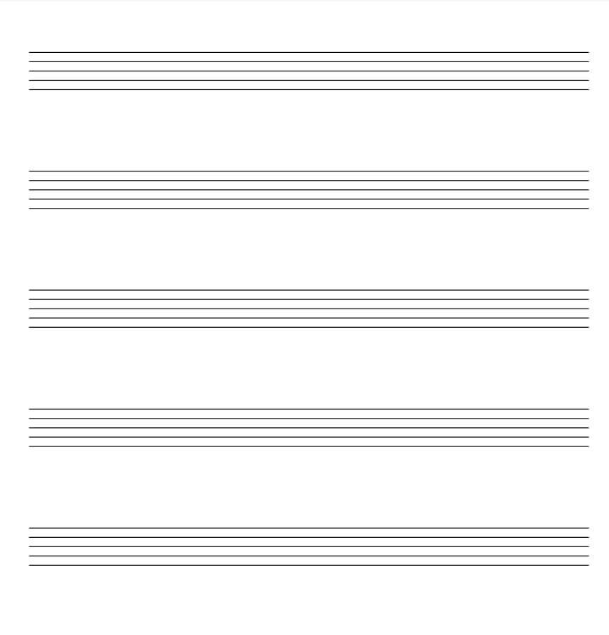

**Discussion Questions**:

1. Explain the ways that music relates to math.
2. What did you notice about each bar of music in the selection you picked?
3. How do you know you got the mathematical translation of your music correct?
4. Describe another application of fractions to a real-life situation (outside of math class).

|  |  |  |  |  |
| --- | --- | --- | --- | --- |
| **Criterion D: Applying Mathematics in Real-Life Contexts** | | | | |
| **(0)** | **Beginning (1-2)** | **Developing (3-4)** | **Accomplished (5-6)** | **Exemplary (7-8)** |
| *I have not achieved a standard described by any of the descriptors to the right*. | *I am able to:*  **identify** some of the elements of the authentic real-life situation  **apply** mathematical strategies to find a solution to the authentic real-life situation, with limited success. | *I am able to:*  **identify** the relevant elements of the authentic real-life situation  **select**, with some success, adequate mathematical strategies to model the authentic real-life situation  **apply** mathematical strategies to reach a solution to the authentic real-life situation  **describe** whether the solution makes sense in the context of the authentic real-life situation. | *I am able to:*  **identify** the relevant elements of the authentic real-life situation  **select** adequate mathematical strategies to model the authentic real-life situation  **apply** the selected mathematical strategies to reach a valid solution to the authentic real-life situation  **describe** the degree of accuracy of the solution  **discuss** whether the solution makes sense in the context of the authentic real-life situation. | *I am able to:*  **identify** the relevant elements of the authentic real-life situation  **select** appropriate mathematical strategies to model the authentic real-life situation  **apply** the selected mathematical strategies to reach a correct solution  **explain** the degree of accuracy of the solution  **explain** whether the solution makes sense in the context of the authentic real-life situation. |