More practice with Volume…
1. A right prism measures 6.2 cm x 4.7 cm x 2.3 cm. Find the volume of the prism and express your answer to two decimal places.

2. A soup can has a radius of 4.3 cm and a height of 11.6 cm. What is the volume of the soup can to the nearest tenth of a cubic centimeter?

3. Find the volume of this right triangular prism.
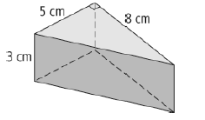

4. A sandbox is shaped like a right rectangular prism. The sandbox is 0.45 m high, 2 m wide and 2.6 m long. The sand is 0.25m deep, what is the volume of sand in the box?

5. The volume of a cylinder is 867.5 cm³ and the area of the circular base is 69.4 cm². What is the diameter of the cylinder?

6. What is the volume of the piece of birthday cake shown?
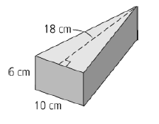
1) 67.02cm³ 2) 673.5 cm³ 3) 60 cm³ 4) 1.3 m³ 5) 9.4 cm 6) 540 cm³

