The Quest to Resurrect Extinct Species
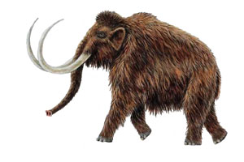
By Virginia Gewin | ( Excerpt From MARCH 2015 ISSUE of Discover Magazine )

Cheating Extinction

As researchers struggled to reconstruct ancient genomes, the world’s first de-extinction had already, surreptitiously, taken place. In 2003, Spanish scientists had used the same cloning method that helped create Dolly the sheep to resurrect the Pyrenean ibex, a wild goat endemic to the French mountain range. They injected intact nuclei from the last living ibex into more than 400 enucleated eggs of the domestic goat. They then implanted those eggs into surrogate mothers — either Spanish ibexes or ibex-goat hybrids. Six of the seven animals that became pregnant miscarried, and the other gave birth via Caesarean section to a kid that died after just 10 minutes. More recently, an Australian team used the same strategy to resurrect the gastric-brooding frog, a fantastical creature that swallowed its eggs and coughed up babies. They managed to transfer the extinct frog’s nuclei into the egg cells of a barred frog, but so far, the embryos have yet to fully develop.
Such methods may help resurrect recently departed species, but it will be all but impossible to find tissues with intact nuclei for long-gone species. To resurrect these species, scientists plan to use the extinct organism’s genetic code as a blueprint. That became feasible in 2005 when the first commercial next-generation (next-gen) DNA sequencing machines became available. (See “Making a Woolly Mammoth,” page 45.) “This is what we had been waiting for,” says Hendrik. Today, next-gen sequencing allows scientists to sequence an entire human genome in hours for less than $1,000, far faster and cheaper than ever before. And the same technology enables researchers to uncover the genetic blueprint of an extinct animal.
To turn that blueprint into a living organism, scientists will also need a surrogate mother. A modern relative is the best bet. Beth Shapiro, an ancient DNA researcher at the University of California, Santa Cruz, is using the band-tailed pigeon genome as a guide to piece together a draft passenger pigeon genome. Ben Novak, a biologist funded by Revive & Restore, the nonprofit group Brand established, will use that blueprint to try to revive the extinct bird. So far, Shapiro and Novak have amassed 88 passenger pigeon samples from museum collections, but it will be a long, hard slog to determine which genes distinguish a passenger pigeon from a rock pigeon, and what the genes do, Shapiro says.
It’s the woolly mammoth that’s probably the furthest along toward de-extinction. Hendrik plans to publish the most complete woolly mammoth genome yet, and George Church’s team at Harvard is already introducing specific DNA variants — genes for hair, tusks, subcutaneous fat and cold resistance in blood — into cultured cells from Asian elephants, with the goal of preparing the rebuilt mammoths for life on the tundra. But even making an elephant whose genes are 9 percent mammoth might take 20 years, and we may never re-create an exact duplicate of the extinct species, Church says.
Because it’s so hard to replace all the genes that make a woolly mammoth — or a passenger pigeon or dodo or Steller’s sea cow — a unique species, the re-created animals won’t be exactly what went extinct. Some will be clones, like the baby Pyrenean ibex. Some could be genetically engineered hybrids. Others will likely be wholly synthesized — new beasts altogether.

REFLECTION - on a separate page, consider the following and write a thoughtful reflection that addresses the following questions:

1. Why are Asian elephants used instead of African Elephants?
2. Summarize the differences between the two proposed techniques to create a woolly mammoth. Which do you think is more plausible?
3. Just because we can resurrect an extinct species, does that mean we should? What are the benefits of doing so? What are the risks?

See Also Ted Talk on Bringing Back the Wooly Mammoth: https://www.youtube.com/watch?v=O8e8Ttfz-pY
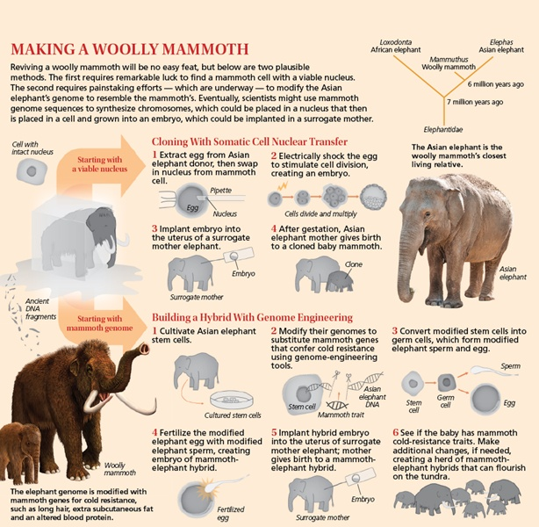

 | Beginning | Developing | Accomplished | Exemplary
 | Does not demonstrate a basic understanding of concept. Substantial errors throughout. | Basic understanding of concepts. Errors and inconsistency reveal some missing elements. | Solid understanding of concepts. Most answers are correct. Few errors. | Complete and in depth understanding of concepts. Answers are correct, with elegant connections to AP Themes.
Intro provides overview of elephants and their uses
Technique 1 is summarized, specific details included
Technique 2 is summarized, specific details included
Discusses ethics of procedure, exploring pros & cons

