CONCEPT 3: APPLYING THE CHROMOSOMAL BASIS OF INHERITANCE TO ANALYZE THE EFFECTS OF SEX CHROMOSOMES, LINKED GENES, AND RECOMBINED RECOMBINES GENES
Campbell: Chapter 15

Goal: to analyze mechanisms of chromosomal inheritance
You must know:
- How the chromosome theory of inheritance connects the physical movement of chromosomes in meiosis to Mendel’s laws of inheritance
- The unique pattern of inheritance in sex-linked and linked genes

Remember...Chromosome Theory of Inheritance
- Genes have specific _____________ on chromosomes
- Chromosomes segregate and assort ____________________

Sex-Linked Genes ( ): A sex linked gene is a gene located on the X sex chromosome.
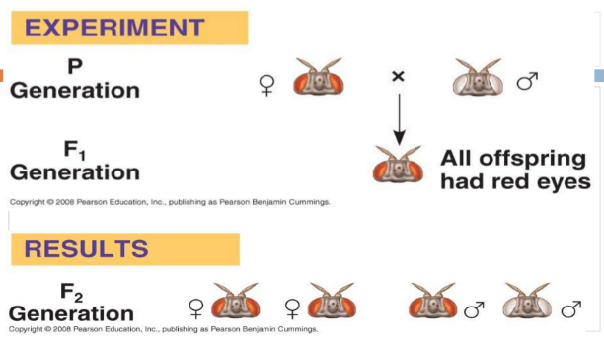
Morgan’s Sex-Linked Discovery in 1910!

Conclusion?
The gene for fly eye colour is found on the “_____”
sex chromosome!

- Genes on the X chromosome are said to be ____________________. X-linked genes have distinctive inheritance patterns because they are present in different numbers in females (XX) and males (XY)

- X-linked human genetic disorders are much more common in ___________________ than in females due to the X-linked inheritance pattern

- A human male has two __________________, the X and the Y. Unlike the ________________ (non-sex chromosomes), the X and Y don’t carry the same genes and aren’t considered homologous.

- A human female has two X chromosomes. These X chromosomes do form a _________________ pair.

- The human Y chromosome plays a key role in determining the sex of a developing embryo. This is mostly due to a gene called SRY (“sex-determining region of Y”). SRY is found on the _______ chromosome and encodes a protein that turns on other genes required for male development.
Colour Blindness: Sex-Linked Gene
What happens if you cross a normal female with a colour blind male?

What happens if you cross a carrier female with a normal male?

What happens if you cross a carrier female with a colour-blind male?

Other examples of Sex-Linked Genes:
Duchene Muscular Dystrophy

Hemophilia

Try This!
Neither Tom nor Rhonda has muscular dystrophy, but their firstborn son has it. What is the probability that a second child will have this disease?

What if the child was male? Female?

X-Inactivation

As it turns out, the level of gene activity produced by a single X chromosome is the normal ________________ for a human.
Men have this dosage because they only have one X chromosome!
Women have the same dosage because they shut down one of their two X chromosomes in a process called ___________________________

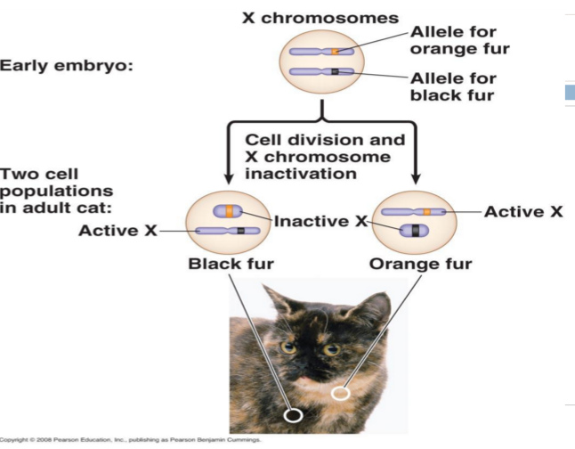
In X-inactivation, an X chromosome is compacted "crumpled up into a ball", to make a small, dense structure called a _____________. Most of the genes on the Barr body are inactive, meaning that they are not transcribed.

  - Done by adding __________groups to DNA.
  - Happens randomly in each cell when the female is an embryo

Example of X-Inactivation: Calico Cats!

Practice Problems
Remember: When writing genotypes, you need to write both the alleles and the sex chromosomes – i.e. X^{N}X^{N}
- In fruit flies, the gene for white eyes is sex-linked recessive. (R) is red and (r) is white. Cross a white-eyed female with a normal red-eyed male.

  - What percent of the males will have red eyes? White eyes?
  - What percent of the females will have red eyes? White eyes?
  - What total percent of the offspring will be white-eyed?
  - What percent of the offspring will be carriers of the white eye trait?

- In cats, the allele (B) produces black color but (b) produces a yellow color. These alleles are incompletely dominant to each other. A heterozygote produces a tortoise shell color. The alleles (B) and (b) are sex-linked as well. Cross a tortoise shell female with a yellow male.

  - What percent of their offspring will be yellow?
  - What percent of their offspring will be black?
  - What percent of their offspring will be tortoise shell?
  - Why is it impossible to have a tortoise shell male offspring?

- In humans, the allele for normal blood clotting, H, is dominant to the allele for hemophilia, h. This is a sex-linked trait found on the X chromosome. A woman with normal blood clotting has four children: a normal son, a hemophiliac son, and two normal daughters. The father has normal blood clotting. What is the genotype for each member of the family?

4. The bison herd on Konza Prairie has begun to show a genetic defect. Some of the males have a condition known as "rabbit hock" in which the knee of the back leg is malformed slightly. This condition is controlled by a sex-linked gene and it is recessive. Now, suppose that the herd bull (the dominant one which does most of the breeding) who is normal (X^{N}) mates with a cow that is a carrier for rabbit hock.
a) What are his chances of producing a normal son (bull)?
b) If he mates with this cow every year, what percentage of their daughters will have normal knees?
c) What percentage of their daughters will be carriers of rabbit hock?

5. Red-green color blindness (b) is a recessive sex-linked trait. A colorblind male marries a normal female. Their daughter is colorblind.
a)What are the genotypes of both parents and the daughter?
b) Can a colorblind father have daughters who are not colorblind? Explain.
c) If a normal sighted woman whose father was color-blind marries a color-blind man, what is the probability that they will have a colorblind child?

6. Clouded leopards are a medium sized, endangered species of cat, living in the very wet cloud forests of Central America. Assume that the normal spots (X^{N}) are a dominant, sex-linked trait and that dark spots are the recessive counterpart. Suppose as a Conservation Biologist, you are involved in a clouded leopard breeding program. One year you cross a male with dark spots and a female with normal spots. She has four cubs and, conveniently, two are male and two female. One male and one female cub have normal spots and one each have dark spots.
a) What is the genotype of the mother?
b) Suppose a few years later, you cross the female cub that has normal spots with a male that also has normal spots. How many of each genotype will be found in the cubs (assume 4)?
c) Will any of the cubs from this latest cross have dark spots?
d) If so, how many and of what sex will they be?

