**Station 1**

a) Use the formula to calculate the total surface area of the cylinder to the nearest hundredth of a centimetre. Draw a net. Use 3.14 for symbol.

Radius = 5cm

Height = 6cm



b) Sketch the top, front, and side views of this solid. 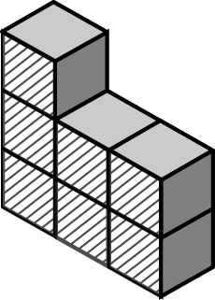



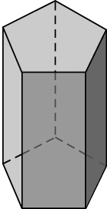

Sketch the top, front, and side views of this solid.

If you turn the polyhedron from #3 90° degrees counterclockwise, how would the three views change? Sketch and label each new view.

**Station 2**

Calculate the surface area of the label on a can of soup with the dimensions. Draw a net. Use 3.14 for symbol.

Height = 11cm

Diameter = 6cm

b) Draw and label the measurements of the three views of this triangular prism.



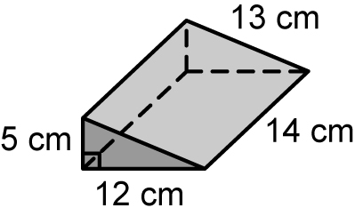

**Station 3**



Rahim’s dad wants to paint the outside of his garage, including the roof.

a) How many sides of the garage need to be painted? _______

b) Name the two shapes that make up the front and the back side of the garage. __________ and ________

c) Calculate the total surface area that needs to be painted. Show your work. Round your answer to the nearest tenth of a metre.

**Station 4**



Calculate the total surface area

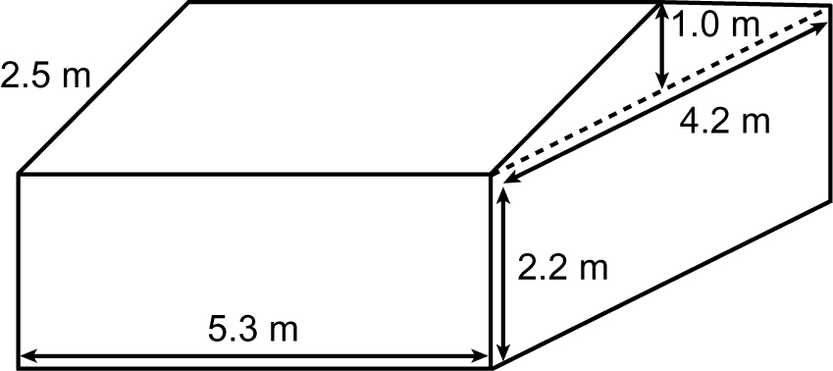

**Station 5**

a) Calculate the total surface area:

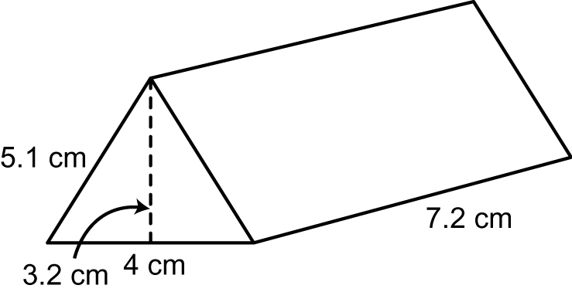

b) Draw the net for the object. Label the measurements on the net. Find the total Surface Area.

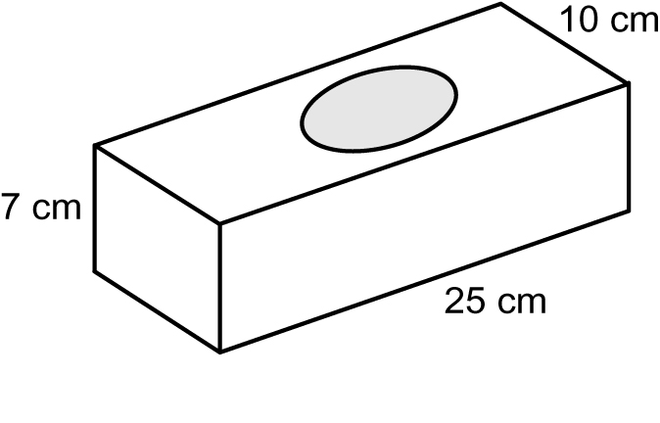

**Station 6**

**Solve a** Burning Question (on the whiteboard) that has not been solved yet

