Restriction Mapping
1. Two freshmen college students performed the following set of restriction digests on a newly isolated plasmid, pBLA230. The reaction they carried out, along with the fragments obtained in single and double digest reactions, were:
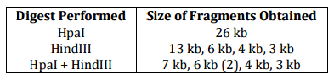
Using this information, construct a restriction map of pBLA230

2. Show the restriction map for pDA102. Which is a total of 4.35 kb.
Sall: 2.30, 0.25, 1.80
Hhall: 2.10, 1.55, 0.70
Sall + Hhall: 1.20, 1.10, 0.75, 0.70, 0.35, 0.25

3. Plasmid pBR607 is a 2.6 kb plasmid containing Ampicillin and Tetracycline resistance markers, an origin of replication and unique restriction sites for the restriction enzymes EcoRI, BamHI, and PstI.

Size Standards | EcoRI & PstI | EcoRI & BamHI | EcoRI, PstI & BamHI
Give the restriction map for pBR607 for the enzymes EcoRI, BamHI, and PstI, show on the agarose gel picture below where the approximate positions of the restriction fragments generated from the given restriction digests would be located after carrying out electrophoresis. 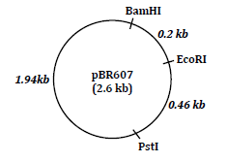
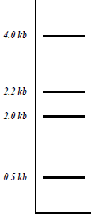

4. As part of an undergraduate project, a student was attempting to construct a restriction map for the plasmid pUC23 using the restriction enzymes EcoRI and BamHI. After carrying out both single and double enzyme digest reactions and electrophoresing each reacting mix trhough an aragose gel, the picture below is obtained, showing the number of DNA fragments produced in each reaction, along with the sizes of each fragment. From the information, construct a restriction map of the pUC23 for enzymes EoRI and BamHI.

