Pre AP Biology 11
Concept 2: Analyzing the processes of DNA Replication

You must know:
- The structure of DNA.
- The major steps to replication.
- The differences between replication, transcription, and translation.
- How DNA is packaged into a chromosomes.
- Refer to pg 117-122 in Holtzclaw, Ch 16 in Campbell

To Recap:

1. What is the purpose of DNA replication? To make an_________________ of DNA

2.When does it occur? Before _____________________

3. How does the new cell compared to the old cell? The _____________________daughter cells have the exact same DNA as the _____________________parent cell

4. Where does DNA replication take place? In the___________________

Each strand is a __________________(parent) for the _______________________strand (daughter)

Three steps of DNA Replication:
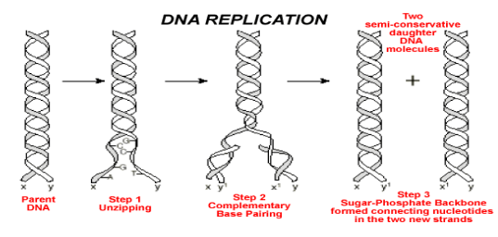

DNA is considered Semiconservative
What does that mean?

Each helix of DNA is made up of one parent (________________) and one daughter (__________________)

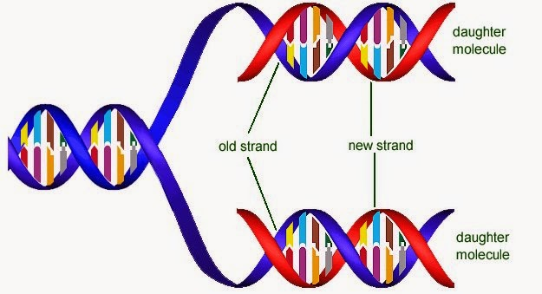

DNA Replication

Some Vocabulary: Parent Strand, Daughter Strand, Leading Strand, Lagging Strand, Okazaki fragments, Replication Bubble, Replication Fork, 5’ to 3’, continuous synthesis, discontinuous synthesis, semi-conservation

Enzymes: helicase, topoisomerase, SSBP (single-stranded binding proteins), primase, DNA polymerase III, DNA polymerase I, DNA ligase

When it is time to replicate DNA (during S phase), proteins bind to the and separate the DNA strands, forming the replication bubble and a ________________
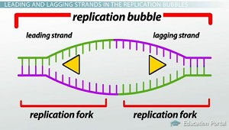
At the replication fork, the enzyme ___________unwinds and unzips the two DNA strands by breaking the hydrogen bonds between nitrogen bases.

Helicase needs help!
Single stranded binding proteins (SSBP) ____________________the DNA by “holding” the two separated parental strands from each other
Topoisomerase helps relieve the ______________________of the parent strands in front of the replication fork

At each replication fork, there are two daughter strands that need to be synthesized: the leading strand and the lagging strand. Both strands can only be synthesized in the _________________

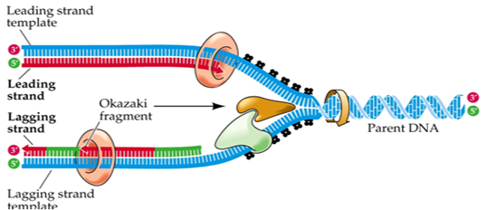

The leading strand is synthesized in the 5’ to 3’ direction continuously ____________________ the replication fork
The lagging strand is synthesized discontinuously ______________________ the replication fork

Process is semi-conservative because each of the new DNA strands will contain one original parent strand and one new daughter strand

Leading Strand:
PRIMASE reads the DNA code and synthesizes an_________________: a short RNA chain (~10 nucleotides long).

DNA POLYMERASE III adds _______________to the primer in the 5’ to 3’ direction (towards the fork)

- Forms ___________________ between the nitrogen base on the parent strand and the complementary nitrogen base of the new daughter nucleotide

- Forms ___________________ between the 3’ end of the previous daughter nucleotide and the 5’ end of the new daughter nucleotide (hence 5’ to 3’ direction)
Lagging Strand:

A Primer is added to the lagging stand as well…but there are many of them here…not just one!

DNA POLYMERASE III adds DNA nucleotides to the primer in the 5’ to 3’ direction (_________________________)

- Forms hydrogen bonds between the nitrogen base on the parent strand and the complementary nitrogen base of the new daughter nucleotide

- Forms covalent bonds between the 3’ end of the previous daughter nucleotide and the 5’ end of the new daughter nucleotide (hence 5’ to 3’ direction)

DNA POLYMERASE III keeps adding DNA nucleotides until it reaches the primer of the next___________________.

DNA Polymerase I takes over and keeps adding complimentary DNA nucleotides to the daughter strand in the 5’ to 3’ direction while ______________________the RNA nucleotides of the primer on the next Okazaki fragment

DNA LIGASE joins the two Okazaki fragments together

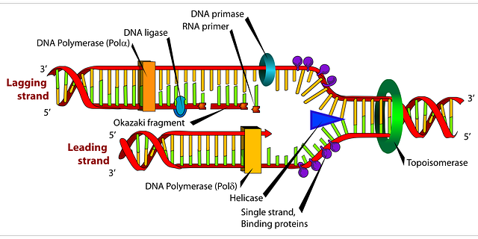

This process is very efficient!

DNA polymerases are good _____________________… a mistake is made only in 1 of every 10 000 nucleotide pairings.

DNA polymerases needs help though… mismatch repair!

Ex: nucleotide excision repair in which the enzyme _________________cuts the damaged segment so that DNA replication “tries again.”

