Exploring the Pythagorean Relationships
- Is the triangle a right triangle? How do you know?

- Write an addition statement showing the relationship between the areas of the three squares.

- Describe in words the relationship between the side lengths of the triangle.

Activity:
- With a partner, cut out 3 squares on the graph paper with the following dimensions: 6cm x 6cm, 8cm x 8cm, 10cmx 10cm

- Arrange the squares to form Triangle 1 as shown:

 | Side | Side Length (cm) | Angle Opposite the Side (º) | Area of Square (cm²)  A = l x w
Triangle | a | 6 | 37
 | b | 8
 | c | 10

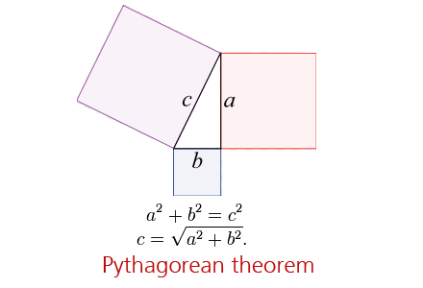

- Measure the angle opposite each side of Triangle 1 with a protractor.
- In your table, record the angle measures to the nearest degree.
- Complete the rest of the table for the Triangle

