AP Biology: Protists
Refer to Ch 28 in Campbell

You must know:
- An appreciation of the “real kingdoms” of Protista.
- How chloroplasts and mitochondria evolved through endosymbiosis.

Eukaryotic
- Not plants
- Not animals
- Not fungi
- Not necessarily _________________(but most are)
“True” sexual reproduction (__________________________)
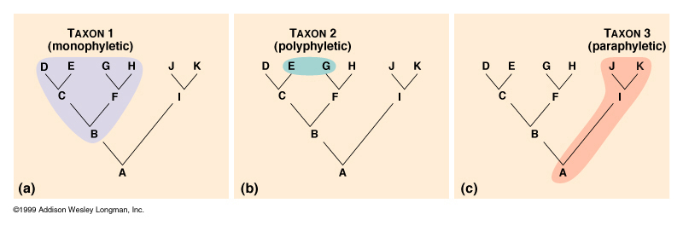
Polyphyletic (or… Paraphyletic?... There is debate!)

- INCREDIBLY diverse
- Biologist no longer consider Protists a kingdom because it is _______________(some protists are more closely related to plants or to fungi or to animals)

Endosymbiosis
- The birth of the Eukaryote?
_________________and _________________evolved through endosymbiosis. They were originally unicellular and engulfed by other cells.

Secondary endosymbiosis: ________________underwent secondary when they were ingested in the food vacuole of heterotrophic eukaryotes and become endosymbionts themselves. Evidence for this is three membranes.
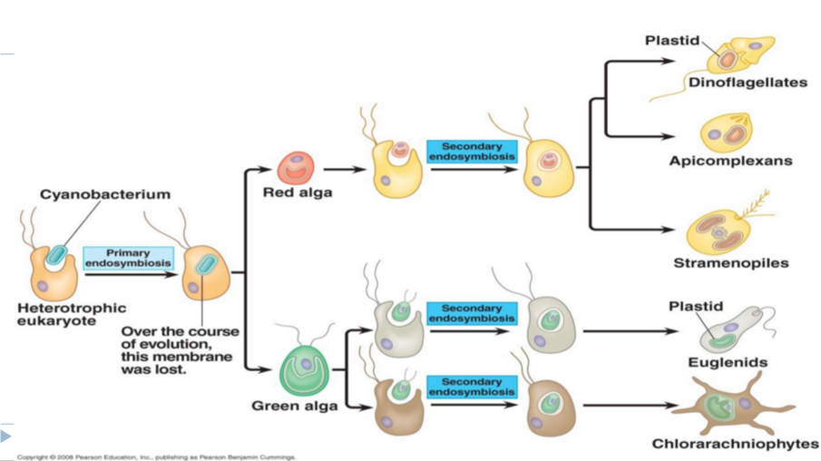

Classification – See page E-2 at back of Campbell
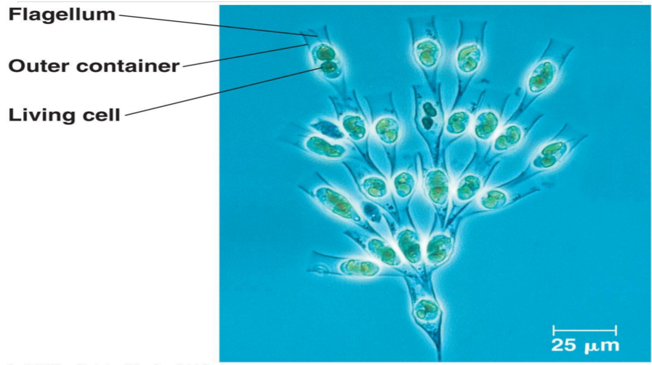

- Three categories?
  - Animal-like
  - Plant-like
  - Fungus-like
  - _______________-like?

- Five “_______________” of the Eukaryotic domain?
  - Excavata
  - Chromalveolata
  - Rhizaria
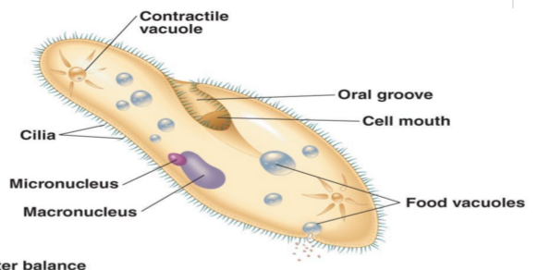
  - Archaeplastida
  - Unikonta

Ecological Connections

- Mutualistic Symbiosis
  - ____________________dinoflagellates and coral polyps
  - Protists and termites

- Parasitic Symbiosis
  - Malaria-causing protist Plasodium

- Photosynthetic Producers
  - ¼ of all the world’s ___________________________done by diatoms, dinoflagenllates, multicellular algae and other protists!
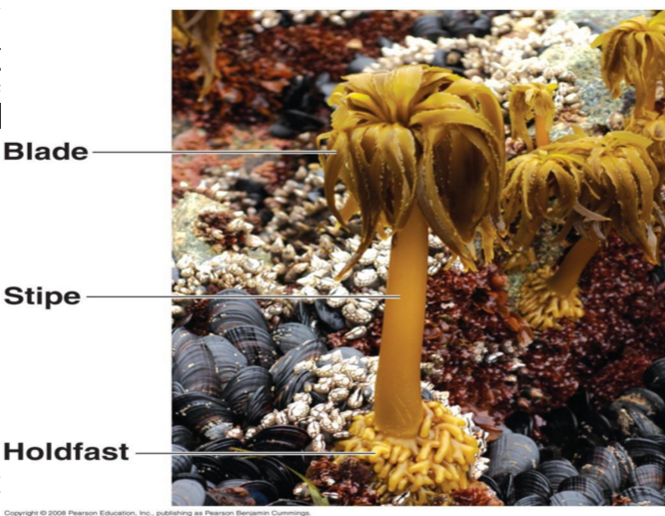
  - Foundation of many food webs

Lab Activity…I’d like to introduce you to:

Paramecium aurelia
Didinium
Amoeba proteus

