Pre AP Biology 11
Protein structure

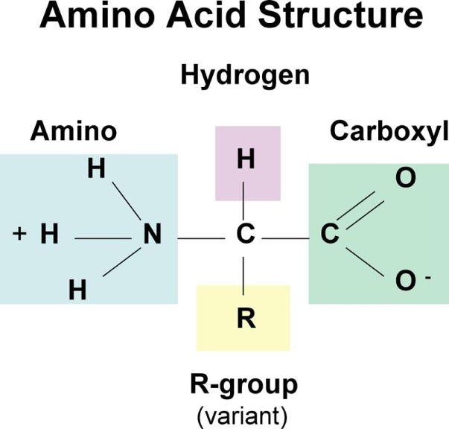
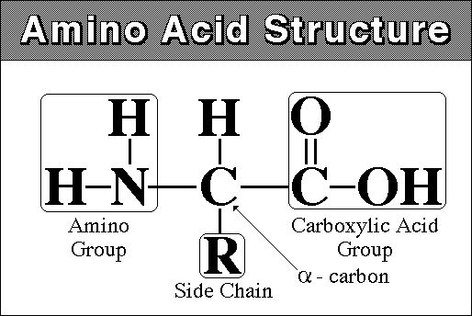
Proteins are the ___________. They are made of _______________ (____________) – there are _________ in total

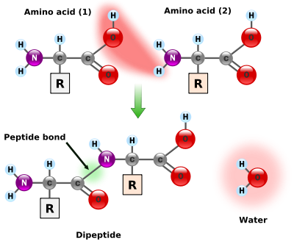
How do they bond together?
A ____________ bond is a type of ____________ bond
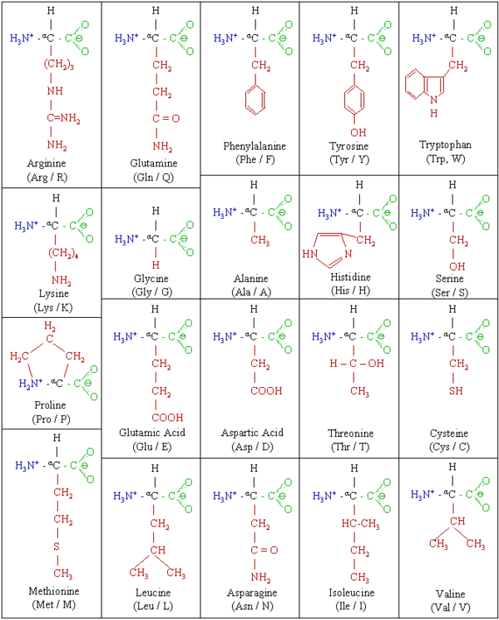
OH + H = H₂O = ______________________
The peptide bond causes the amino acids to be ___________ and leads to ____________ bonding.

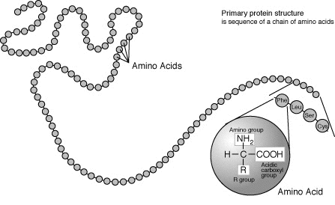
4 Structures of proteins
- Primary - a ___________ chain of amino acids with peptide bonds – different _____________ of the 20 amino acids

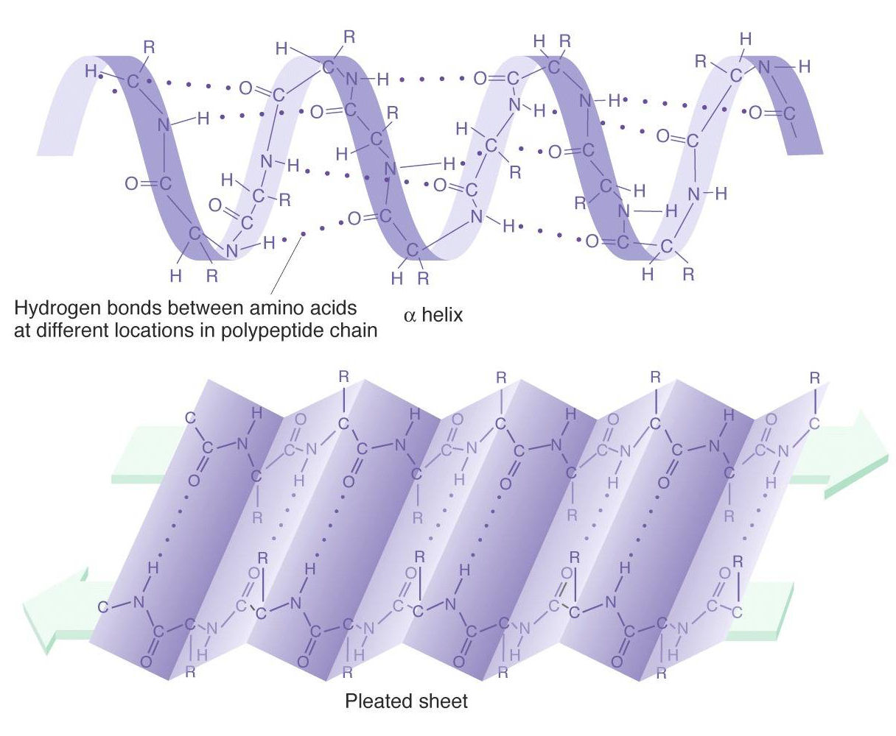
- Secondary – due to the _________ nature of the peptides (amino acids), hydrogen bonds will form between the amino acids. This causes the chain to form a ____________(right hand spiral) or to fold = ________________

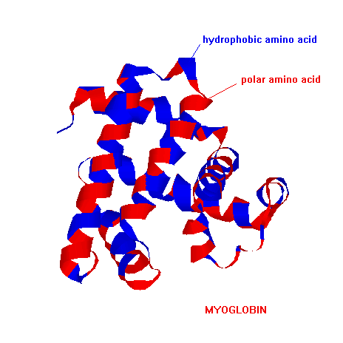

- Tertiary – more folding occurs due the covalent/hydrogen bonds between amino acids and ___________bonding between R-groups. Still only consists of _____ polypeptide chain
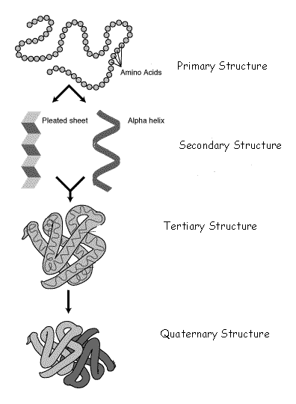
- Quaternary – _______ or more polypeptide chains _____________.

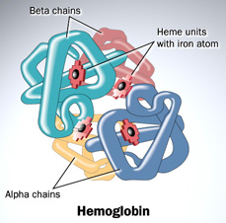
Example is hemoglobin (found in red blood cells)

