Pre AP Biology 11
Concept 1 – Speciation Day 1

- How allopatric and sympatric speciation are similar and different
- How an autopolyploid or an allopolyploid chromosomal change can lead to sympatric speciation
- How punctuated equilibrium and gradualism describe two different tempos of speciation

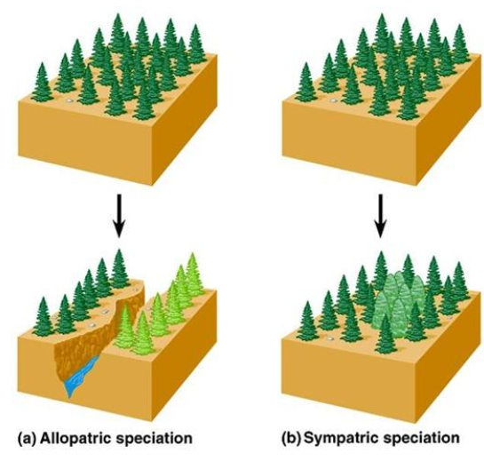
Allopatric vs Sympatric

Allopatric speciation is speciation that results when a population is separated by a __________________. It is also referred to as geographic speciation.

Sympatric speciation is speciation that occurs ____________________________of members of the population.

How big of a physical barrier are we talking?

It depends on the ability of the organism to move about. Birds, mountain lions, pollen, small rodents...they’ll all be able to conquer different barriers. However, once geographic separation has occurred, the gene pools may diverge due to_____________, natural selection and genetic drift

Why then do Islands like the Galapagos have such high species diversity?

Highly isolated populations, such as those on the Galapagos Island, experience very little gene flow and therefore are more likely to experience allopatric speciation.

Gene Flow → The transfer of _____________for one population to another, resulting from the movement of fertile individuals or their gametes

Sympatric Speciation Since individuals are in contact with each other, this happens_________________. It can occur if gene flow is reduced by polyploidy, habitat differentiation, and sexual selection.

Polyploidy - you know this! During ____________________if you have different numbers of chromosomes than expected, you may get a new species.

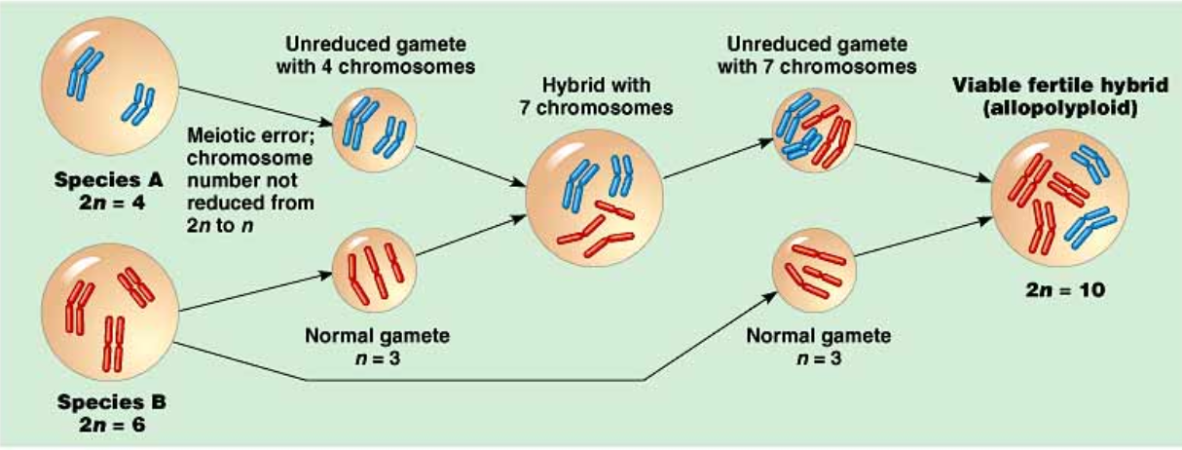

Habitat differentiation - animals spend time in different _________of the same of the same habitat.

Sexual Selection → this is when females select males based on their ___________________and could keep the gene pools separate.

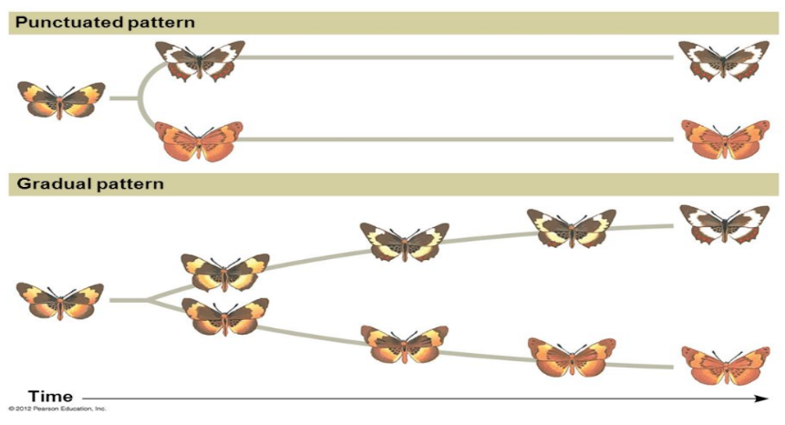
Soooo how fast is speciation really?

Punctuated Equilibrium

The fossil record includes many episodes in which new species appear _________________and then exist unchanged for a long time, and then disappear.

This indicates that speciation occurred
rapidly

Gradual Speciation This process is________________and has more steps.

Two factors that are thought to affect speciation rate are the __________________________and the___________________.

