Pre AP Biology 11
Concept 3: Population Ecology
ANALYZING DENSITY, DISPERSION, DEMOGRAPHICS, GROWTH, AND FACTORS THAT AFFECT GROWTH.
Chapter 53 in Campbell
p. 294-297 in Holtzclaw, Qs #3, 21, 22, 23 p. 304

You must know:
- How density, dispersion, and demographics can describe a population
- The differences between exponential and logistic growth models of population growth
- How density-dependent and density-independent factors can control population growth

How can density, dispersion, and demographics can describe a population?

Density - The number of individuals per unit of __________ or _____________.

Things that affect density:

Dispersion - the pattern of _______________ among individuals within the boundaries of the population
Clumped - patches, usually around a required ______________. Example:

Uniform - result of __________interactions. Example:

Random - ________________ spacing. Not common, since there is usually a reason for dispersion
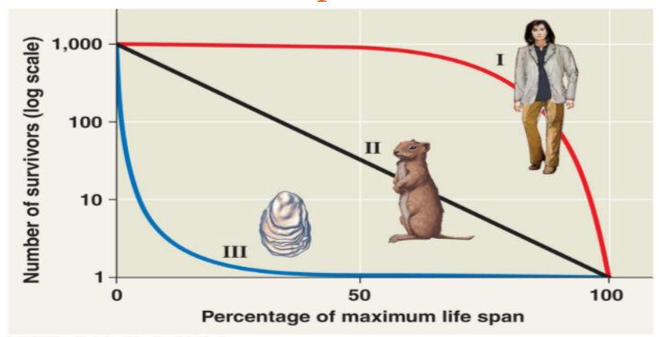
Survivorship Curves

Type 1 - ________death rates early and midlife,
then death rate ___________________ sharply

Type 2 - _______________ death rates

Type 3 - very high ____________death rates, than a flat rate
for the few surviving to older age groups.

Describe the Canadian human population in terms of density, dispersion, and demographics...

What are the differences between exponential and logistic growth models of population growth?

Life History → Traits that affect an organism’s schedule of _________________and ________________
(from birth through reproduction to death)

Life history has ‘trade- offs’

How do the life histories of the dandelion and the coconut palm compare?

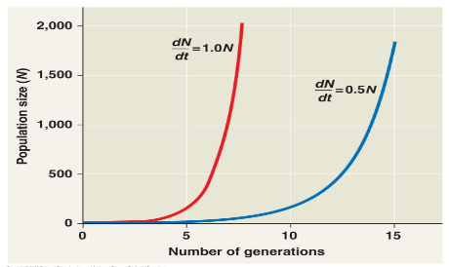
Exponential Growth Model

The formula: the per capita rate of population increase
assuming it is growing at the _________________ rate.

N is _________________&
t is ______________

A population with a higher maximum rate will grow faster
over time.
The J-Shape is characteristic of some populations introduced into new environments or that are rebounding after a catastrophic event.

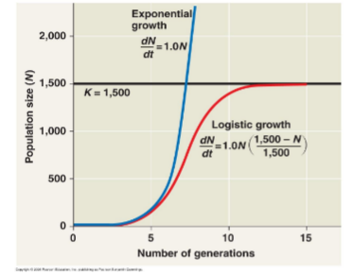
Logistic Growth Mode

K= ______________________________

The maximum population size that a particular environment
can __________________.

Things that influence carrying capacity (limiting factors:

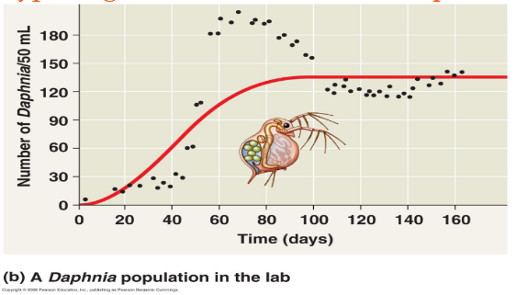
What type of growth model does this Daphnia show?

r-selection – density _________________selection

- maximize reproductive success in ____________________environments
- low densities
- density _____________________.
- r = little competition
- population densities are well ______________carrying capacity.

K-selection – density _______________selection

- populations living at density ______________________imposed by their resources
- competition is relatively strong.

What are the density dependent factors that could affect these populations?

Density dependent factors include:

Try This:

1. Which of the following best describes opportunistic, or r-strategy, organisms?
(a) They reach sexual maturity rapidly
(b) They reach their adult size slowly
(c) They attain a large body size
(d) They live for a long time
(e) The size of their population remains fairly constant
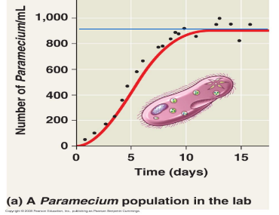

2. a) What is the type of growth from 1-7 days?

b) What does the solid blue line represent?

c) After 9 days, is the population regulated by density dependent or independent factors?

