KINGDOM PLANTAE
CONCEPT 3: ANALYZING THE DIVERSITY OF PLANTS
Chapter 29 and 30: Biological Diversity Continued…
Learning Intentions – Concept 3
You must know:
- Why land plants are thought to have evolved from green algae.
- Some of the disadvantages and advantages of life on land.
- That plants have a unique life cycle termed alternation of generations with a gametophyte generation and a sporophyte generation.
- The role of antheridia and archegonia in gametophytes.
- The major characteristics of bryophytes.
- The major characteristics of seedless vascular plants.
- Key adaptations to life on land unique to seed plants.
- The evolutionary significance of seeds and pollen.
- The role of flowers and fruits in angiosperm reproduction.
- The role of stamens and carpels in angiosperm reproduction.

Review: Biological Diversity
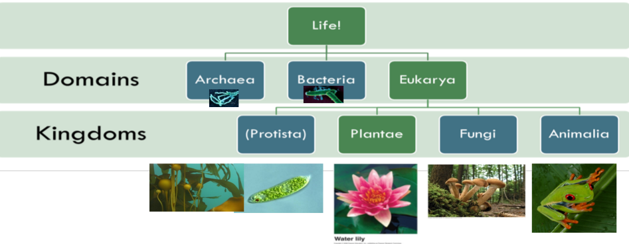
Kingdom Plantae

What makes a plant, a plant?
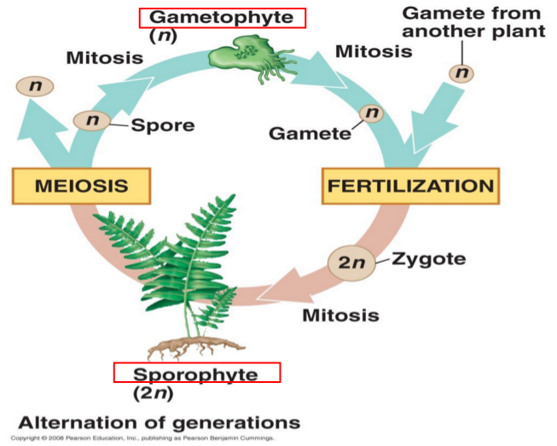
- Produce cellulose for _____________________________
- _________________________ have enzymes that reduce the toxic
effects of photosynthesis
- Produce ___________________ during cell division
- Life cycle highlights__________________________________, with a
gametophyte stage (haploid) and a sporophyte stage (diploid), while
the zygote develops within the tissues of the female parent!

The Evolution of Land Plant

Land plants evolved from __________________more than 500 million years ago.

Plants supply oxygen and are the ultimate provider of most of the food eaten or absorbed by animals or fungi.

The evolution of land plants from the green algae group known as the_________________.

Structure of algae sperm and plant sperm is similar.
Evidence of the Evolution:

- Rosette shaped cellulose synthesizing complexes

- Peroxisome enzymes - _____________________________

- Flagellated __________________(pollen produces sperm)

- Formation of a phragmoplast (beginning of a cell plate)

Movement of plants from water to land

Advantages:

Challenges:

How did each group adapt?

- Nonvascular (Bryophytes example: Mosses)

No xylem or phloem, although some mosses have simple vascular tissue.
Lack of vascular tissue accounts for a_________________.

All bryophytes have the ____________________as the dominate stage of the life cycle: they are larger and longer-living than the sporophytes.

- Seedless Vascular (example: Ferns)

Vascularization!

First plants to ________________ gaining sunlight. Require a film of ____________________for the sperm to reach the egg. __________________ is the dominant stage.

Not only is the stage where there was the evolution of xylem and phloem but also the evolution of _____________________________

Roots → the organs that absorb water and nutrients from the soil. Roots also _________________plants allowing them to__________________.
Leaves → Increase the____________________ of the plant and serve as the primary organ for _______________

- Gymnosperms (example: Pine tree)

Development of Seeds. Seeds are plant __________________packaged with a food supply in a protective coat
.
Naked means → not enclosed in ovaries. ________________ on modified leaves that form cones.

Five adaptations led to the success of seed plants

Reduced Gametophytes.
Mostly microscopic which allowed for gametophytes to develop from spores retained _________________of the parental sporophyte. This ___________the egg...mostly from drying out.

Heterospory.
Production of 2 types of spores. This allows for both __________________parts that each have a single function.

Ovules and the production of eggs
Increase protection of the egg and developing _______________

Pollen and production of sperm.
Sperm (pollen) grain has a _________________that protects it from wind or by hitchhiking on animals. Most have lost their flagellum.

Seeds.
If a sperm fertilizes an egg, the zygote grow into a sporophyte embryo. The whole ovule develops into a seed: the embryo along with a food supply, packaged in a ________________coat.

What advantage do seeds have over spores?

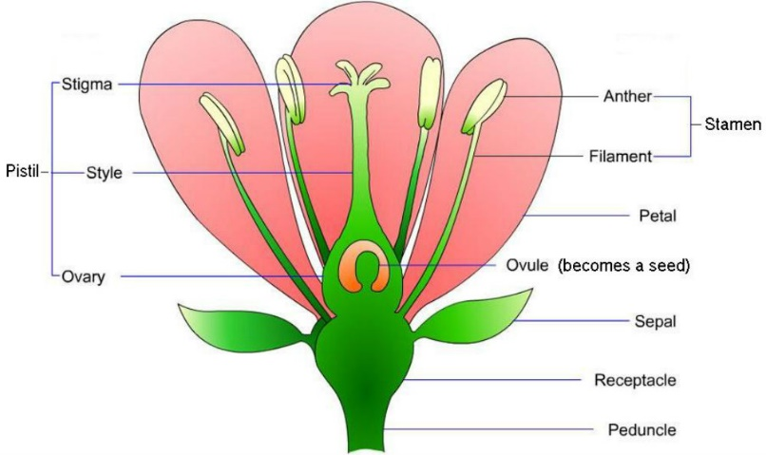
- Angiosperm (example: Rose)

Development of Flowers & fruits. 90% of all plants species!

Reproductive adaptation is the flower

- Insects or other animals transfer pollen from one flower to the sex organs on another flower, which makes pollination more ___________than gymnosperms.

What is the fruit?
The fruit is the _____________________(although it can be other parts as well).

As seeds develop from ovules after fertilization, the wall of the ovary________________.
Fruits protect dormant seeds and aid in their______________.

Angiosperm Classification

Monocot → only have one ______________in the seed, ______________leaf venation, and flowering parts in multiples of______________. Examples: orchids, lilies, grasses

Eudicots → have two ______________in the seed, _____________leaf venation, and flowering parts usually in multiples of_______________. Examples: roses, peas, beans, oak

