**Physics 11 Formula Sheet**

***Special Relativity***

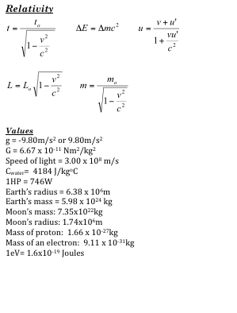

***Waves and Optics***

  

 *nisinθi = nrsinθr*





***Forces and Dynamics***

**  **

**  **

 

*t*

***Work, Energy and Power***

 

 

 = ∆ *E*

*efficiency = W out*  × *100%*

*W in*

*efficiency = E out*  × *100%*

*E in*

*Q = mcΔT*

***Kinematics***

 

 

 

