Photorespiration
Photorespiration is a wasteful pathway that competes with the Calvin cycle. It begins when rubisco acts on oxygen instead of carbon dioxide.

Introduction
Do you have any friends who are awesome people, but who also have some kind of bad habit? Maybe they procrastinate a lot, forget your birthday, or never remember to brush their teeth. You wouldn't stop being friends with them for these reasons, yet from time to time, you might find yourself wishing they would clean up their act.

RuBP oxygenase-carboxylase (rubisco), a key enzyme in photosynthesis, is the molecular equivalent of a good friend with a bad habit. In the process of carbon fixation, rubisco incorporates carbon dioxide into an organic molecule during the first stage of the Calvin cycle. Rubisco is so important to plants that it makes up 30% or more of the soluble protein in a typical plant leaf. But rubisco also has a major flaw: instead of always using CO₂ as a substrate, it sometimes picks up O₂ instead.

This side reaction initiates a pathway called photorespiration, which, rather than fixing carbon, actually leads to the loss of already-fixed carbon as CO₂. Photorespiration wastes energy and decreases sugar synthesis, so when rubisco initiates this pathway, it's committing a serious molecular faux pas.

In this article, we'll explore why photorespiration happens, when it's most likely to take place (hint: think hot and dry conditions), and how it actually works.

Rubisco binds to either CO₂ or O₂

As we saw in the introduction, the enzyme rubisco can use either CO₂ or O₂ as a substrate. Rubisco adds whichever molecule it binds to a five-carbon compound called ribulose-1,5-bisphosphate (RuBP). The reaction that uses CO₂ is the first step of the Calvin cycle and leads to the production of sugar. The reaction that uses O₂ is the first step of the photorespiration pathway, which wastes energy and "undoes" the work of the Calvin cycle.

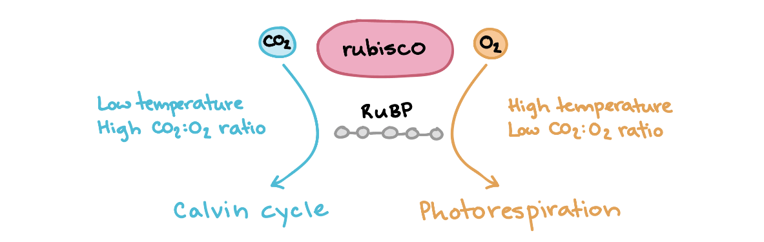

What determines how frequently each substrate gets "chosen"? Two key factors are the relative concentrations of CO₂ or O₂ and the temperature.

When a plant has its stomata, or leaf pores, open CO₂ diffuses in, O₂ and water vapor diffuse out, and photorespiration is minimized. However, when a plant closes its stomata—for instance, to reduce water loss by evaporation—O₂ from photosynthesis builds up inside the leaf. Under these conditions, photorespiration increases due to the higher ratio of CO₂ or O₂.

In addition, Rubisco has a higher affinity for O₂ when temperatures increase. At mild temperatures, rubisco's affinity for CO₂ is about 80 times higher than its affinity for O_{2.} At high temperatures, however, rubisco is less able to tell the molecules apart and grabs oxygen more often.
The bottom line is that hot, dry conditions tend to cause more photorespiration—unless plants have special features to minimize the problem.

Photorespiration wastes energy and steals carbon
Photorespiration begins in the chloroplast, when rubisco attaches O₂ to RuBP in its oxygenase reaction. Two molecules are produced: a three-carbon compound, 3-PGA, and a two-carbon compound, phosphoglycolate. 3-PGA is a normal intermediate of the Calvin cycle, but phosphoglycolate cannot enter the cycle, so its two carbons are removed, or "stolen," from the cycle.
To recover some of the lost carbon, plants put phosphoglycolate through a series of reactions that involve transport between various organelles. Three-fourths of the carbon that enters this pathway as phosphoglycolate is recovered, while one-fourth is lost as CO_{2.}

In the diagram below, you can see a comparison between photorespiration and the normal Calvin cycle, showing how many fixed carbons are gained or lost when either 6 CO₂ or 6 O₂ molecules are captured by rubisco. Photorespiration results in a loss of 3 fixed carbon atoms under these conditions, while the Calvin cycle results in a gain of 6 fixed carbon atoms.

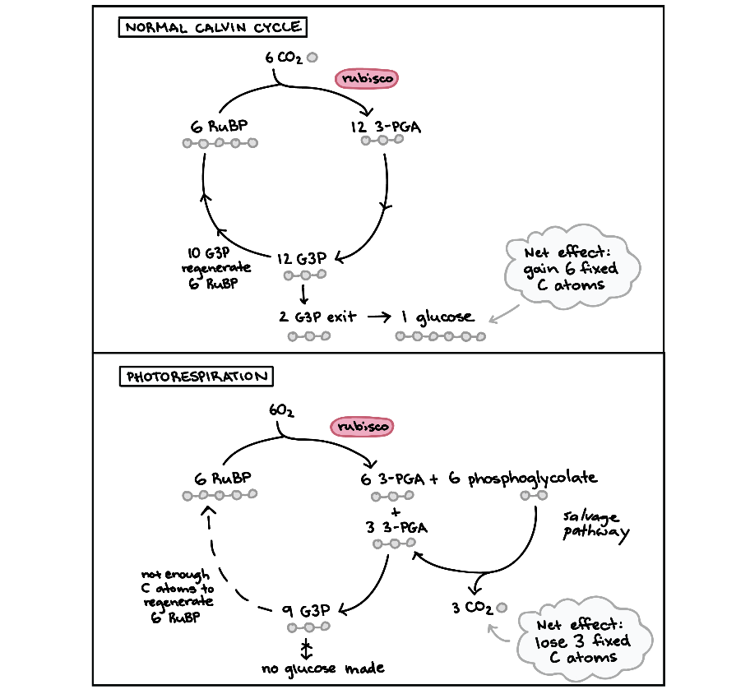

Photorespiration is definitely not a win from a carbon fixation standpoint. However, it may have other benefits for plants. There's some evidence that photorespiration can have photoprotective effects (preventing light-induced damage to the molecules involved in photosynthesis), help maintain redox balance in cells, and support plant immune defenses.

