Partner Review Practice Test Chapter 7

1. Identify the following 3-D object:

a. cylinder b. rectangular prism c. triangular prism d. cube

2. A soup can has a radius of 4.3 cm and a height of 11.6 cm.
What is the volume of the soup can to the nearest tenth of a cubic centimeter?

a. 49.9 cm³ b. 168.4 cm³ c. 673.5 cm³ d. 1816.8 cm³

3. A storage box for skis measures 0.45m high, 0.45 m wide, and 1.7 m long.
What is the volume of the case to the nearest hundredth of a cubic meter?

a. 0.34 m³ b. 0.69 m³ c. 3.44m³ d. 6.88m³
4. A rectangular garage has a volume of 480 m³, a length of 12 m and a width of 8m.
What is the height of the garage?

a. 4 m b. 5 m c. 6 m d. 7m

5. Anita cuts a piece of birthday cake exactly in two equal pieces for her and her brother.
What is the volume of each piece of cake?
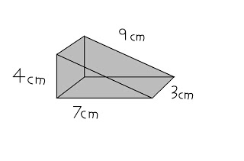

a. 42 cm³ b. 21 cm³ c. 126 cm³ d. 84 cm³

6. A hockey puck has a diameter of 7.6 cm and a height of 3.4 cm. What is the volume of a cylindrical package containing six pucks? Round your answer to the nearest whole number

a. 155 cm³ b. 26 cm³ c. 925 cm³ d. 154 cm³

