Part 1: Application of the Pythagorean Theorem.
Use the Pythagorean Theorem to solve the following problems
1.

To get from point A to point B you must avoid walking through a pond.
To avoid the pond, you must walk 34 meters south and 41 meters east to
the nearest meter, how many meters would be saved if it were possible
to walk through the pond?

Sketch
Given lengths
Missing lengths
Rule
Using the rule
Answer
Explanation

(explain the solution to the problem in words. Justify the steps).
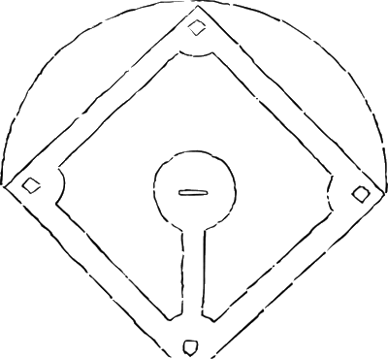
2.

A baseball diamond is a square with sides of 90 feet.
What is the shortest distance, to the nearest tenth of a foot,
between first base and third base?

3
1

Sketch
Given lengths
Missing lengths
Rule
Using the rule
Answer
Explanation

(explain the solution to the problem in words. Justify the steps).

3.
In a computer catalog, a computer monitor is listed as being 19 inches.
This distance is the diagonal distance across the screen. If the screen
measures 10 inches in height, what is the actual width of the screen
to the nearest inch?

Sketch
Given lengths
Missing lengths
Rule
Using the rule
Answer
Explanation

(explain the solution to the problem in words. Justify the steps).

4.
Two joggers run 8 km north and then 5 km west.
What is the shortest distance, to the nearest tenth
of a kilometer, they must travel to return to their
starting point?

Sketch
Given lengths
Missing lengths
Rule
Using the rule
Answer
Explanation

(explain the solution to the problem in words.
Justify the steps).

5.
Seth made a small rectangular table for his workroom.
The sides of the table are 36 cm and 18 cm. If the diagonal
of the table measures 43 cm, is the table square? A table
which is “square” has right angles at the corners.
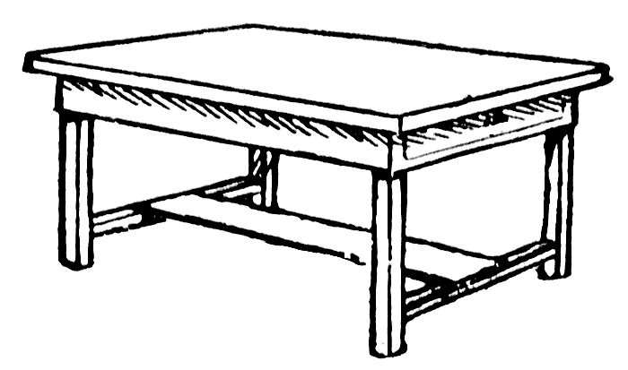

Sketch
Given lengths
Missing lengths
Rule
Using the rule
Answer
Explanation

(explain the solution to the problem in words.
Justify the steps).

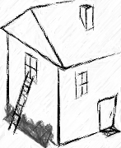
6.
You’re locked out of your house and the only open window
is on the second floor, 25 feet above the ground. You need to
borrow a ladder from one of your neighbours. There’s a bush
along the edge of the house, so you’ll have to place the ladder
10 feet from the house. What length of ladder do you need to
reach the window?

Sketch
Given lengths
Missing lengths
Rule
Using the rule
Answer
Explanation

(explain the solution to the problem in words.
Justify the steps).

