Electric Circuits Notes
1 – Circuits

Open the PhET Simulation: Circuit Construction Kit.

Create a simple circuit consisting of a battery, a single light bulb and a switch.
Use this to answer the following:
What are the two things required for electricity to flow:

There are two ways to describe the flow of electricity. In the top right corner you can toggle between the two. Briefly describe each:
- Electron Flow:

- Conventional Current:

Unless otherwise stated, in this class we will use conventional current!

Drawing actual components is difficult if you have the art ability of a Physics teacher. Instead we use schematics! In the bottom right corner you can toggle between realistic and schematic view.
Use this function to complete the table below:

Schematic | Name | Function
 | wire
 | cell/battery
 | light bulb
 | resistor
 | switch
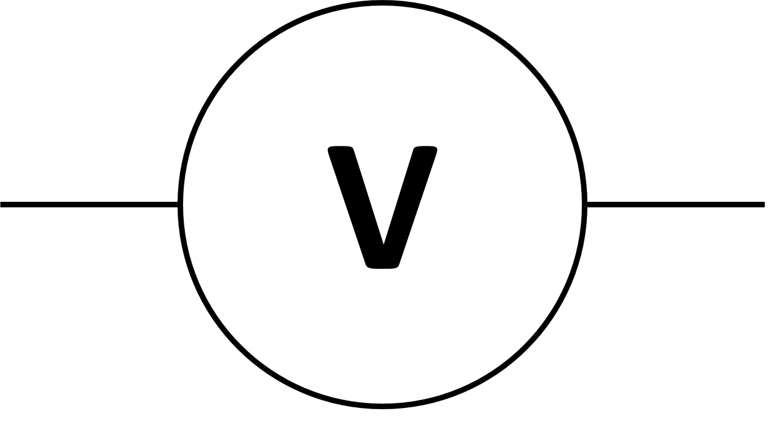 | voltmeter | Measures voltage across a component
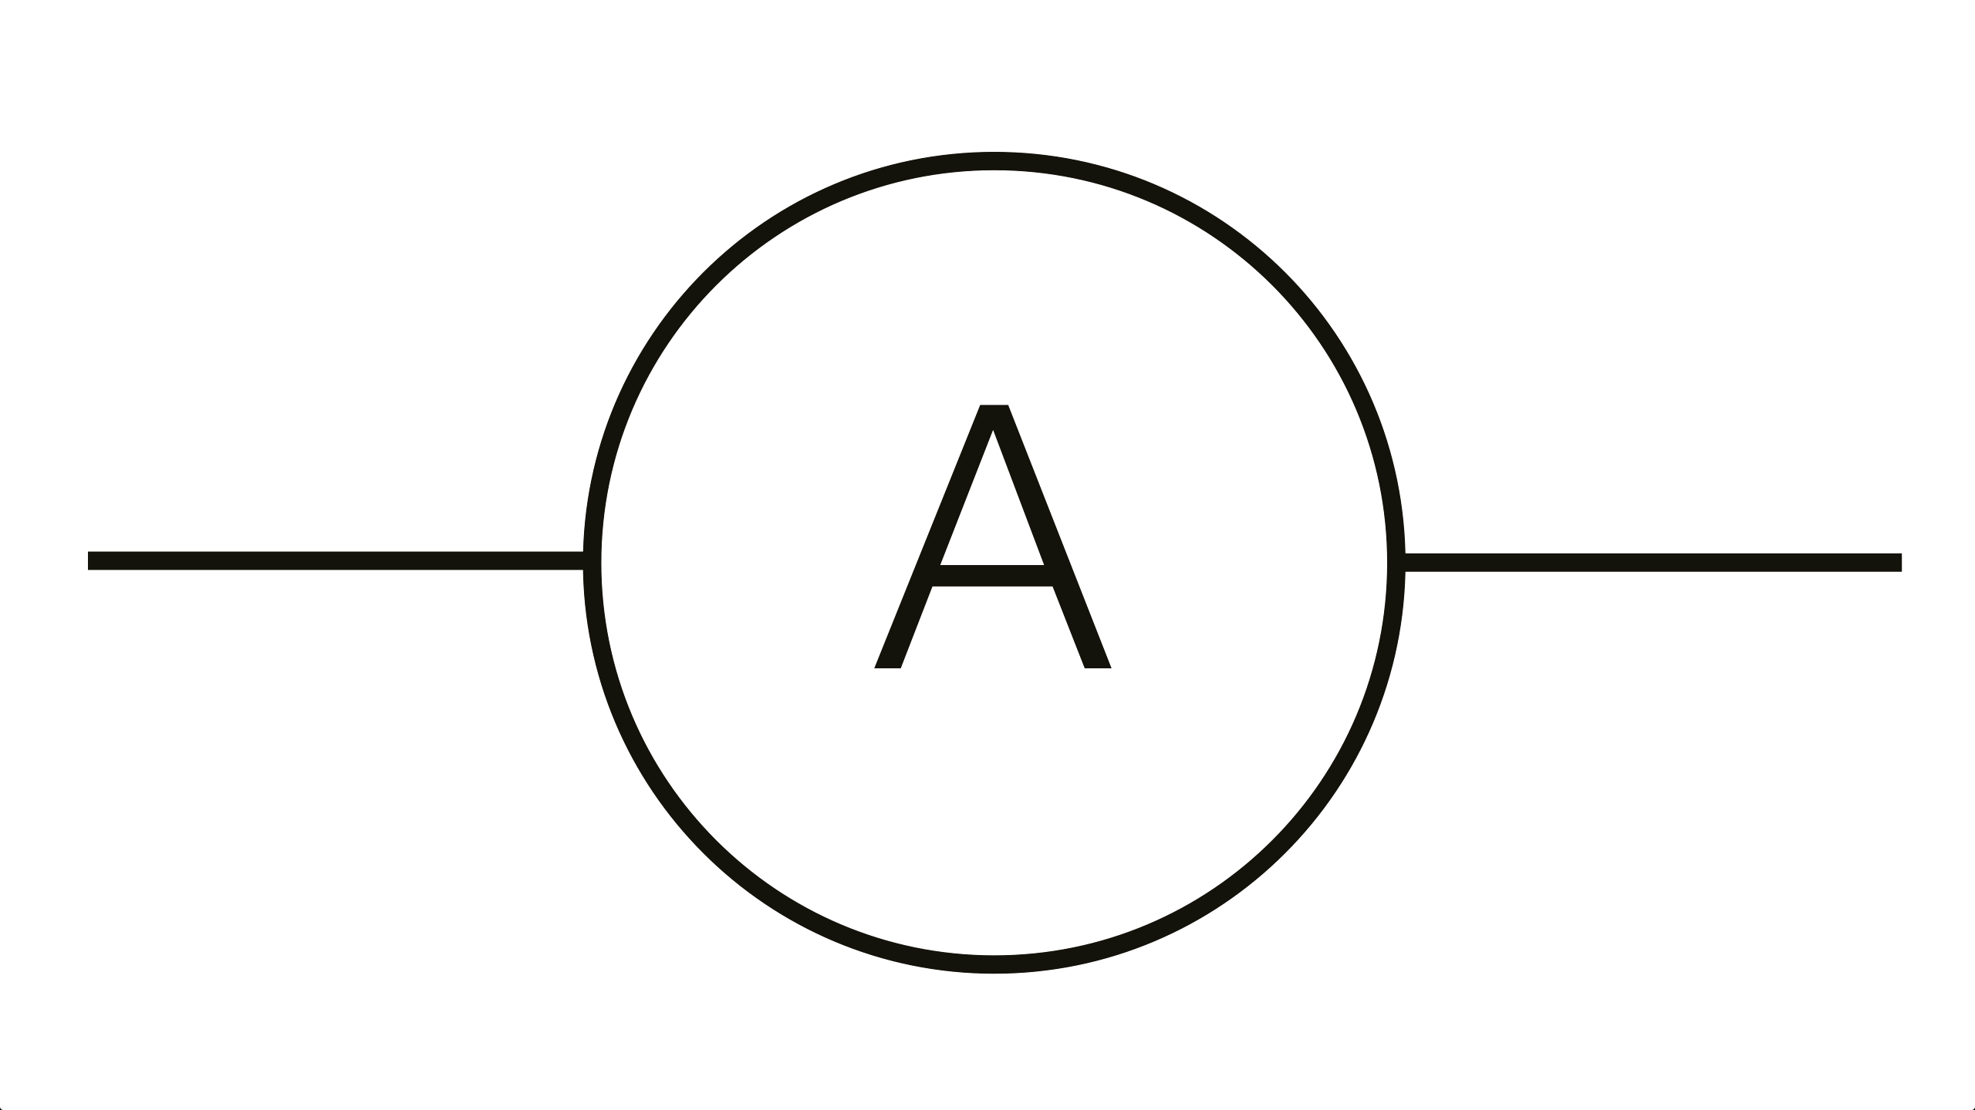 | ammeter | Measures the current through a circuit

There are two ways that we can attach devices to a circuit. Give a brief explanation of each one below:
(1) Series:

Ex. Draw a battery of two cells connected to two resistors in series.

(2) Parallel:

Ex. Draw a battery of two cells connected to two resistors in parallel.

Measuring Voltage and Current

We can measure the voltage in a circuit using a voltmeter and the current in a circuit using an ammeter.

We need to connect these two devices in different ways. Create a simple circuit and then play around with the voltmeter and ammeter (located on the right). Note whether they need to be connected in series or parallel in order to work.

Voltmeters need to be connected in ________________________.

Ammeters need to be connected in _________________________.

Draw a schematic that shows a light bulb connected to a battery with a voltmeter and an ammeter correctly measuring the voltage across and the current through the light bulb.

This simulation uses direct current. However, there is another type of electricity called alternating current. Do some research and find a definition of each.

Direct Current:

Alternating Current:

Electric Circuits Notes
2 – Circuits
Many particles are either positively or negatively charged. The charge of a particle (Q) is measured in coulombs. For example, the charge of a proton or electron is called the elementary charge, e = 1.6 x 10⁻¹⁹ C.

Current electricity is all about…

The number of charges flowing per second is defined by the specific quantity – current.

Current (I): The unit of current is __________________ or ____________ ( ).

Voltage (V):

The units of voltage are __________________ ( )

Resistance (R):

The units of resistance are __________________ ( )

These three quantities are related using
Ohm’s Law:

Power
We often talk about the amount of power used by different electrical devices. This is often confused with voltage or energy.

Recall that power is…

From the definition of power and Ohm’s Law we can derive some formulae to describe electric power.

Example: An electric fan has a resistance of 12 Ω and requires 0.75 A of current to function properly. What voltage is required to operate the fan?

Example: An electric heater emits 1.00x10² W when connected to a 120 V power line. What is the resistance in the heater?

Series and Parallel Circuits Simulation

Open the PhET Simulation: Circuit Construction Kit.

- Cells:
Cells | Voltage
Cell #1
Cell #2
Cell #3
1+2 in series
1+2+3 in series

Drag out three individual cells. Measure the voltage across each one individually and record the value. Then connect the cells in series to make a battery and record the values.

Describe the advantage of batteries made by cells attached in series.

Use some wires to attach the cells in parallel to make a battery. Measure the voltage and describe the voltage across the whole battery.

Describe the advantage of batteries made by cells attached in parallel.

(2) Simple Circuit:
Construct a circuit with one 9 V cell, one switch and one light bulb
Draw a schematic.

Using a voltmeter and an ammeter, measure the voltage and current through the light bulb.
Include the meters and measurements on your schematic.
Note the brightness of the bulb.
Observe the electrons as they move through the circuit. In this simulation the light bulb has a default resistance of 10 Ω and the wires have a resistance so low that it can be treated as 0 Ω. Do the electrons move at different speeds when they are moving through areas of high or low resistance? Explain why or why not.

You can change both the voltage of the cell and the resistance of the light bulb by right-clicking on them. While an ammeter is connected, manipulate either one and summarize the following relationships:
Current vs. Voltage Current vs. Resistance

(3) Series circuit: Construct a circuit with one 9 V cell, one switch and 3 light bulbs in series
Draw a schematic, including ammeters and voltmeters.
Measure V and I at each bulb
 | Voltage | Current
Light Bulb 1
Light Bulb 2
Light Bulb 3
Total
(at battery)

How does the brightness of the bulbs compare to the simple circuit?

Series Circuits General Rules:
Voltage: | Current: | Resistance:
V_{T} = | I_{T} = | R_{T} =
(4) Parallel circuit: Construct a circuit with one 9 V cell, one switch and 3 light bulbs in parallel
Draw a schematic, including ammeters and voltmeters.
Measure V and I at each bulb
 | Voltage | Current
Light Bulb 1
Light Bulb 2
Light Bulb 3
Total
(at battery)

How does the brightness of the bulbs compare to the simple circuit?

Parallel Circuits General Rules:
Voltage: | Current: | Resistance:
V_{T} = | I_{T} = | R_{T} =

Electric Circuits Notes
3 – Kirchhoff’s Laws
We have already seen that we can connect devices to a circuit in two ways: _______________________ or ______________________.

The manner in which we attach components of a circuit can greatly affect the nature of the circuit in particular its ____________________ there are a number of laws that we must use called Kirchhoff’s Laws.

Kirchhoff’s Current Law
For a series circuit:

In a series circuit there is only one path so the current must be…

For a parallel circuit:

In a parallel circuit the charge can take different paths. Therefore the amount of charge at any point…

Kirchhoff’s Current Law can be directly stated as: the sum of currents entering a junction…

I_{T} =

I_{T} =

Kirchhoff’s Voltage Law

Kirchhoff’s Voltage Law is stated as: The sum of the potential differences in a circuit must…

In a way this is simply restating the…

Remember that there is an increase in the potential across the terminals of a ________________ and that there is a decrease in potential across a _____________________. Essentially these increases and drops must add up to zero.

For a series circuit:

Since there is only one path, the total voltage increase across the battery must equal the total drop across each resistor.

V_{T} =

For a parallel circuit:

Note that the potential difference is…

V_{T} =

Kirchhoff vs Ohm

Kirchhoff does not have a law for resistance. We could perform an arduous derivation to find the formula using Kirchhoff’s other law and Ohm’s Law.

Instead, let’s just reason it out.

For a series circuit:

The total resistance in a series circuit is the __________ of the ______________________. Since each electron must push its way through each resistor, it should make sense that the resistances are cumulative.

R_{T} =

For a parallel circuit:

We already know that as we add resistors in parallel, the total resistance…

If the electrons are forced through one path, then there will be much more friction than if there are multiple paths to choose from. This is true even if the additional pathways are of higher resistance.

R_{T} =

Let’s recap:

Value | Series | Parallel

Example:
What are the values of I₁, I₂
and I₃ in the circuit shown?

Example:
What is the value of R₂ in the circuit shown?

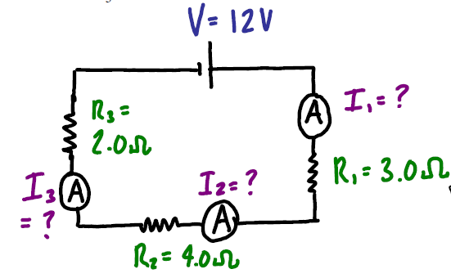

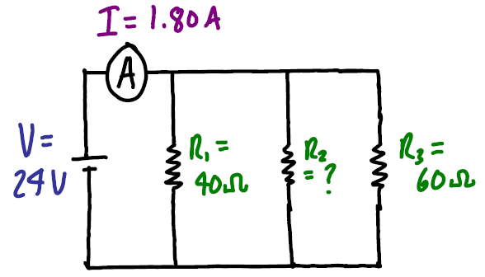

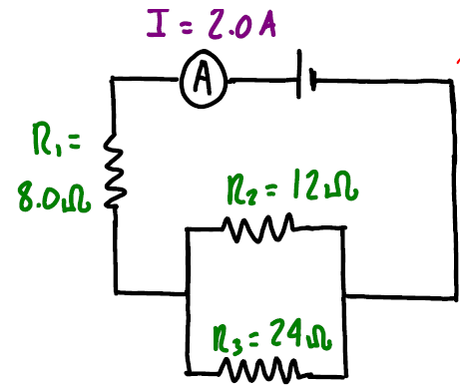
Example:
What is the potential difference supplied by the power source in this circuit?

Example:
What are the values of V₁, V₂ and R₂ in the circuit?

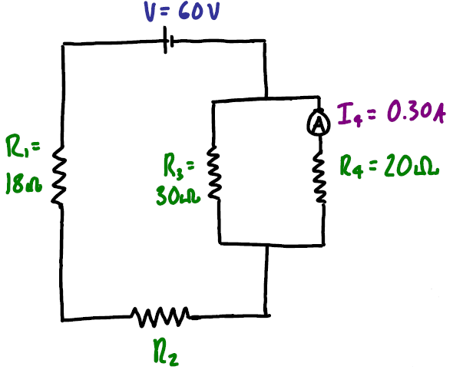

Electric Circuits Notes
4 – Electromotive Force
We know that a battery is a source of potential difference (______________) or electric energy. When not connected to a circuit there is a potential difference between the terminals.

This voltage is also known as…

Despite the name, this is a ___________________ not a ________________.
This dates back to a time when we thought that the two were equivalent.

For example a car battery has an EMF of ___________ and an alkaline battery has an EMF of ____________.

However, as soon as a battery is connected to a circuit and current flows through it the potential difference across the terminals is always…

This is due to the fact that every battery has…

Because of this _______________ ________________ the terminal voltage is always _______________ than the EMF of the battery when it is in use.

Where:

Note: Ir =

Note: If the battery is not connected to a circuit…

Example:
If a 12.0 V battery has an internal resistance of 0.220 ohms, what is the terminal voltage of the battery when a current of 3.00 A flows through the battery?

Consider the following diagram showing a circuit with an external resistance, _______, internal resistance ______ and EMF _______.

When a battery goes dead it is because…

Example:
A 12.0 V car battery is being charged by an alternator that can supply 15 V. If the internal resistance of the battery is 1.3 ohms, what is the current through the battery?

When a rechargeable battery is being charged an external voltage is applied to the battery. In order to force electrons backwards into the battery the external voltage must be…

In fact the external voltage must be:

