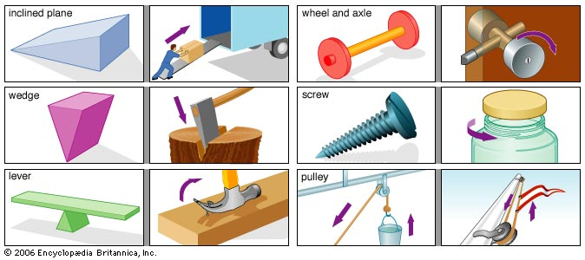
Unit 7: Work, Energy and Power
6 – Efficiency
Efficiency is a measure of how much…
Machines are useful because they allow us to use _________ force over a __________ distance to do the _________ work.

The 2nd Law of Thermodynamics states that whenever work is done, some energy is converted to heat.
Therefore:
Work in:
Work out:

Ex: A lever is used to lift a 50.0 kg object 10.0 cm. To do this we must apply a force of 75 N to the end of the lever which displaces 1.00 m. Find the efficiency of the lever.

The Efficiency of a machine is:

There are no units for efficiency, it is expressed as…

Worksheet 7.6: Efficiency

1) An 8.5 x 10² kg elevator is pulled up at a constant velocity of 1.00 m/s by a 10.0 kW motor. Calculate the efficiency of the motor.

2) A 5.00 x 10² W electric motor lifts a 20.0 kg object 5.00 m in 3.50 s. What is the efficiency of the motor?

1) 83% 2) 56% 3) 0.048 s 4) 43%
3) If a 1.00 x 10² kW motor has an efficiency of 82%, how long will it take to lift a 50.0 kg object to a height of 8.00 m?

4) A 955.0 kg car is accelerates uniformly from rest to 16.0 m/s while moving 18.0 m across a level surface. If the car uses 125 000 W of power, what is the efficiency of the car?

Purpose: To determine the efficiency of simple machines and other devices.
Efficiency Lab
h
d
Station 1: The Ramp
Materials: ramp, wooden block, spring scale, string, meter stick
Data and Calculations:
d:
h:
mass:
Force: Ramp Efficiency: ___________%
Questions:
1) Does increasing the mass being pulled up the ramp affect the ramp’s efficiency (within significant figures)? Propose an explanation.
2) Does changing the angle of the ramp affect its efficiency (within significant figures)? Propose an explanation.
d₂
d₁
Station 2: The Pulley
Materials: pulley, string, mass, spring scale, meter stick
Data and Calculations:
d₁:
d₂:
mass:
Force: Pulley Efficiency: ___________%
h₁
h₂
Station 3: Bouncy Ball
Materials: bouncy ball, meter stick
Data and Calculations:
h1:
h2:
Bouncy Ball Efficiency: ___________%
Questions:
1) Why does the ball not bounce up to the same height it is dropped from?
2) What happens to that “lost” energy?

