Solve:

a) 3(-8 + 3) – [-4 x -2] b) 24 + -7x-2 - 3

**Practice (without a calculator).**

a) (+5) x (-3) b) (-6) x (+2)

c) (-7) x (-3) d) (+12) x (+3)

e) (-4) x (+ 4) f) (-8) x (-3)

Multiplying two integers in either order gives the same result

(-5) x (+3) =

(+3) x (-5) =

*What question does this represent?*

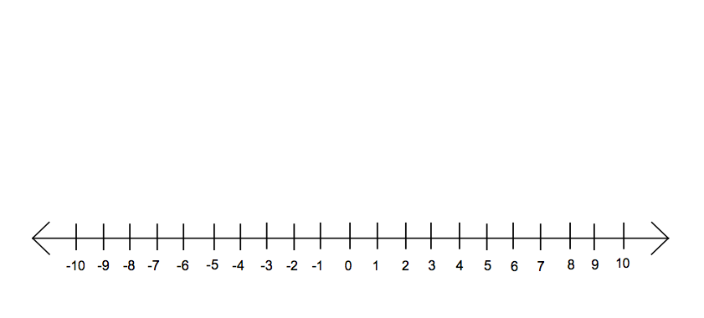

The Sign Rule:

The product of two integers with the ­­­­­­­­­_________________ sign is __________________

The product of two integers with _________________ signs is __________________

What about (-5) x (+2)?

Number line Integer chips



How would you show (+3) x (+2) with integer chips?

How would you show (+2) x (+3) on the number line below?

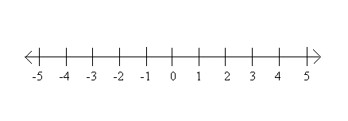

**Math 8: Unit 8 Integers**

8.1 and 8.2 🡪 Multiplying Integers