Molecular Genetics
Are we controlled by our DNA?
Refer to pg 119-150 in Holtzclaw, Chapters 16-21 in Campbell
Gene Expression
You must know:
You must know:
- The functions of the three parts of an operon
- The role of repressor genes in operons
- The impact of DNA methylation and histone acetylation on gene expression
- The role of gene regulation in embryonic development and cancer
The Operon – p. 131 in Holtz.

What is it?
- Unit of genetic function
- Found in bacteria/phages/some eukaryotes
- Consists of:
Promotor –

Operator –

Genes of the Operon –

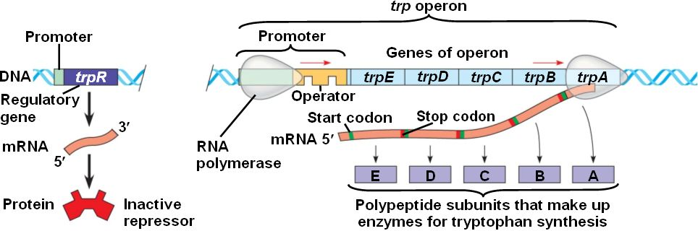

Regulatory Genes
What do they do?
Produce ___________________________that bind to the operator of an operon to block ____________________________________

Repressible Operon
Usually “on,” can be __________________

Inducible Operon
Usually “off,” can be ______________
The Trp Operon – Repressible
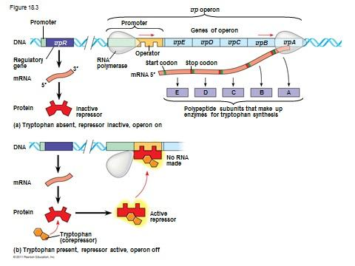

The Lac Operon – Inducible

