Math 8 Midyear PRACTICE Exam 2018

You are being assessed with Criteria A: Knowledge and Understanding & Criteria C: Communication
You may use your calculator for the following questions.

Section A – knowledge and recall, solving simple familiar problems.
If you answer most of the questions in this section correctly you will achieve level 4 on Criterion A

NON Calculator Section:

1. a) -6 + -7 b) -7 x 2 c) 3 - -4 d) -10÷ -5

Calculator:

2. Which expression does this diagram represent?

a. b. c. d.

3. One completely shaded grid represents 100%. What percent does this diagram represent?

a. b.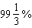 c.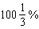 d.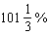

4. Solve for x in the equation 3x – 9 = 3
a. 4 b. 3 c. -3 d. 12

5. Determine the lowest common denominator for the following group of fractions: , , and .
a. 60 b. 80 c. 120 d. 140

6. Calculate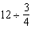.
a. b. c. 9 d. 16

7. Identify each of the following as a ratio, a rate or a unit rate
a. 12 marks out of a total of 20 marks b. 25 cars sold in 5 days
c. 25 L of gas used to travel 390 km d. 8 m per min

8. True or False: A part-to-whole ratio can be written as a fraction, a decimal, and a percent

9. What is the equivalent ratio to 2:4
a. 1:2 b. 2:8 c. 2:1 4:2

10. How would you write 15 green crayons to 10 red crayons in ratio notation?

11. The temperature increased from 4 °C to 12 °C in four hours. Determine the average hourly temperature increase.

a. 2 °C/h b. 4 °C/h c. 3 °C/h d. 6 °C/h

12. Determine –5 × (–10) × (–2).
a. −100 b. 25 c. d. 125

13. Solve and show your work: ½ x + 9 = 2

14. The area of the backyard of a house is 180 m². If 1.5% of the backyard is planted with flowers, the area not covered with flowers is _________________________.

15. Determine . Express your answer in lowest terms.
a. b. c. d.

16. 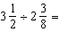 _________________________

17. What is the unit rate? There were 180 people on 3 buses.

18. Which is the better deal? $3.99 for 2L of orange juice or $4.50 for 3L of orange juice?

19. Apples sell at 7 for 84 cents. How much for 21 apples?

Section B– Solving simple and complex familiar problems.
If you answer most of the questions in this section (and in sections A and B) correctly you will achieve level 6 on Criterion A.
20.
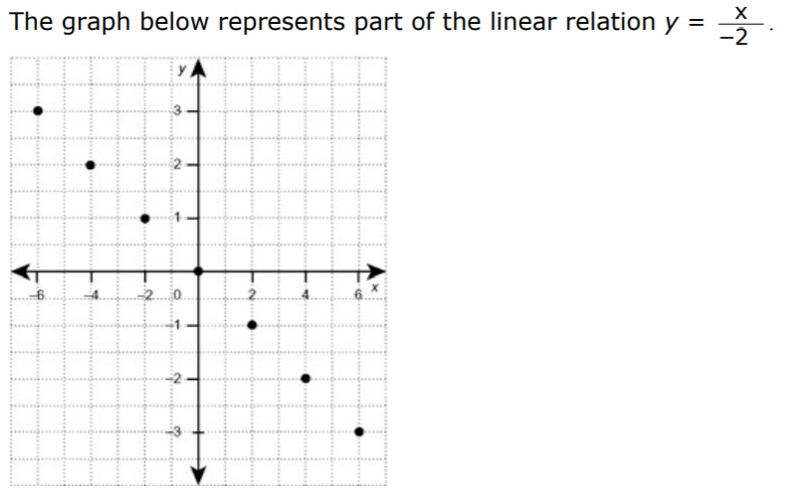
a) Use the graph to estimate y when x = 1.

b) Use the equation to calculate y when x = 16.

21.When a sum of money is divided equally among three people, each person receives $25. Write and solve an equation to determine the value of the sum of money. Verify your solution.

22. In a class of 30 students, have a computer in their home. Of the students who have a computer in their home, have high speed Internet access. Of the students with high speed Internet access, are using a Mac computer. What fraction of the class uses a Mac computer for high speed Internet access? How many students is this?

23. Elisha plans to install a new ceiling in her basement. Each ceiling tile covers an area of 1.25 m². The area of the basement ceiling is 50 m². If Elisha has only 21 ceiling tiles, what percent of the ceiling can she tile?

24. Mike used 2.5 kg of grass seed to cover 35.5m² of lawn. How many kg of seeds
would he use to cover 248.5 m² of lawn? Solve 2 different ways….as a unit rate and as proportional reasoning.

25. Solve. Check your work. −4 − = −7

Section C – Solving challenging problems in an unfamiliar situation
If you answer most of the questions in this section (and in sections A, B and C) correctly you will achieve level 8 on Criterion A.

26. (+42) ÷ [(−7) - (−1)] × (+2)³

27. A series of school trips are planned involving 384 students. One quarter of the students are to travel by train, of the students are to travel by bus, and the remainder are to travel by van. How many students are to travel by van?

28. Kathy earns $8/h washing dishes. If she works overtime, she is paid $12/h. Last week Kathy worked 48 hours. Eight of those hours were overtime. How much did Kathy earn?

29. Victoria High School is planning a 24-hour relay race. Students can walk or run either 2-km or 5-km segments. There are 110 students signed up for the 2-km option and 90 for the 5-km option. Based on last year’s results, 15% of students in the 2-km group and 35% of students in the 5-km group will not finish.
a) What fraction of all students entered are expected to complete their distance? Express your answer in reduced form.
b) Using last year’s statistics, what do you predict will be the total distance travelled by the students who complete their segment?

