For the following mixed operation questions…don’t forget to use the **order of operations**! A.K.A **BEDMAS**

For example: 8 ÷ 4 + (-3 – 2) - 23 Calculate: a) 8 + 6 x 5 – 40

b) 3 x [7 – (-3)] + (-23) c) (4 + 2) ÷ 6 + 3(-6+7)

Using a number line, solve the following questions:

a) (+7) – (+3) b) (-3) – (+5)

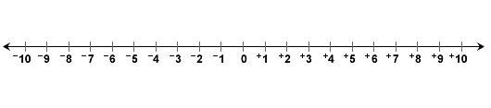 

c)(+2) – ( -2) d) (-3) – (+2)

 

e) (-6) – (-9) f) (+4) – (-1)

 

**Subtracting a Negative Number:**

When you subtract a negative number, it’s like adding a positive!

The Double Negative Rule: “I’m not, not going to do my homework!”…means you’re doing your homework! (good choice)

For Example:

(+6) – (-2)

**Subtracting Integers**

Integer subtraction can be modelled using integer chips OR number lines.

For example: (+5) – (-3)

