Ellie and Lucas are going to the skateboard park to try out the new ramp. Is the new ramp a right triangle? Explain your thinking.

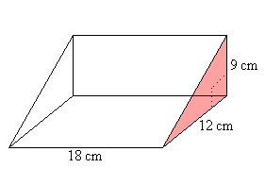

Find the height of a triangle with a base of 4 cm and a hypotenuse of 11 cm. Round to the nearest tenth of a centimeter. Show your work.

w

f=7cm

h=12cm

r

x=5cm

y=6cm

Determine the length of r

Determine the length of w