The top row or left column in a table of values has the same label as the ________________axis. The second row or right column has the same label as the _______________axis.

|  |  |  |  |  |
| --- | --- | --- | --- | --- |
| Radius of the circle |  |  |  |  |
| **Diameter of circle** |  |  |  |  |

|  |  |
| --- | --- |
| Radius of the circle | **Diameter of circle** |
|  |  |
|  |  |
|  |  |
|  |  |

You can use the coordinates of the points on a graph to make a table of values:

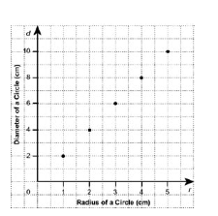¡

**Math 8: Unit 9 🡪 Linear Relations**

9.1 Analysing Graphs of Linear Relations