To find the circumference of a circle, use the formula **C = π × d** OR **C = 2 × π × r**

Use 3.14 as an approximate value of **π**

The Area, A, of a circle is the space the circle encloses.

To find the area of a circle, use the formula: A = **π × r2 OR A = π r2**

Find the circumference of each circle to the nearest tenth of a centimeter.

a) *d = 7cm* b)  *r = 4cm*

Find the area of each circle to the nearest tenth of a centimeter.

a) *d = 8cm* b)  *r = 2cm*

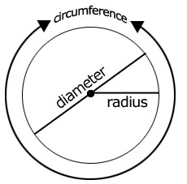

A circle is a set of points that are equal distance away from a fixed point, called the ______________.

The _____________________ is the distance from the centre of a circle to the outside edge.

The letter  *r* is often used to represent the radius.

The ____________________ is the distance across a circle through its centre.

The letter  *d*  is often used to represent the diameter.

The distance around a circle is called the ________________________________.

The letter *C*  is often used to represent the circumference.

The diameter is two times the radius.  *d = 2r*

The radius is half the diameter: *r – d ÷ 2*

**Area of a Circle**

l = 17m

d=5.5m

**r=10cm**

**h= 22cm**

Find the surface area.

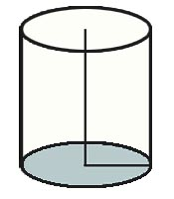

Find the surface area of the can.

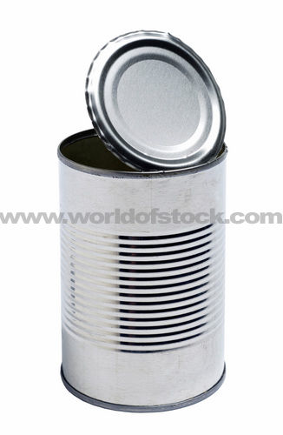

**5.4 Surface Area of a Cylinder**