L5: Simulations Name:
Ma8 U4 Probability Date:

Opening Problem
On average a basketball player makes about half of the foul shots attempted per game. Suppose there were twelve shots in a game.
Describe how you would conduct a trial of a simulation that models the results of the simulation.
How could we “create” a way to simulate a basketball game using the following…
Flipping a coin | Spinning a spinner | Rolling a die

Choose a method above and conduct 10 trials and record your results.

Creating a simulation using a random number generator
What is the probability of making the foul shot?
If you had the numbers 01-100, what range of numbers would represent making the shot?

Using the random numbers generated below, run through 12 trials and record your results
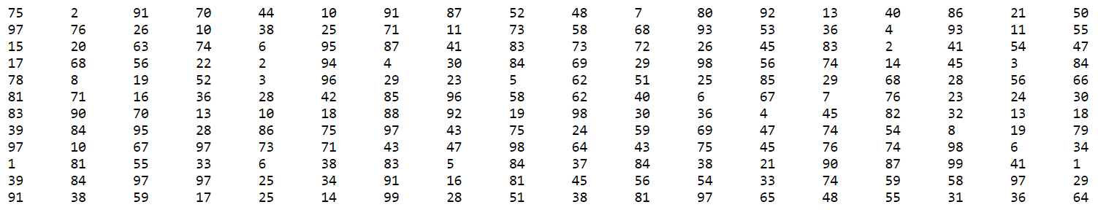

Suppose the basketball player makes 2/3 of the foul shots. Describe how you would conduct one trial of a simulation that models the results of twelve foul shots.
Use your chosen method and run through 12 trials and record your results.

With practice the basketball player now makes 75% of her foul shot attempts. Suppose she attempts 20 foul shots in a game. Answer the following questions and justify your answers.
- Could you use a coin to simulate the attempted foul shots?

- Could you use a six-sided number cube?

- Could you use a spinner? If so, what would it look like?

- Could you use a standard deck of 52 cards?

- How many trials should be conducted to obtain reasonable results?

Your turn
Gina is planning the time needed to get to her soccer game. There are two traffic lights between her house and the soccer field. These lights are red (or yellow) 60% of the time. Gina wonders how likely it is that both lights will be red on her way to the game.
- How can we model this situation?
- Conduct 10 trials and record your results in a table.
- What is your theoretical probability of both lights are red? What is the experimental probability that both lights are red?

Practice Problems
- Boxes of Oatie Smacks cereal contain a toy racing car in one of five colours: green, purple, black, blue and red. The likelihood of each colour car is the same.
- Describe how can we use the following to design a simulation to simulate the minimum number of boxes of cereal needed to buy each colour.
Spinner | Random Number Generator | Bag of Marbles

- Choose one of the above methods and conduct your simulation. Record your results.

- Students in grade 8 are each given one flower seed from a package of mixed flower seeds. The package contains an equal number of daisy, marigold, poppy, and snapdragon seeds. They randomly choose one of four locations to plant their seeds; the front garden at school, the back fence at school, the seniors center next door or in a pot to take home.
- Design a simulation to find the probability of planning a marigold in a flower pot.
- Conduct 10 trials of the simulation and record your results.
- Compare the experimental probability with the theoretical probability.

- Based on her history, Mindy scores 3/5 of her shots on goal in a field hockey game. Supposed she attempts 8 shots on goal in a game. Describe how you would use the list of randomly generated numbers to create a simulation and find the probability of scoring a goal in 8 attempts. Conduct your simulation and record your results.
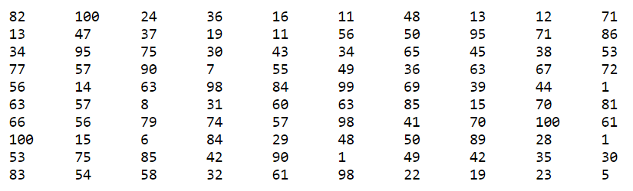

- The Bumble Bee’s chance of winning a football game is 20%. Suppose they play 15 football games in a season. How could you use a spinner to create a simulation for this situation? What would the probability of winning the game during the 15 game season be based on your simulation? Use an online spinner and conduct a simulation and record your results.

- Krunch-a-Munch cereal packs on of five games in each box. About how many boxes should you expect to buy before you get a complete set? What is the chance of getting a set in eight or fewer boxes? Use any method to design and conduct a simulation and record your results.

