L4: Determining Probabilities Using Fractions Name:
Ma8 U4 Probability Date:

Opening Problem
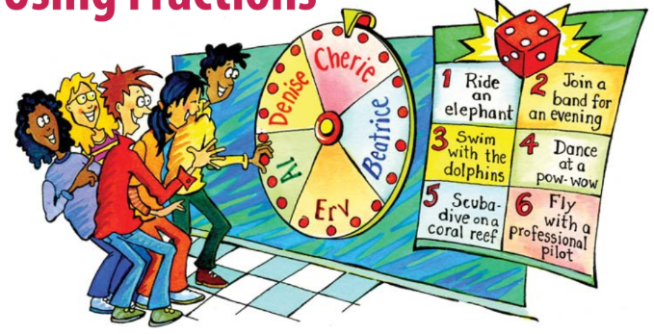
Create a table that will show you all the possible outcomes possible from spinning the wheel and rolling a dice.

Both Al and Erv love to swim. How likely is it that one of them will be chosen and get to swim with dolphins or scuba dive on a coral reef?

Example: Calculating Probabilities Using a Table and Multiplication
Mackenzie spins a spinner divided into five equal regions and rolls a four-sided die once each.
- Create a table to represent all the possible combinations of outcomes (aka sample space). How many outcomes are there?
- From the table, what is P (blue, 2) expressed as a fraction?
- Use multiplication to determine P (blue, 2).
- From the table, what is P (red or blue, < 4) expressed as a fraction?
- Use the method from part c) to calculate P (red or blue, < 4)

Example #2: Using a Tree Diagram to Calculate Probability
A blue, standard six-sided die and a red, four-sided die, numbers 1, 2, 3, and 4 are each rolled once. Create a tree diagram and determine the probabilities of the following. Use multiplication to verify your answer.
- P (blue = 4, red = 4)
- P (blue < 4, red < 4)
- P (blue = 4, red < 4)

Example 3: Using Probability to Determine if a Game is Fair or Not
Recall: Heads Wins!
You are approached by a classmate who invites you play a game with the following rules: Each of you takes turns flipping a coin. You toss your coin first, and your friend tosses next.
- He gives you $1 each time one of the coins lands on tails.
- You give him $1 each time the coin lands on heads.
- Create a tree diagram for all the possible outcomes and probabilities of the two tosses
- What are the possible outcomes?
- What is the probability of you winning?

Now your classmate wants to change the rules of the game. He suggests the following rules after you flip a coin.
- If you get heads, you give him $2.
- If you get tails, he then flips his coin.
- If he gets heads, you give him $1.
- If he gets tails, he gives you $2.
Who is most likely to win? Justify your reasoning.

Practice Problems
- Jason rolls a standard six-sided die and Rachel spins a spinner with three equal sections. What is the probability of rolling an even number and spinning a B? Draw a tree diagram and a table to verify your answer.

- In Bag #1 there are 5 red marbles and 2 black ones. In Bag #2 there are 6 blue marbles and 4 black ones. A marble is drawn from each bag. What is the probability that both marbles are not black? Express your answer as a fraction, decimal and a percent.

- It is Random Menu night at the Guess Grill restaurant. You do not order your own meal! For $3.99 you are given one of four possible appetizers and one of six possible main courses. Jeremy figures that he would be happy with three of the four appetizers and three of the main courses.
  - What is the probability that he will be happy with both his appetizer and his main meal?
  - What is the probability that he will be unhappy with both his appetizer and main course?

