Welcome to Math 8
Introduction Assignment

This Assignment is intended to familiarize you with some of the basic concepts and skills related to Math 8 that we will explore at Rockridge this year. Use a calculator is you like and feel free to look up any formulas you need.

Your Name: ___________________________ Block: ______ Due Date: ____________________

There are three parts to this assignment:

Part A: Art with Geometry (Done by hand only)
Part B: Math Riddle (Show your work!)
Part C: Your Math Experiences (Google Classroom)

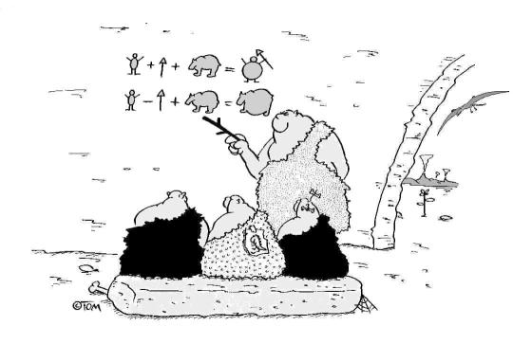

Part A: Art with Geometry

On the back of this page, draw a picture about yourself. Use a ruler for the straight lines. If you have them, use a compass and a protractor as well. Use the space provided below. You will be sharing this picture with your peers. If you prefer, sketch it now and complete it on a computer later. You must include the following in your scene:
- Parallelogram
- Circle
- Isosceles triangle
- A 60º angle
- A pair of perpendicular lines

Concept 1: Geometry
Beginning | Developing | Accomplished | Exemplary
Does not demonstrate a basic understanding of concept. Substantial errors throughout. | Basic understanding of concepts. Errors and inconsistency reveal some missing understanding of the concepts. | Solid understanding of concepts. Most answers are correct with only a few errors. | Complete and in depth understanding of concepts.
Part B: Math Riddle
Answer the questions on the following page, then look up each answer in the Decoder Table. Put the letter that matches the answer in the blank beside the questions.
For example, 1. A circle with a radius of 2.4 cm has a diameter of 4.8 cm, which matches W in the Decoder Table. Put a W in the blank beside 1.

Important: Show your work in the space provided or on a separate piece of paper and attach the paper to this assignment when you hand it in.

Decoder Table: Questions:
W | 1. | A circle with a radius of 2.4 cm has a diameter of _______.
 | 2. | (-7) – 5 =
 | 3. | Area of a triangle with a height of 0.7cm and a base of 6cm
 | 4. | The probability of getting a head with tossing a fair coin
 | 5. | 10 – 22 =
 | 6. | On a graph, the point 2 units to the left and 4 units up from (0,0)
 | 7. | ¾ + 1 ¾ =
 | 8. | Evaluate y + 7 when y = 2
 | 9. | 0.5 + 1.2 +0.8 =
 | 10. | -4 – (7 + 1) =
 | 11. | 3 x 4
 | 12. | Area of a circle with a radius of 0.82cm
 | 13. | Evaluate s + m when s = -2 and m = -3
 | 14. | -2 + (-4) + (-6)
 | 15. | 0.5 x (3.28 + 1.72)
 | 16. | 5 1/3 – 2 1/3 – ½ =
 | 17. | Area of a rectangle with a length of 4cm and a width of 0.7cm
 | 18. | Line segments in the same plane which do not intersect
 | 19. | On a graph, the point at the origin
 | 20. | Lines that meet at a right angle
 | 21. | 2x3x2 =
 | 22. | 8 + (-3) + (-10) =
 | 23. | ¼ is ______ percent
 | 24. | 7/10 + 1 2/5 + 2/5
 | 25. | 0.25 is _______percent
 | 26. | Line segments which intersect at 90º
 | 27. | On a graph, the point 2 units to the right & 4 units down from (0,0)
 | 28. | The probability of getting a tail when tossing a fair coin
 | 29. | -13 + 8 =
 | 30. | 2 x (-7 + 13) =

A | -12
E | Parallel
F | Perpendicular
G | (2, -4)
H | 2.1 cm²
I | -5
L | (-2, 4)
N | 12
O | (0,0)
R | ½
S | 2.8 cm²
T | 2.5 or 2 ½
U | 25
W | 4.8 cm
Y | 9

Now unscramble the letters to solve the riddle. The letter for question 1 has already been written in.
“How far can a dog run into the woods?”

 |  |  |  |  | W
3. | 2. | 6. | 20. |  | 1. | 14. | 8. |  |  | 10. | 26. | 24. | 18. | 4. |  | 15. | 12. | 5. | 9.
13. | 16. |  | 22. | 17. |  | 28. | 23. | 11. | 21. | 29. | 30. | 27. |  | 19. | 25. | 7.
Part B: Rough Work

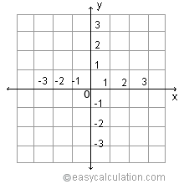

Concept 2: Grade 7 Coursework
Beginning | Developing | Accomplished | Exemplary
Does not demonstrate a basic understanding of concept. Substantial errors throughout. | Basic understanding of concepts. Errors and inconsistency reveal some missing understanding of the concepts. | Solid understanding of concepts. Most answers are correct with only a few errors. | Complete and in depth understanding of concepts.

Part 3: Your Math Experiences

This part is for you to tell the teacher a bit about yourself and your math skill. Write a short paragraph (three to five sentences) on GOOGLE CLASSROOM. Within the paragraph answer the following questions:

- How do you feel starting math in high school? Excited? Anxious?
- What topics do you like in math?
- Are there certain topics that you find challenging or difficult?
- What do you expect to achieve from grade 8 math?
- Any other thoughts for your teacher?

