Name:_______________________ Block:______
The Story Behind the Green Chicago River
http://greenchicagoriver.com/
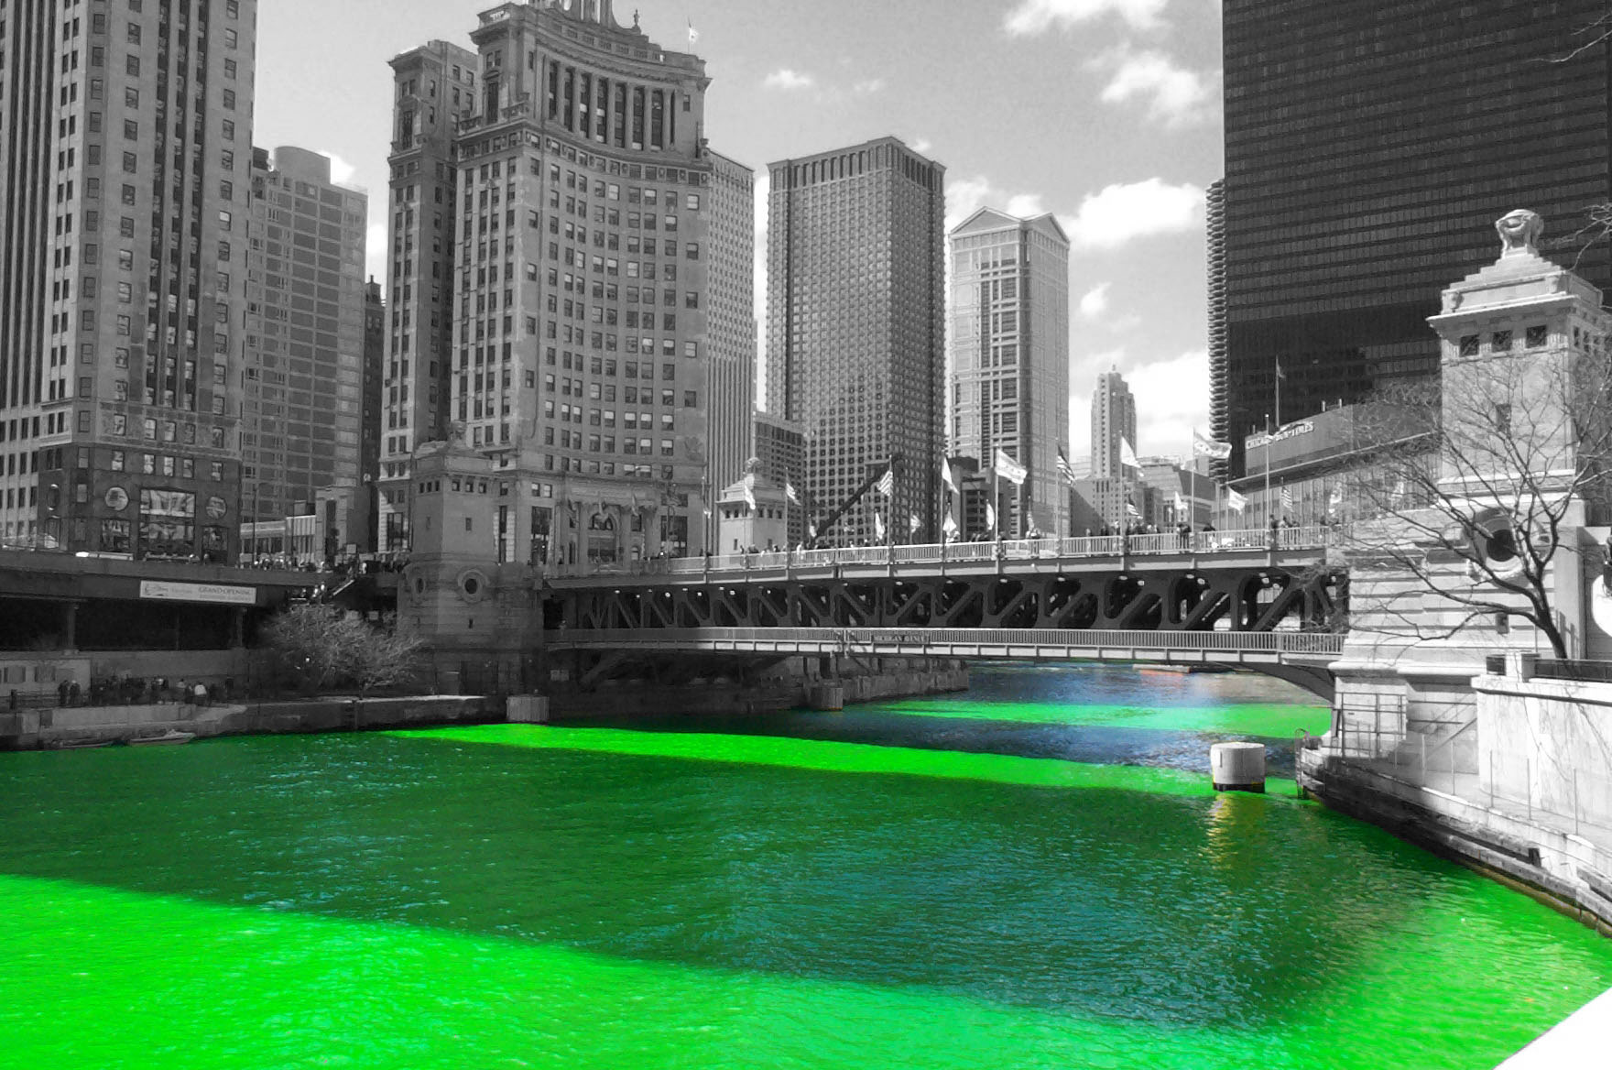

In Chicago, there is a St. Patrick’s Day parade on March 17th. In Chicago the parade has an extra highlight of green. For over 40 years, the local plumbers union has been dying the Chicago River green during the hours of the parade. How do they do that?
Evidently there is a dye that is used by plumbers to locate leaks in pipes and the color of the dye is very close to the emerald green that is associated with Ireland.
It must take an awful lot of dye to colour a river. I wonder how much dye it takes?

1. The main stem of the Chicago River is about 2300 m long, on average, 6 meters deep, and about 61 meters wide. I wonder what the volume of that water is in cubic meters? Please show your work.

But plumbers of Chicago do not deal with volume of water in cubic meters of water but with gallons (it is American after all). I know that 1m³ = 1000 liters and I found out on the internet that 1 liter = 0.26 gallons. Hint: try setting up equivalent ratios for unit conversions. You are going to have to multiply.

2. How many liters of water are in the Chicago River? How many gallons is that? (for our American friends)

There are several ways to dispense the dye. The two most popular ways are as a liquid and as a powder. As a powder you get more bang for your quantity of dye powder. This is measured in pounds of dye. As a general rule, 1-pound of powdered dye will provide a strong visual concentration in 1 250 000 gallons of water.

3. Calculate how much powder you might need to create a strong visual concentration in the number of gallons of water we calculated form the main stem of the Chicago River.

I just found out that 1 pound of powder takes the volume of about 1000 cm³

4. They store the powder in cylinder containers that have a height of 30 cm and a diameter of 8cm. How many containers of powder will they need to dye the main stem of the Chicago River?

I read that the plumbers have figured out how much dye to use in the river by trial and error. At first they used 100 pounds of dye and the river stayed green for a week! (The river is normally a murky green colour.) Now the plumbers just use about 40 pounds of dye. The powder is actually orange when it goes in the water and it turns green when it mixes with the water.
5. Your answer may or may not have come out to that number. How accurate are your calculations? What would make your findings more accurate? How would you change this investigation to provide more accurate results? (use the other side of this paper if you need more room).

