AP Biology 12
Analyzing how the animal immune system defends the body against disease
Chapter 43

You Must Know...
- Several elements of an innate immune response
- The differences between B and T cells relative to their activation and actions
- How antigens are recognized by immune system cells.
- The differences in humoral and cell-mediated immunity
- Why helper T cells are central to immune responses

Innate Immune Responses of Vertebrates….are the same whether or not the pathogen has been encountered previously

Phagocytic White Blood Cells (leukocyte) – remember what phagocytosis is?

1. Barrier defenses → __________ & ____________ membranes. A physical barrier as well as production of secretions to regulate skin pH, tears and antimicrobial lysozyme in saliva.

2. Cellular innate defenses → Phagocytic white bloods cells and antimicrobial proteins that combat pathogens that ______________________________i.e. a cut.

3. Toll-like Receptors (TLRs) → Phagocytic white blood cells recognize microbes using these __________________.

TLR Signalling The Human Lymphatic System:
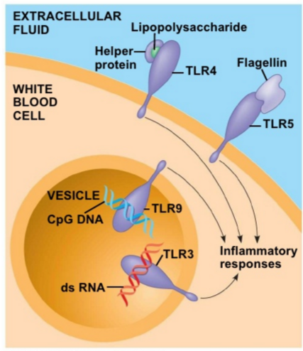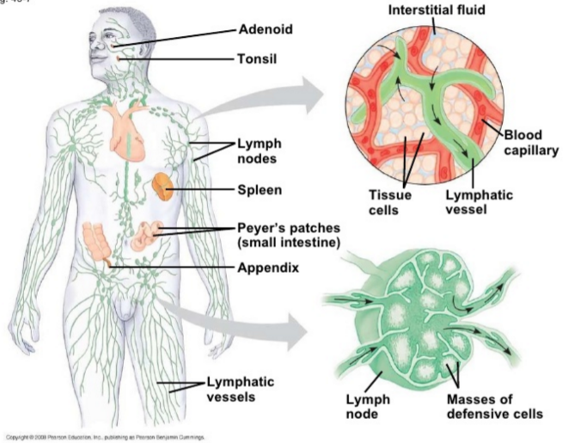

Neutrophils → white blood cells that ingest and destroy microbes by __________________

Monocytes → migrate into tissues and develop into ________________.

Eosinophils → defend against parasitic invaders such as worms by positioning themselves near the parasite and releasing ___________________________.

Dendritic cells → populate tissues in contact with the environment. They capture ______________, display ___________ and start the ________________________.

Antimicrobial Proteins

Interferon → proteins provide innate defense against ______________ infections. They cause cells adjacent to infected cells to produce substances to inhibit viral replication

Complement System → roughly 30 proteins with a variety of functions that ______________the immune response.
Example: Lyse invading cells.

Inflammatory Response

1. Activated macrophages and _____________ at the injury site release signaling molecules that act on nearby capillaries

2. Capillaries widen and become more _____________________, allowing fluid containing antimicrobial peptides to enter the tissue. Signaling molecules released by immune cells attract additional phagocytic cells.

3. Phagocytic cells _____________ pathogens and cell debris at the site, and the tissue heals

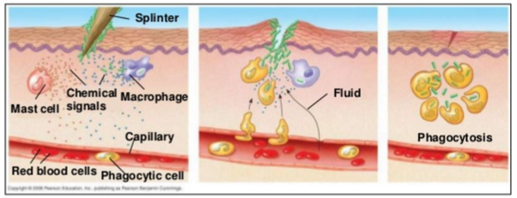

Histamine → released by mast cells in response to ________________. They trigger the dilation and permeability of nearby capillaries. This aids in delivering ______________________and phagocytic cells to the injured area.

Natural Killer Cells (NK) → help to recognize and remove ______________________ cells.

Adaptive Immunity - Receptors provide pathogen-specific recognition

Two types of Lymphocytes (white blood cells)

- B cells - proliferate in _________________

- T cells - mature in the ___________________

They both circulate through the blood and lymph and recognize antigens. Each B and T cell responds to _______antigen.

Antigens → _______________________________ that elicit a response by lymphocytes. B and T cells recognize antigens through their receptors on the membrane

Antibodies → proteins secreted by ________________during an immune response

B or T cell activation → when the antigen binds to a B or T cell. B cell activation is enhanced by_________________ (small proteins)
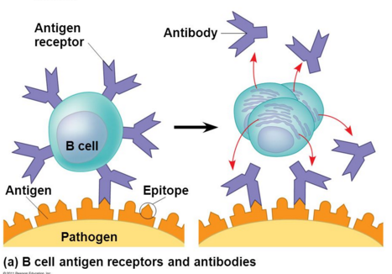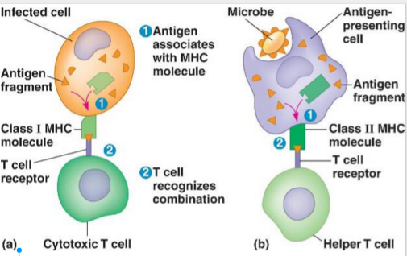

- B cell receptors bind ____________antigens
- T cell receptors bind antigen that are displayed by ___________________cells (APCs) on their MHCs
- Major histocompatibility complex (MHC) molecules → proteins that are the product of a groups of genes.
  - Class I MHCs are found on ______________cells of the body except RBCs
  - Class II MHCs are made by _________________of the immune system, including dendritic cells, macrophages and B cells.

The main function of MHC molecules is to _______________to peptide fragments derived from pathogens and _____________ them on the cell surface for ________________ by the appropriate T-cells

Primary Immune Response → when the body is ___________exposed to an antigen and a lymphocyte is activated

Secondary Immune Response → the _______antigen is encountered at a later time. It is faster and of great magnitude.
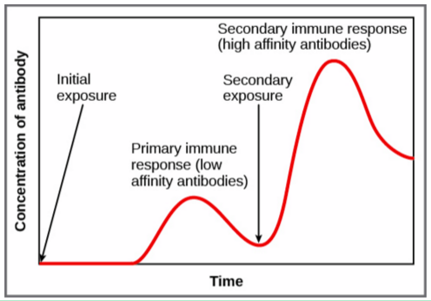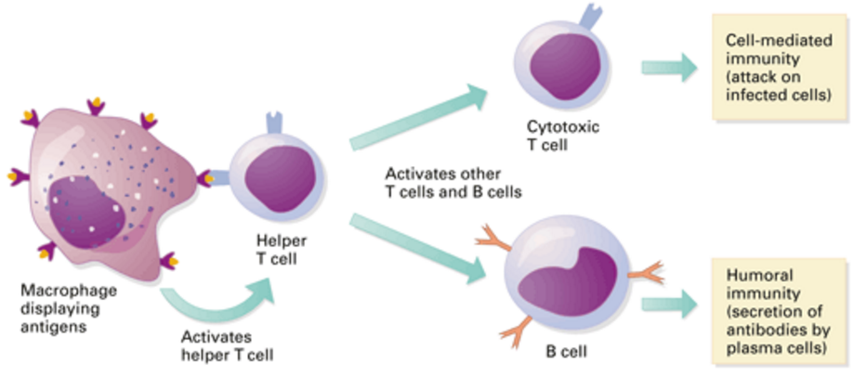

Adaptive immunity defends against infection of body fluids and body cells

Acquired immunity has 2 branches:

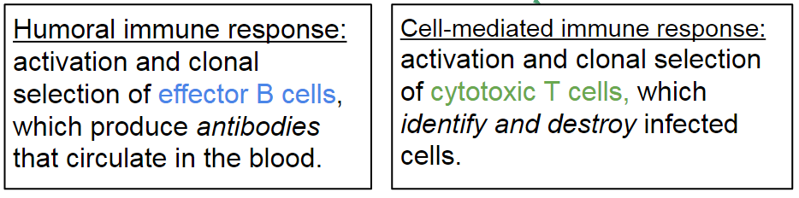

Helper T Cells: aid in both Humoral and Cell-Mediated Responses. When activated by class II MHC molecules, they secrete ______________that stimulate and activate both _______________and __________________.

Cytotoxic T cells: bind to class I__________________, displaying antigenic fragments on the surface of infected body cells. Cytotoxic T cells ______________infected body cells.

RECAP
- B cells make antibodies, which provide humoral immunity. This helps fight pathogens that are circulating in body fluids.
- Cytotoxic T cells destroy body cells that are infected by a pathogen or cancer cells.
- Helper T cells activate both B and T cells.

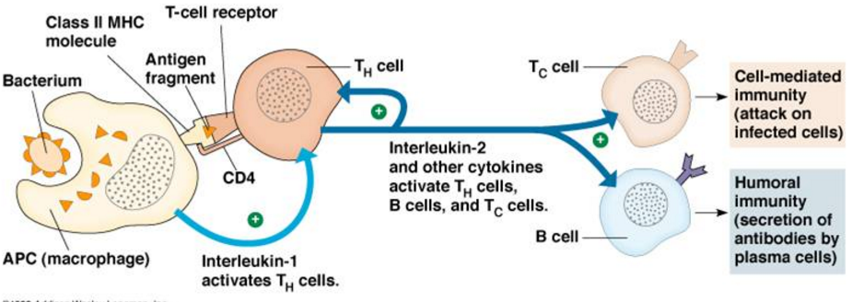

Activated B Cells memory cells & plasma cells. Plasma cells antibodies (circulate and destroy antigens)

Modes of antibody action:

- Neutralization: antibodies bind the pathogen`s _____________ proteins which prevents it from entering infecting cells

- Opsonization: results in increased _______________of the antigen

- Lysis: caused by activation of the____________________.

Active immunity: develops ______________in response to an infection; is also develops artificially by immunization (vaccination)

In immunization, a non-pathogenic form of a microbe elicits an immune response resulting in ____________________of that microbe
.
Passive Immunity: when an individual __________________ antibodies.
Example - those passed to the fetus across the placenta and to infants via milk

Remember...___________________ on red blood cells determine if a person has type A, B, AB or O.

Transfusion with incompatible blood leads to destruction of the transfused cells and life -threatening situation for the patients. Antibodies to nonself blood antigens already exist in the body.

MHC molecules are responsible for stimulating the __________________________of tissue grafts and organ transplants. The chances of a successful transplant improve if the donor's tissue bearing MHC molecules closely match the patient's. The recipient also must take immunosuppressant drugs.

Disruptions in the immune system

Allergies (example: hay fever) - IgE antibodies produced after first exposure to an allergen attach to receptors on__________________. The next time the same allergen enters the body, it bonds to the mast cell-associated IgE molecules, inducing the cell to release ______________and other mediators that cause vascular changes and typical symptoms.

Mast cell: a cell filled with basophil granules, found in numbers in connective tissue and releasing histamine and other substances during inflammatory and _____________reactions.
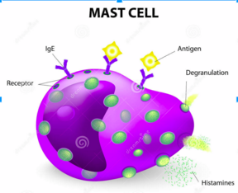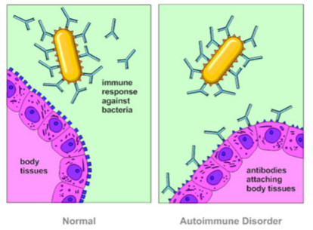

The immune system _______________the molecules of the body, allowing cytotoxic T cells to attach and damage the body's own healthy cells.

HIV infects helper T cells. People with AIDS are _________________________.

