Mechanisms of Evolution
Concept 4: Analyzing the evolution of populations through Hardy-Weinberg (microevolution)
Chapter 23 in Campbell, pg 155-158 in Holtzclaw

The Evolution of Populations
You must know:
- How mutation and sexual reproduction each produce genetic variation
- The conditions for Hardy-Weinberg Equilibrium
- How to use the Hardy-Weinberg equation to calculate allelic frequencies, to test whether a population is evolving.
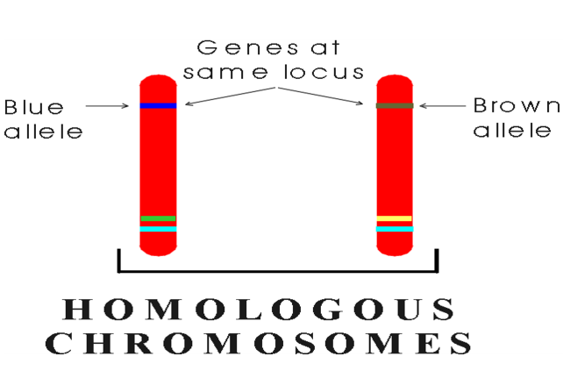
Genetic Variation
If only one allele exists for a particular _________in a population, that allele is said to be _________in the gene pool and all individuals are homozygous for that allele.
If there are two or more alleles for a particular locus in a population, individuals may be either ___________or ________________.

Each allele has a frequency (proportion) in the population. example: 80% blue and 20% brown.

Preservation of Genetic Variation

- Diploidy – “hiding” ______________alleles
- Heterozygote advantage -Heterozygote genotype has a higher ______________than either the homozygote dominant or homozygote recessive genotype.

- The specific case of heterozygote advantage due to a single locus is known as overdominance.
  - Ex) sickle cell anemia - malaria

What alters allele frequencies?

Three major factors:

- Natural Selection – causes adaptive evolution

Selection results in alleles being passed to the next generation in proportions _____________from their ____________in the present generation.
Consistently favouring some alleles over others in _________________.

Adaptive evolution is that which results in a better match between organisms and their environment.

2. Genetic Drift - __________________ can also cause allele frequencies to fluctuate unpredictably from one generation to the next, especially in ___________populations (3:7 Head to Tail vs 30:70 Head to Tail)

    - Founder Effect → when a few individuals become _____________from a larger population, this smaller group may establish new population whose gene pool differs from the source population.

    - Bottleneck Effect→ a _________________in the environment, such as a fire or flood, may drastically _____________the size of a population.

A severe drop in the population size can cause the bottleneck effect because the population has passed through a restrictive bottleneck in size. By chance alone, certain alleles may be _____________among
the survivors.

3. Gene Flow → transfer of alleles into or out of a population due to the ______________of fertile individuals or their gametes.
It tends to ___________the genetic differences between populations. If it is extensive enough, gene flow can result in neighboring populations combining into a single population with a common gene pool.
Natural Selection – causes adaptive evolution
- Relative Fitness - Fitness ____________to other members of the population… (your contribution to the gene pool of the next generation!)

- Three ways natural selection can work:
  - Directional selection
  - Disruptive selection
  - Stabilizing selection
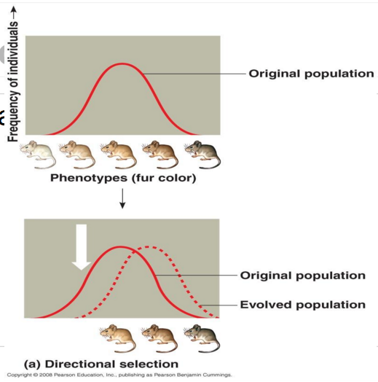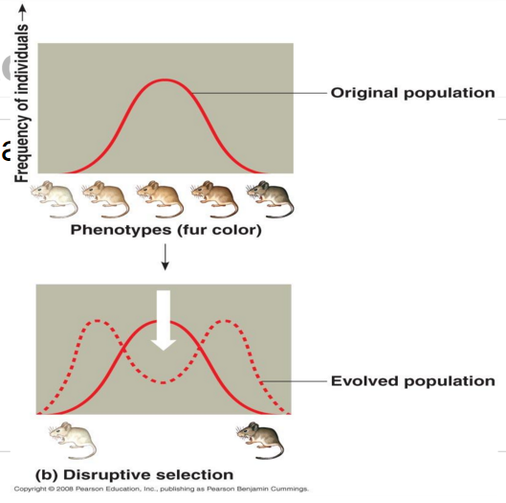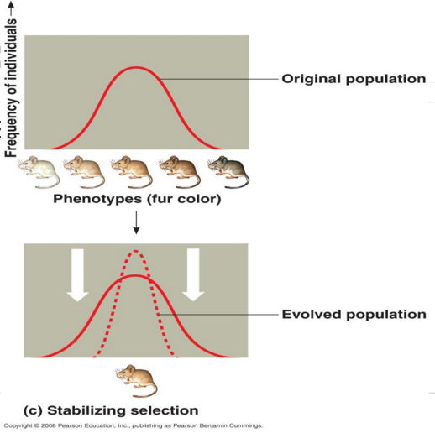
In what sense is natural selection more “predictable” than genetic drift?

Introducing…The Hardy-Weinberg Principle!
- Clarifies the factors that alter allele frequency
- A non-evolving population is in Hardy-Weinberg equilibrium.

Conditions for Hardy-Weinberg Equilibrium:

The Hardy-Weinberg Formula p² + 2pq + q² = 1 where p + q = 1

In a certain population of 1000 fruit flies, 910 have red eyes while the remainder have sepia eyes.
- The sepia eye trait is recessive to red eyes.
- How many individuals would you expect to be homozygous for red eye color?

Hint: The first step is always to calculate q²!
Start by determining the number of fruit flies that are homozygous recessive…

Biology 11 pre AP
Lab 8 – Population Genetics and Evolution
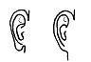
Exercise 8A - Ear Lobes!
- a completely dominant trait
free allele – dominant (A)
attached allele – recessive (a)

Frequency of individuals with free ear lobes: p² + 2pq
Frequency of individuals with attached earlobes: q²

 | Phenotypes |  |  |  | Allele Frequency based on the H-W Equation
 | Free  Ear Lobes  (p² + 2pq) |  | Attached  Ear Lobes  (q²) |  | p | q
Class Population | # | % | # | %

Discussion:
1. What is the percentage of heterozygous free ear-lobed people in this class?

2. What is the percentage of homozygous free ear-lobed people in this class?

3. Can we tell which of the free ear-lobed people are homozygous and which are heterozygous? Why or why not?

