How does the DNA code use RNA to make a protein?
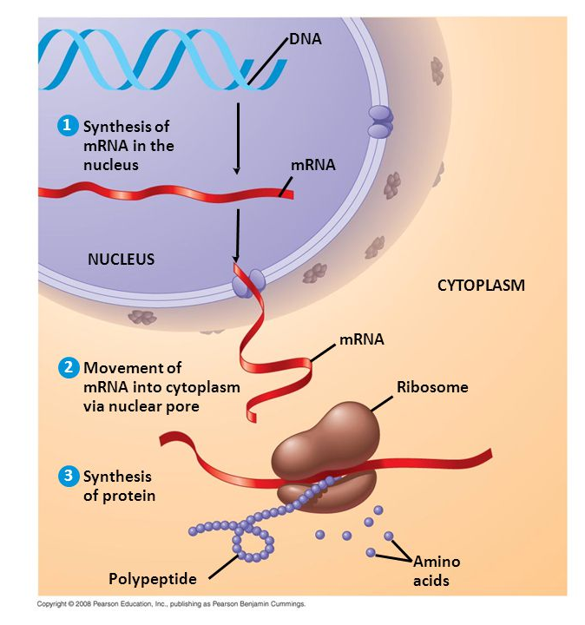
There are 2 (kinda 3) stages in the process of making a protein from DNA
- Transcription - happens in the ____________
mRNA modification - happens in the ____________
2. Translation - happens in the __________________
Transcription – initiation
_______________________joins with several transcription factor proteins at the ________________, which is a special sequence of base pairs on the DNA template strand that signals the beginning of a gene.
The transcription factor proteins, along with the RNA polymerase, is called the ___________________________. This moves along the DNA template strand at about 40 base pairs per second producing pre-mRNA.
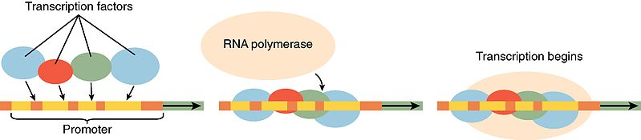
Transcription – elongation
During elongation, RNA polymerase adds free floating __________________ (A, U, G, C) to the DNA template strand, reading the DNA in the 3’ to 5’ direction.
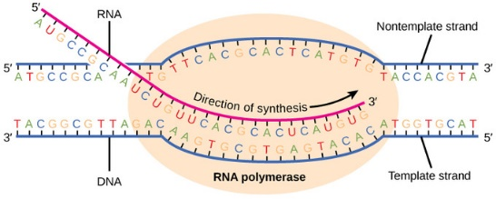
Transcription – termination
When the RNA polymerase reaches the ___________________________ of base pairs on the DNA template strand, it completes the production of pre-mRNA and releases it into the nucleoplasm.
mRNA Modification
Before mRNA is ready to leave the nucleus there needs to be a 5’ _______ (methyl group) and a 3’ _______________
Introns are spliced out and exons are left to be ____________.
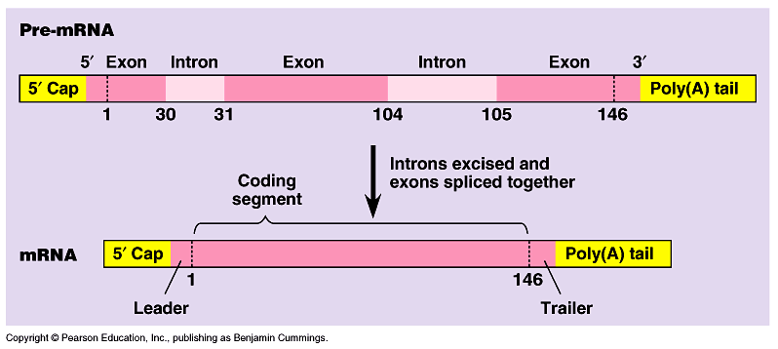
Breaking the mRNA Code
The mRNA is now carrying the instructions to make a protein! To read the code, each ribonucleotide corresponds to a specific amino acid.
______________ ribonucleotides ‘letters’ make __________ amino acid ‘word’. This words are called __________
Remember…there are 21 amino acids.
What is the corresponding amino acid sequence for an mRNA molecule that reads like this?
AUGCCUCCGCAUGAGUGA
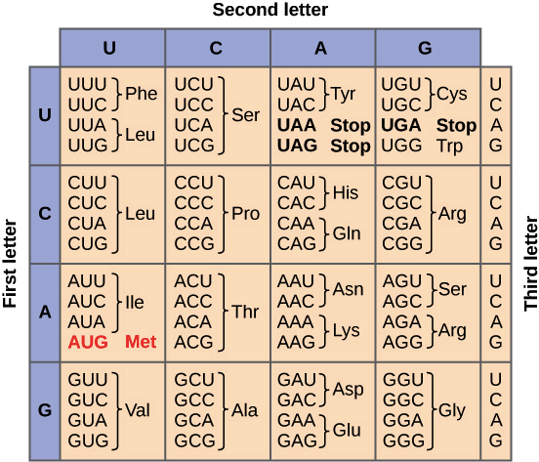
Translation
Translation occurs at the ribosome. The ribosome is a large complex of ________________ and ___________. It consists of two subunits. Several ribosomes can attach to an mRNA molecule simultaneously. This allows for many polypeptide chains to be synthesized at once.

Translation – Initiation
The large and small ribosomal subunits binds to form the _______________________. Once this has occurred, the transfer RNA carrying methionine amino acid is bound to the __________on the ribosome. The ___________is aligned with the next codon which will bind to the incoming tRNA.
The 3 letter sequence on the tRNA is referred to as the _____________. The __________________allows for some flexibility ultimately allowing the mRNA to be translated by fewer tRNAs
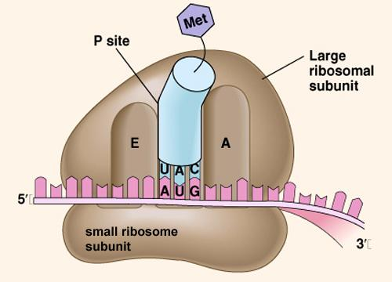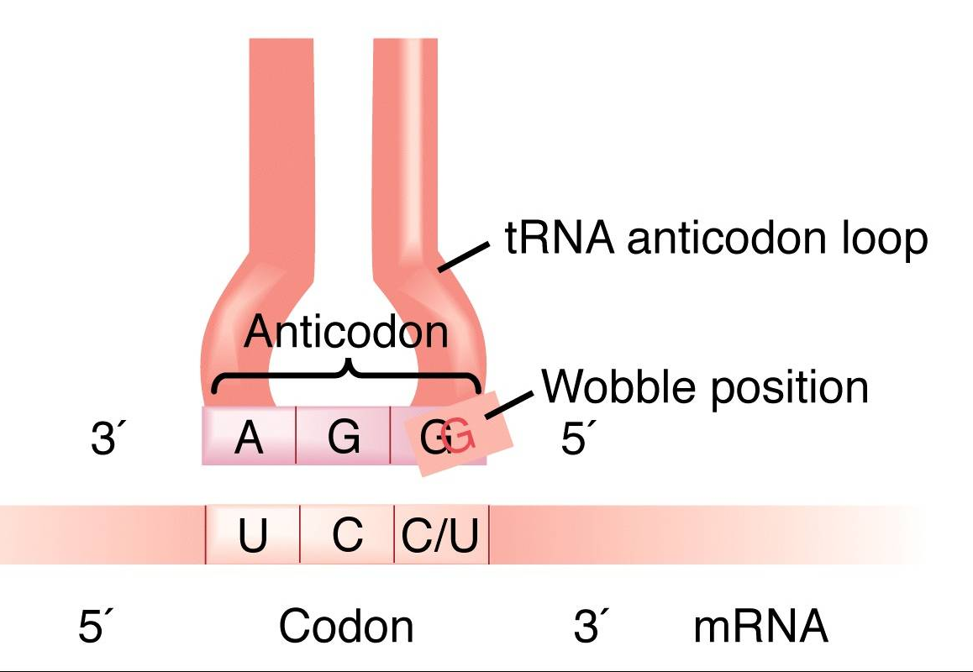

Translation – Elongation
In this stage, amino acids are brought to the ribosome by tRNAs and linked (_________________) together to form a chain, or ____________________. Once the peptide bond is formed, the mRNA is pulled onward through the ribosome by exactly one codon. This shift allows the first, empty tRNA to drift out via the ________________. It also exposes a new codon in the A site, so the whole cycle can repeat.
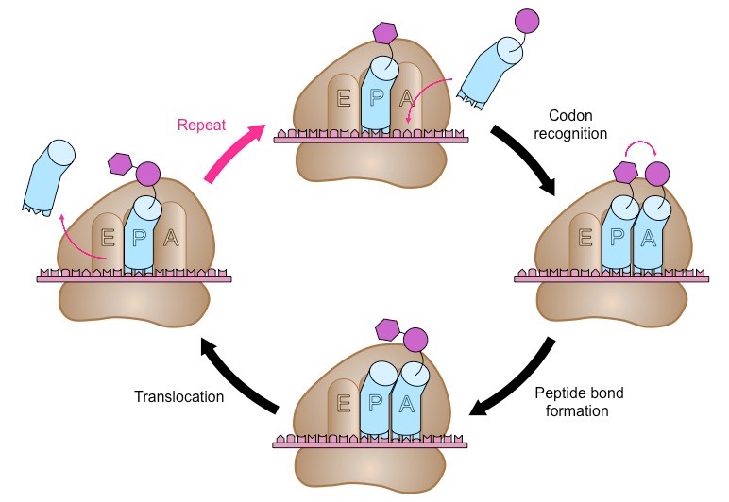
Translation – Termination
Termination happens when a __________ in the mRNA enters the A site. Stop codons are recognized by proteins called________________, which fit into the P site. Release factors mess with the enzyme that normally forms peptide bonds: they make it add a water molecule to the last amino acid of the chain. This reaction separates the chain from the tRNA, and the newly made protein is _____________.
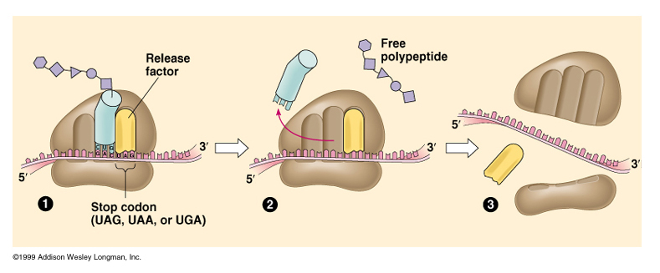
What next?
Translation "equipment" is very ____________. After the ribosomal subunits ________________from the mRNA and from each other, each element takes part in another round of translation. Polypeptides often need some __________. During and after translation, amino acids may be chemically altered or removed. The new polypeptide will also _____________ into a distinct 3D structure, and may join with other polypeptides to make a multi-part protein.

