The Amazing Hoop Gliding Competition
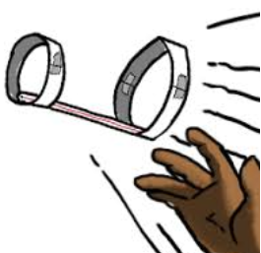

You’ve heard of hoop jumping but what about hoop gliding? Your first assignment of physics 11 is to
design a hoop glider that will fly farther than any of your peers’. Consider things like the length of the
straw, the number of hoops, the materials you choose…the list goes on! You will win your materials in the Junkyards Wars so good luck! May the best hoop jumper glider win!

Materials list:

Prototype Design: (Label with materials and approximate dimensions)
After your original trials, make changes to your drawing in a different colour

Data and Observations/notes:
Trial # | 1 | 2 | 3
Original Design (distance in meters)

After any Changes
(distance in meters)

Reflection:
- What about your original design did you change? How did the change affect your flight design? Why do you think that is?

- How does this thing work? What is the physics behind it? (In your own words please).

- What application does this have to ‘real life’?

Beginning | Developing | Accomplished | Exemplary
Does not demonstrate a basic understanding of concept. Substantial errors throughout. | Basic understanding of concepts. Errors and inconsistency reveal some missing elements. | Solid understanding of concepts. Most answers are correct. Few errors. | Complete and in depth understanding of concepts. Answers are correct with elegant connections and explanations.

