1. Image that your sample size is not 100 people but 400 people!

On the grid below, colour in the number of squares that represent 4 people if the total grid is 400.
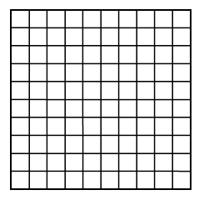
What percent of the total population is this?

2. Try the following examples:
a) 85 pounds  Shade in the boxes that represent 10 pounds | b) 162 days  Shade in 25% of the boxes. How many days is that?
a) How many people would be represented by half a square?
… by one-fourth of a square?
… by twenty small squares?
… by ten small squares?

3. Let’s go back to the example with 400 people:
400 people
b) How many squares represent 200 people?
…100 people?
…40 people?
…4 people?

4. Twenty percent of a company's 240 employees are classified as minorities.
- Use a percent grid to show that 20 percent of a business's 240 employees are classified as minorities.
- How many employees are classified as minorities?
5. Twenty-five acres of land are donated to a community, but the donor stipulates that six acres of this land should be developed as a playground.
- Use a percent grid to represent this situation.
- What percent of the land is to be used for playground?
6. In Hazzard County, 57 of the schools have a teacher-to-student ratio that meets or exceeds the requirements for accreditation. These 57 schools represent 38 percent of the schools in the county.
- Use a unit square sketch to represent this situation.
- How many schools are in Hazzard County?

