Graphs of Wrath
Ms. Brady was interested in seeing the relationship between the variables velocity and time. She took three suped-up Hot Wheels cars and ran them through an extensive timing circuit. Here are three sets of data recorded in Ms. Brady’s secret laboratory lair:
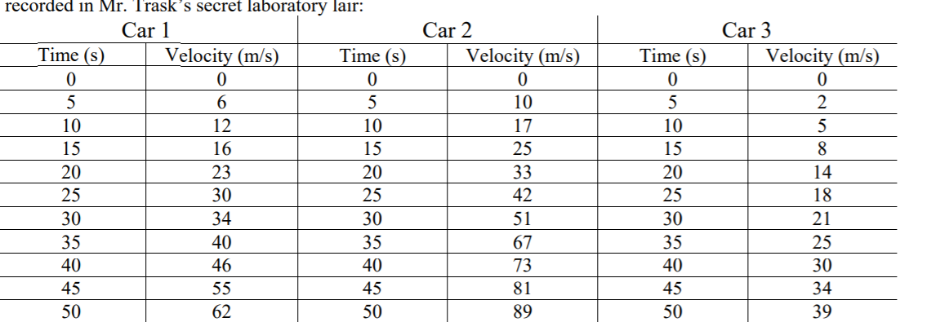
Your challenge as Ms. Brady’s assistant/lackey is to provide a beautiful graph of all three sets of data on only ONE piece of graph paper (Ms. Brady’s lab is a bit budget). Follow the steps like we did in our notes and you will be fine. You MUST have all data fit on your graphs, so you will have to make some tough decisions about your variable range on the axes. Also, use as much space as possible. Ms. Brady will be looking to make sure your graph is readable and all your labeling and calculations are on the graph as well.
Questions (show all work on your graph paper):
1) Find: Slope of the line for car 1 Slope of the line for car 2 Slope of the line for car 3
2) a. Write an equation for the line for car 1. b. Use this equation to predict how fast car 1 will be traveling at t = 90 s.

Discussion:
- Pretend car 2 has some really bad tires, which heat up and get sticky the longer the vehicle moves. As the tires get stickier, the car’s acceleration decreases. What would you predict the graph of car 2 would look like? Sketch a graph.

2) Pretend that at t = 55s the driver of car 3 sees an adorable marmot in the road and jams on the brakes, suddenly stopping. What would you predict the graph of car 3 would look like? Sketch a graph.

Physics 11 Graphing Rubric
 | Beginning | Developing | Accomplished | Exemplary
Main Title | Title is either not present or missing all of the following:  unique, underlined or not at the top of the graph | Title is missing two of the following:  unique, underlined or not at the top of the graph | Title is missing one of the following: unique, underlined or not at the top of the graph | Title is unique, underlined, at the top of the graph
Calculations | Calculations are missing or not on graph and not correct | Calculations are on the graph but not correct | Calculations are correct, but not on the graph | Calculations are on the graph and correct
Axis Subtitles | x/y axis are not labelled | x/y axis are mislabelled and no units | x/y axis are labelled but not units | x/y axis are labelled correctly with units
Scale/size | The scale intervals are neither easy to read and the entire graph paper is not used | The scale intervals are not easy to read and do not go up by regular, countable numbers | Scale is created in easy to read intervals but entire graph paper is not used | Scale is created in easy to read intervals. The entire graph paper is used
Line of best fit | Line of best fit does not exist. Author has connected the dots. | Line of best fit is not an accurate representation of the average AND is not drawn with a ruler AND is forced through (0,0) | Line of best fit is in the middle of the points but either not drawn with a ruler OR it is forced through (0,0) | Line of best fit is in the middle of the points made with a ruler. It does not necessarily go through (0,0)
Neat | Missing all of the following:  pencil, straight lines, no white out | Missing two of the following:  pencil, straight lines, no white out | Missing one of the following: pencil, straight lines, no white out | Contains all of the following: pencil, straight lines, no white out
Discussion Questions | Answers are neither clear, accurate or complete | Answers are somewhat clear, accurate and complete | Answers are mostly clear, accurate and complete | Answers are clear, accurate and complete

