Graphing Activity – Math 8
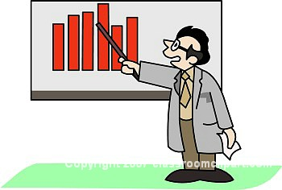

- Choose a graph from the front.

- Answer the following questions:

What type of graph is it?

What is the message of the graph?

Is it an accurate representation of the data? Explain.

In your opinion, is it a good graph?

- Discuss your graph with a friend. Pick another graph and critique it.

