Mendelian Genetics

Concept 2: Analyzing the effects of complex genetic crosses such as
incomplete/co- dominance, multiple alleles, pleiotropy, epistasis, polygenetics, and lethal alleles.

Degrees of Dominance

Complete Dominance
Homozygous Dominant and Heterozygous are _________________________
Monohybrid Phenotypic Ratio

Incomplete Dominance
Heterozygotes display a ______________ phenotype
Monohybrid Phenotypic Ratio

Co-dominance
Heterozygotes display _______________ (separate, distinguishable)
Monohybrid Phenotypic Ratio

Multiple Alleles

Many alleles for ________ gene

Example: If a male with blood type AB has children with a female with blood type O, what is the predicted phenotypic ratio of their children?
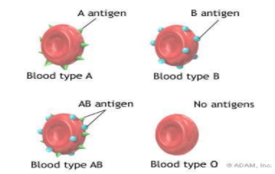

Pleiotropy

One gene that has ____________ effects on phenotypic characters

Epistasis
One gene having an effect over ___________ gene

Example:
In corn, a dominant allele “I “ inhibits kernel colour, while the recessive allele “i “ permits colour when homozygous.
At a different locus, the dominant allele P causes purple kernel colour, while the homozygous genotype pp causes red kernels.
If plants heterozygous at both loci are crossed, what will be the phenotypic ratio of the offspring causes red kernels.

Polygenic Inheritance
Two or more genes affecting one _____________ character
Quantitative characters – continuum rather than “either/or”

General Rule: number of phenotypic classes resulting from a cross of heterozygotes equals the number of alleles involved plus one.

Try this
The height of spike weed is a result of polygenetic inheritance involving three genes, each of which can contribute an additional 5cm to the base height of the plant, which is 10cm. The tallest plant (AABBCC) can reach a height of 40cm.
A) If a tall plant (AABBCC) is crossed with a base-height plant (aabbcc), what is the height of the F₁ plants?
B) How many phenotypic classes will there be in the F₂?
c) What is the probability of seeing a 20cm plant in the F₂ generation?

Lethal Alleles

Recessive lethal allele
2:1 ratio if lethal ___________ birth

Dominant lethal allele
Must show effects after reproductive age. Why?

Environmental Effects

Hydrangeas - Plant a tin can next to them and see what happens!

