Pre AP Biology 11
CONCEPT 4: APPLYING THE CHROMOSOMAL BASIS OF INHERITANCE TO ANALYSIS THE EFFECTS OF ALTERATIONS IN CHROMOSOME NUMBER OR STRUCTURE.
Campbell: Chapter 15 Holtzclaw: pg 111

You must know:
- How the chromosome theory of inheritance connects the physical movement of chromosomes in meiosis to Mendel’s laws of inheritance
- How alteration of chromosome number or structurally altered chromosomes can cause genetic disorders

Alteration of Chromosome Number

How?__________________________
- Occurs when homologous chromosomes do not separate properly during meiosis II.

Result? _________________________
- Incorrect number of a chromosome
  - Trisomic: three copies of the chromosome
  - Monosomic: one copy of the chromosome

___________________
- More than two complete sets of chromosomes

Other ways chromosome abnormalities happen
Mitosis: problems with cell division
Maternal Age: Women are born with all the eggs they will ever have. Errors may crop up in the eggs' genetic material with age. Because men produce new sperm throughout their lives, paternal age does not increase risk of chromosome abnormalities.
Environment: No conclusive evidence however it is still possible that the environment may play a role in the occurrence of genetic errors.

Most common non disjunction in humans

Trisomy 21:
Trisomy 18:
Trisomy 13:

Sex Chromosome Aneplodiy

XXY
XYY
XXX

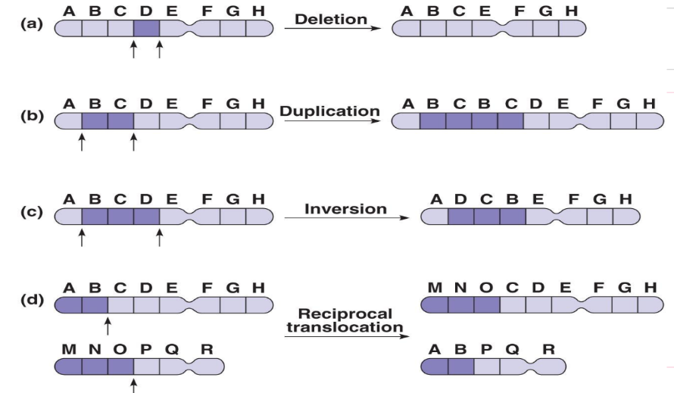
Rearrangement of Chromosome Structure

Portions of a chromosomes may be ______or _______________ during crossing over

- Deletion: Fragment is lost. Missing ____________.

- Duplication: Extra fragment. ___________ genes.

- Rings: A portion of a chromosome has broken off and formed a_______________. This can happen with or without loss of genetic material.

- Inversion: ____________section! May affect genes.

- Translocation: Moving a piece to a ____________________chromosome.
Example:

