Regulation of Gene Expression in Eukaryotes
In all organisms, certain genes are expressed at any given time while other genes are not. Both prokaryotes and eukaryotes regulate gene expression at the______________________ stage. However, the greater _________________ of eukaryotic cells makes it possible for gene expression to be regulated at many other stages as well.
There are multiple points where a Eukaryotic gene expression can be regulated
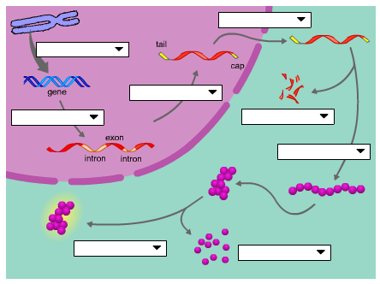

Let’s talk about a couple of them…
- Regulation of Chromatin Structure
The packaging of DNA:
Histones
- a small protein with an overall __________charge that bind __________DNA in the chromatin structure

Nucleosomes
- a bead like unit of DNA, consists of DNA wrapped around ___________.

DNA methylation
The addition of ____________groups to DNA which causes DNA to be more _______________ and reduces gene expression
Histone Acetylation
Acetyl groups are added to amino acids of __________________and makes the chromatin less tightly packed and ____________________transcription.

2. Regulation of Transcription Initiation

DNA control elements that bind transcription factors are involved in regulation. (page 359 Campbell)
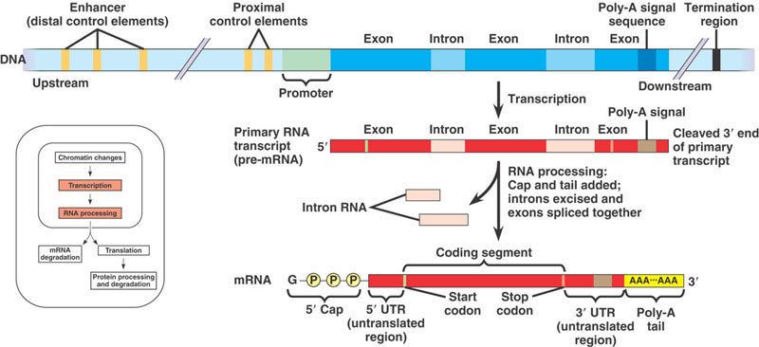
Regulated Transcription
Transcription Factors:
- a regulatory proteins that bind to__________ and affects transcription
Transcription Initiation Complex:
- the completed assembly of _________________and ________________bound to a promoter
Enhancer Regions:
- DNA sequence__________ from the gene, contains control elements
Activators:
- bind to certain ________________and __________________to form initiation complex
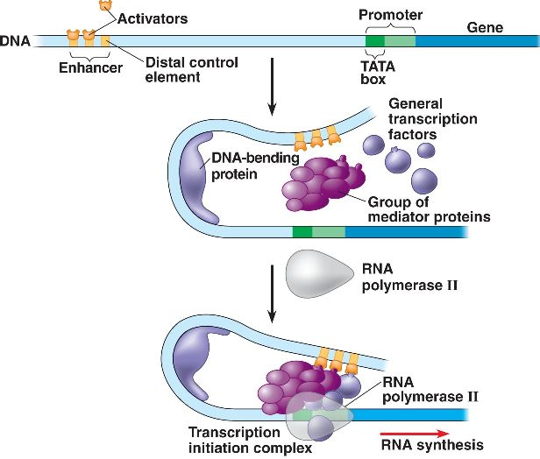
3. Post Transcriptional Regulation
Occurs after transcription and just after translation, when proteins are processed.
example: micro RNA (miRNA) and small interfering RNA (siRNA) can bind to _________and degrade the mRNA or bind to mRNA and block its ___________

Protein Degradation
A___________________, an enormous protein complex shaped like a trash can, chops up unneeded proteins.

3. Post Transcriptional Regulation

Epigenetic inheritance
These chromatin modifications do not entail a change in the DNA ___________ however, they may be _________________in future generations of cells. This is called epigenetic inheritance. The DNA sequence is not changed, just its ____________________.

