Fungi
The Evolutionary History of Biodiversity
Concept 2: Analyzing the diversity of bacteria, archaea, protists, and fungi (Ch 26, 27, 28, 31)

You must know:
- The characteristics of Fungi.
- Important ecological roles of fungi in mycorrhizal associations, and as decomposers and parasitic plant pathogens
Refer to Ch 31 in Campbell

Fungi and __________________are more closely related to each other than either is to plants or most other eukaryotes

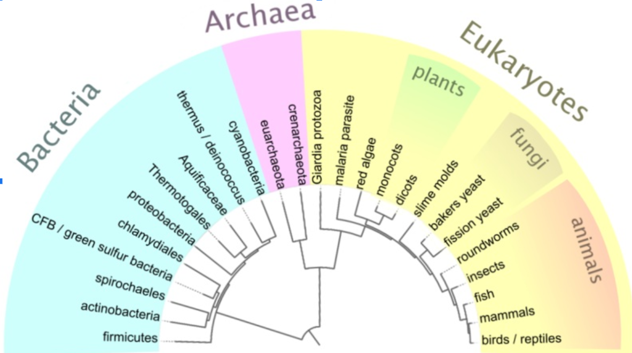

Characteristics of Fungi

Multicellular heterotrophs
- Fungi are VERY diverse but they do share some common traits, specifically, the way they derive________________.
- The _______________make their own food...just like animals (heterotrophs)
- But, unlike animals, they don’t eat their food...instead they __________nutrients from the environment outside its body!
- Many do this by secreting hydrolytic enzymes to its surroundings (ie plant walls).

Body Structure
The most common fungal body structure are _____________filaments and ____________yeasts (yes! Yeast is a fungi)

Multicellular
- Typically form a network of tiny filaments called__________________. Hyphae consist of tubular cell walls surrounding the plasma membrane and cytoplasm

- Fungal cell walls are strengthen by_____________, not cellulose (the same stuff in arthropod shells that make them crunch!)

- Fungal hyphae form an interwoven mass called a __________he infiltrates the material on with the fungus feeds
- Some fungi have specialized hyphae that allow them to feed on living animals.

- Mutually beneficial relationships between fungi and plant roots are called__________________. Mycorrhizae improve delivery of phosphate ions and other materials to plants because the vast network is more efficient. In exchange, plants supply the fungi with organic nutrients such ss carbohydrates.

- Mycorrhizae are a HUGE deal. Most agriculture and forestry industries rely on them. Without human, mycorrhizal fungi colonize solids by ______________dispersal

Reproduction
Sexual or asexual...either way...it’s mostly through spores.
Spores can be carried long distances by____________________. If they land in a _____________place where there is food, they germinate and produce new mycelia

Lichens
A lichen is a _____________association between a photosynthetic microorganism and a fungus in which millions of photosynthetic cells are held in a mass of fungal hyphae.

These photosynthetic cells are unicellular or filamentous __________________or________________. The algae generally occur an inner layer below the lichen surface and the fungus is what gives it the overall shape.

Where else do you see Fungi?

30% of the 100 000 know species of fungi are parasites or pathogens...mostly to plants

50 fungal species are known to parasitize animals - these infections are called mycosis.
Examples: ringworm, athlete’s foot, coccidioidomycosis (tuberculosis-like symptoms) yeast infections, indoor molds

Practical uses include: cheeses, citric acid in colas, truffles for eating, yeast for beverages and cooking

Also used in the medical field: some fungi produce antibiotics (penicillium)

