Electrical Gradient
ANALYZING THE STRUCTURE & FUNCTION OF THE CELL MEMBRANE

You must know:
Why membranes are selectively permeable.
The role of phospholipids, proteins, and carbohydrates in membranes.
How water will move if a cell is placed in an isotonic, hypertonic, or hypotonic solution and be able to predict the effect of different environments on the organism
How electrical gradients are formed and their function in cells

What is the role of phospholipids, proteins, and carbohydrates in membranes?

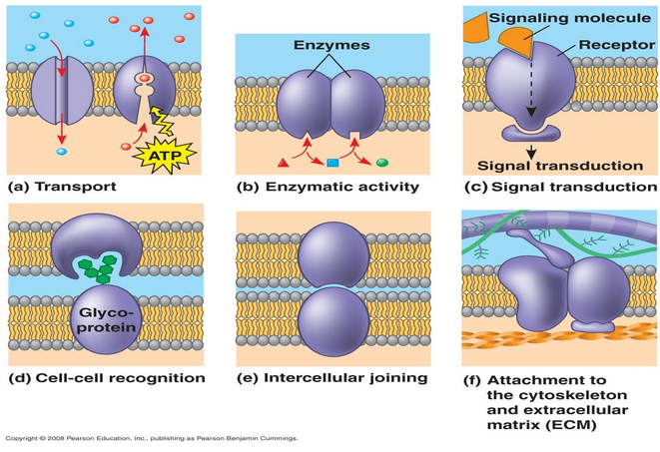

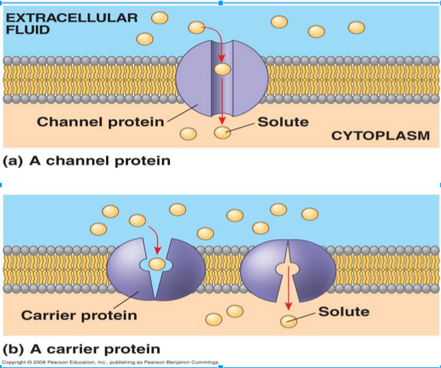

The Sodium/Potassium Pump - Active Transport
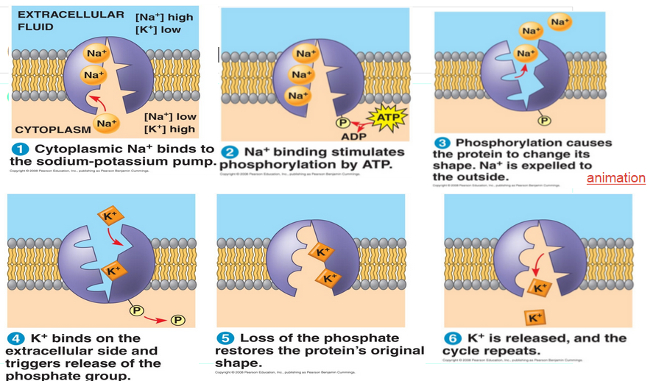

What is the effect of the Na+/K+ Pump?

- Increase Na+ outside the cell
- Increase K+ inside the cell
- This results in more + ions outside the cell than inside the cell...the inside is -65mV
- This is an Electrochemical Gradient

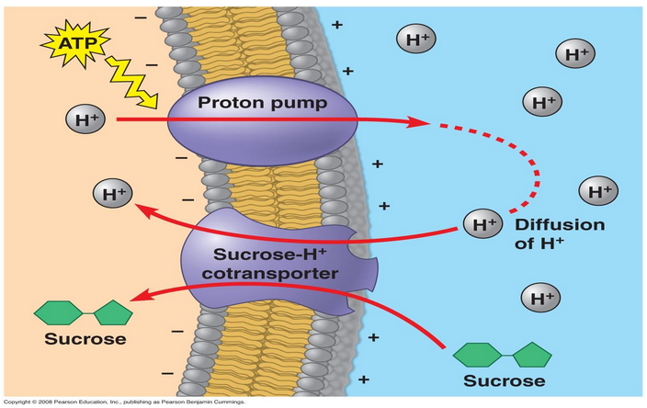
Cotransport

Exocytosis & Endocytosis

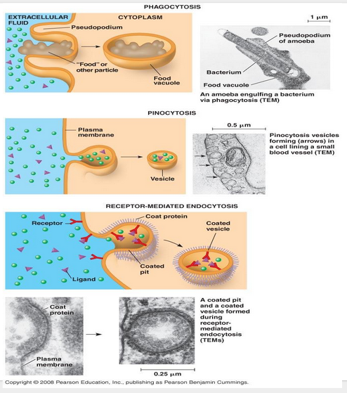

How electrical gradients are formed?

You need to know the following terms:

- Active transport
- Sodium-potassium pump
- Membrane potential
- Electrochemical gradient
- Cotransport
- Exocytosis
- Endocytosis
- Phagocytosis
- Pinocytosis
- Receptor-mediated endocytosis

