Pre AP Biology 11
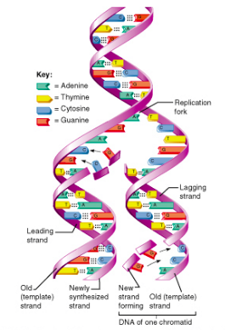
DNA Replication Activity: Paperclips and Enzymes

Introduction: You will be making a short sequence of a human gene that controls the body’s
production of the growth hormone (hGH), which causes growth during childhood and adolescence.
This gene is actually made of 573 nucleotide base pairs. You will only construct the first ten bases in
the gene.

Materials: Gather the appropriate number of paper clips and enzymes/proteins

Number of  Paper Clips | Colour | Nitrogenous Base |  | Enzymes and Helper Proteins (1 of each)
14 |  | Adenine |  | helicase, topoisomerase, single stranded binding proteins, primase, polymerase III,  polymerase I, ligase, nuclease
14 |  | Thymine
9 |  | Cytosine
9 |  | Guanine
4 |  | Primer

STEP ONE: Use the colored paper clips according to the key above and construct the primary (top) strand of the hGH according to the diagram of the gene below. Link the ten appropriate colored clips.

 | 1 | 2 | 3 | 4 | 5 | 6 | 7 | 8 | 9 | 10
Primary Strand | A | A | G | C | T | T | A | T | G | G
Complementary Strand

STEP TWO: Now construct the complementary (bottom) strand of the hGH gene by linking ten more clips into a chain according to the pattern above.

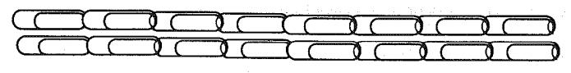

STEP THREE: Set the two chains side-by-side as shown in the drawing above so that A bonds with T, and C bonds with G. You now have a model of the hGH gene (the first ten bases only.) Compare the two chains with each other side-by-side to verify that C bonds with G, and A bonds with T. When this gene replicates in the nucleus of a cell, the double-strand begins to separate at one end. Separate these strands using HELICASE, TOPOISOMERASE and SSBP. Draw on the enzymes and protein on the diagram below

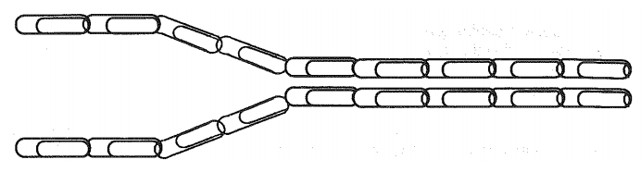

STEP FOUR : As it separates, new nucleotide bases are moved into place by enzymes, which form the beginning of two new identical molecules. PRIMASE inserts a primer. Draw in PRIMASE and the primer on both the lagging and leading strand.

STEP FIVE: Then POLYMERASE III places the new bases into place so that the A bonds with T, and the C bonds with G.
Use the other available clips to create the beginning of two new strands. Remember there is a leading strand and a lagging strand. Label the leading stand and the lagging strand on the diagram below.

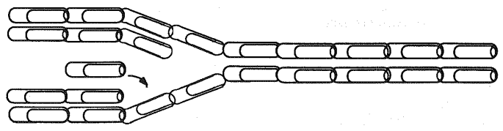

STEP SIX: Continue separating the strands and bring in appropriate new bases (clips) to create two complete new double-stranded hGH gene molecules. POLYMERASE I removes the primer and puts in the correct nucleotide. Draw that in the diagram below:

STEP SEVEN: Lastly, LIGASE comes in a seals all of the covalent bonds in the sugar-phosphate back bone. Show that in the drawing below.

1. Examine the two double-stranded DNA molecules. Are they identical or different in any way?

2. You now have two copies of a segment of the hGH gene on your table. During periods of growth and cell division, the chromosomes, which are made up of genes, must divide. What features about DNA replication causes each new DNA molecules to be exactly like the original?

STEP EIGHT: To demonstrate a gene mutation, place one of your paper clip hGH DNA strands in front of you. Identify the second nucleotide base called Adenine (A). To cause a mutation, remove this clip and replace it with a Cytosine (C) clip. You have just demonstrated how a mutation occurs. This replacement usually occurs when the DNA is replicating. NUCLEASE comes in to repair the mismatch. Draw the location of the mutation and NUCLEASE

4. If NUCLEASE doesn’t catch this mistake, when this mutated DNA molecule replicates, will the resulting new DNA be similar or different from the original hGH gene? Explain.

6. In your own words, explain how mutations can occur in cells and how this might affect the resulting protein.

