**DNA Introduction and Structure**

DNA is a: DNA stands for:

It’s a complex molecule that codes for the _________________ information of an organism

The base unit of a polymer of DNA is a ________________.

**The Sugar of DNA**

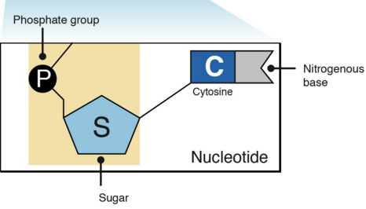 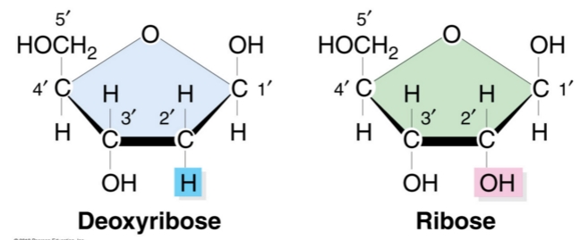

**Nitrogenous Bases of DNA**

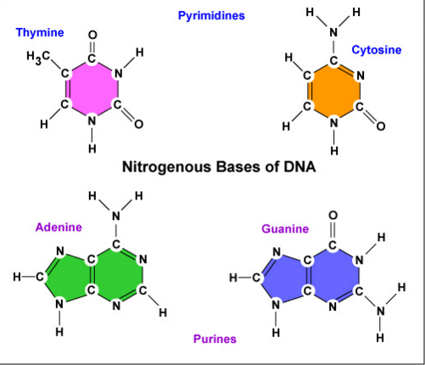 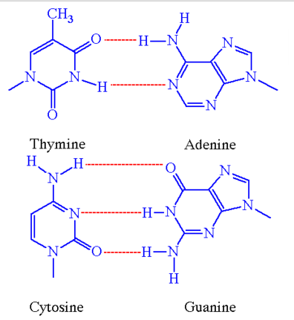



The nitrogenous bases are bonded together by: _________________________________

