Digestion Notes (PLO C1 and C2) Name: _____________________
An animal’s digestive system depends on the animal’s diet. Regardless, the key to digestion in surface area. When this is maximized, with the help of mechanical digestion, chemical digestion if more efficient.

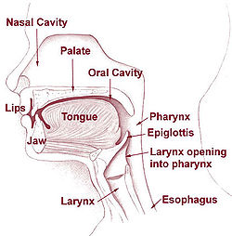
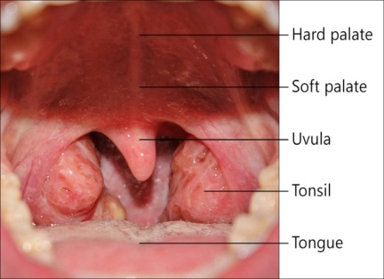
Swallowing: occurs in the pharynx. During swallowing the soft palate (uvula) covers the nasopharynx and the _epiglottis_ covers the glottis (the opening to the larynx -voice box))
Saliva is secreted as you chew.
It is full of enzymes to
help break down your food to
prepare it for absorption

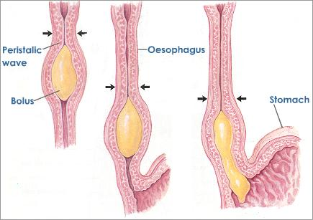
Peristalsis – rhythmic _contractions_ (of muscles) that moves _food__along. Found in the __esophagus, stomach, small intestine and large intestine_____.

At this point your food is called bolus .

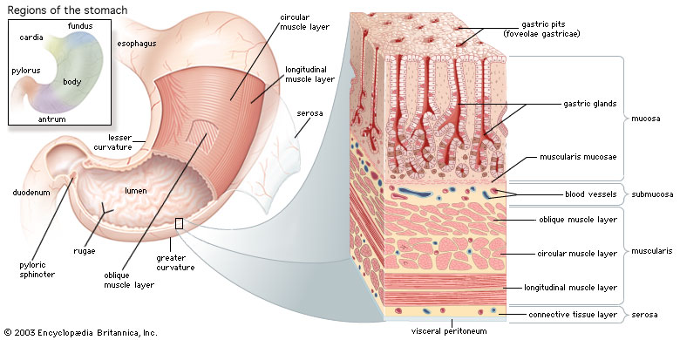
Stomach:
- thick walls, contains _gastric pits_ that lead to _gastric glands
- Mechanical digestion is achieved by the rugae
- the folds disappear as the stomach grows to _1_L max capacity
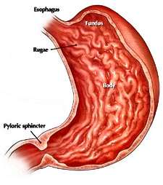
- gastric juice produced by the gastric glands contains pepsinogen__ (the precursor for pepsin) (enzyme), _hydrochloric acid___,water and __mucus__).
- Hydrochloric acid causes the pH of the stomach to be pH = 2_ and helps to break down the food in the stomach along with pepsin_____.
- __mucus_ protects the walls from the _acid___ (HCl)
- _alcohol__, __aspirin__ and _glucose are absorbed into your blood stream here.
- empties in about 2-6 hours and the food is now called __chyme__
- The chyme travels through the _phyloric___ sphincter into the small intestine

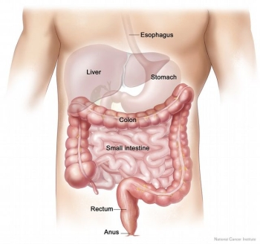
Small intestine: – takes part in chemical__digestion- with the release of _enzymes_ that break down _carbs_, _proteins and _nucleic acids_.
Also, takes part in __physical__ digestion – through continued __peristalsis.
The first section of the small intestine is called the duodenum where there is a great deal of secretion and absorption.
Villi: Finger like __projections_ on the _wall_ of the small intestine, increase the _surface area_ available for absorption of _nutrients___.
Microvilli: _microscopic__ extensions that produce enzymes (such as peptidase and maltase) and absorb __nutrients____.
Glucose, amino acids and nucleic acids are absorbed into the _blood__ capillaries
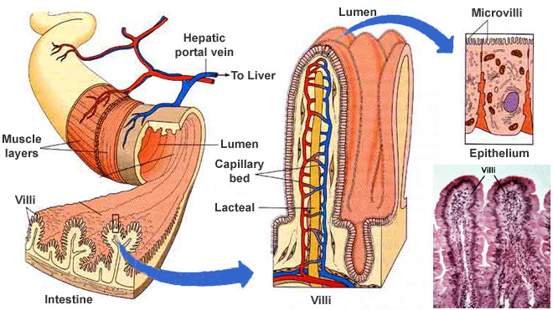
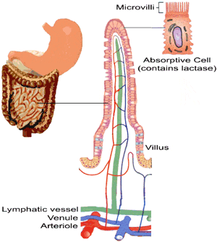
Fats including Glycerol and fatty acids are absorbed into the __lacteals and enter the __lymphatic__ system

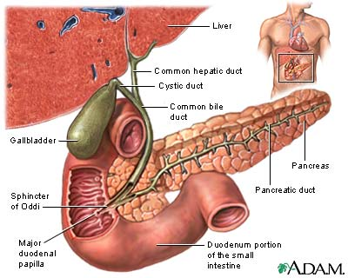
Bile: made in the _liver__, stored in the _gall bladder_, secreted through the __common bile duct_ into the _small intestine___. The bile emulsifies _fat_ – breaks it down into fat _droplets___.
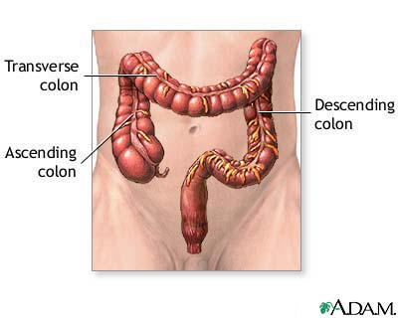
Pancreas: produces _pancreatic juice_ which consists of __sodium bicarbonate, pancreatic amylase, trypsinogen (the precursor for trypsin), nuclease and lipase.
Large Intestine: The beginning portion is called the cecum. The main role of the large intestine is to remove water and bile salts. contains anaerobic (live without __oxygen) bacteria which break down food and produce __vitamins__ and other molecules which can be _absorbed__.

