Concept 5: Ecosystems – Analyzing productivity, energy flow, and chemical cycling.
Chapter 55 – Pre AP Biology 11

Ecosystems (Ch 55)
How energy flows through the ecosystem by understanding the terms that relate to food chains and food webs
The difference between gross primary productivity and net primary productivity
The carbon and nitrogen biogeochemical cycles

- consist of all the organisms living in a community, as well as the abiotic factors with which they interact

Ecosystems range from a microcosm _____________to a large area __________
Ecosystem Dynamics involve two main processes: ____________________ and _____________________

Flow of Energy
- The first law of thermodynamics states that energy cannot be created or destroyed, only transformed
Energy enters an ecosystem as _______________, is conserved, and is lost from organisms as ______.
- The second law of thermodynamics states that every exchange of energy increases the entropy of the universe
In an ecosystem, energy conversions are not completely ________, and some energy is always lost as heat.

Cycling of Chemicals

- The law of conservation of mass states that matter cannot be created or destroyed.
Chemical elements are continually ______________within ecosystems
Ex) In a forest ecosystem, most ________ enter as dust or solutes in rain and are carried away in water
Overall: Ecosystems are open systems, absorbing energy and mass and releasing heat and waste products

Trophic Levels

Autotrophs - build molecules themselves using photosynthesis or chemosynthesis as an energy source

Example:

Heterotrophs - depend on the biosynthetic output of other organisms

Example:

Trophic Levels
Put the words on the screen in order of energy flow:

Primary Productivity
The amount of light energy converted to chemical energy (organic compounds) by an ecosystem’s autotrophs during a given period of time

Background:
Photosynthesis: carbon dioxide + water → glucose + oxygen

Cellular Respiration: glucose + oxygen → carbon dioxide + water

Gross primary production (GPP) -

Net primary production (NPP) -

Ecological Efficiency
Describes the proportion of energy represented at one trophic level that is transferred to the next trophic level
- On average, efficiency is only ~10%
10 percent of the productivity of one trophic level is transferred to the next level. The remaining 90% is consumed by individual ________________or to ________________
- Applications:

Ecological Pyramid: Used to show relationship between trophic levels
Horizontal bars or tiers: represent relative size in terms of either:
Tiers are stacked in the order in which energy is transferred.
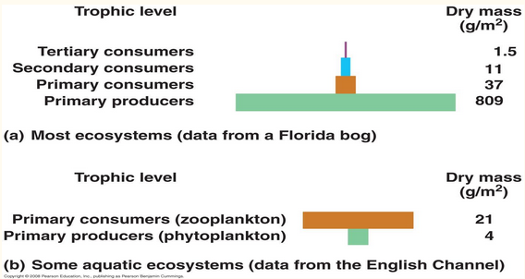
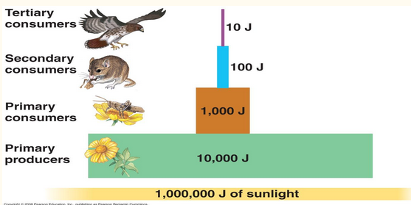

Biogeochemical Cycle
Describes the flow of essential elements from the environment to living things and back to the environment. p. 1209-1214 in Campbell
For each of the following essential elements, you much know:
The reservoirs
The process of assimilation
The process of release

- Hydrolytic Cycle (water cycle)

- Carbon Cycle (required for the building of all organic compounds)

- Nitrogen Cycle (required for the manufacture the building blocks of proteins and nucleic acids)

- Phosphorus Cycle (required for the manufacture of ATP and all nucleic acids. Cycle is similar to other mineral cycles like calcium)

