AP Biology Plant Form and Function
Concept 4: Analyzing how water and nutrients move through a plant
(Ch 36 and Investigation 11)

You must know: (Ch 36)
- The role of passive transport, active transport, and cotransport in plant transport.
- The role of diffusion, active transport, and bulk flow in the movement of water and nutrients in plants (with water potential calculations)
- How the transpiration cohesion-tension mechanism explains water movement in plants.
- How pressure flow explains translocation.
- The function of stomata in gas exchange in plants.
- The role of water potential and transpiration in the movement of water from roots to leaves.
- The effects of various environmental conditions on the rate of transpiration.
- How to identify xylem and phloem and relate their structure to their function.

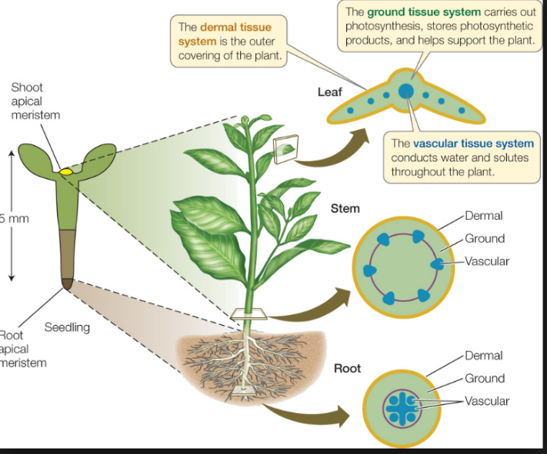
Types of Tissue
Dermal tissue – ______________protective covering

Vascular tissue – carries out transportation of materials between ______________________

Xylem – transports ___________and _____________up from roots into the shoots

Phloem – transports ______________ from leaves to other parts of plant (sites of growth)

Ground tissue – not ___________or __________________

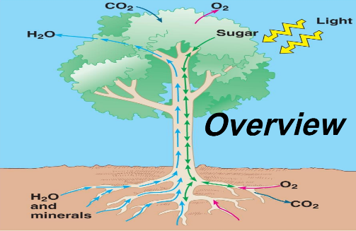
How does water & dissolved nutrients get from the roots to the leaves in these tall trees? _____________
How does sugar get from the leaves to the roots in plants for winter storage?__________________

Transport in Plants

Water and minerals in the soil are absorbed by _________________. Water and minerals are transported upward from roots to shoots as ___________________.

Transpiration, the loss of water from leaves (mostly through _____________), creates a force within leaves that pulls xylem sap upward. Through stomata, leaves take in CO₂ and release O₂. Roots exchange ________________ with the air spaces of soil, taking in O₂ and discharging CO₂.

Phloem sap can flow both ways between shoots and roots. It moves from sites of sugar ______________ (usually leaves) or ________________ (usually roots) to sites of sugar use or storage. Sugars are produced by photosynthesis in the leaves.

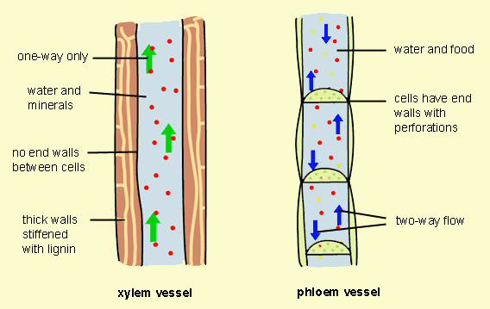
Xylem | Phloem

How we categorize plants:
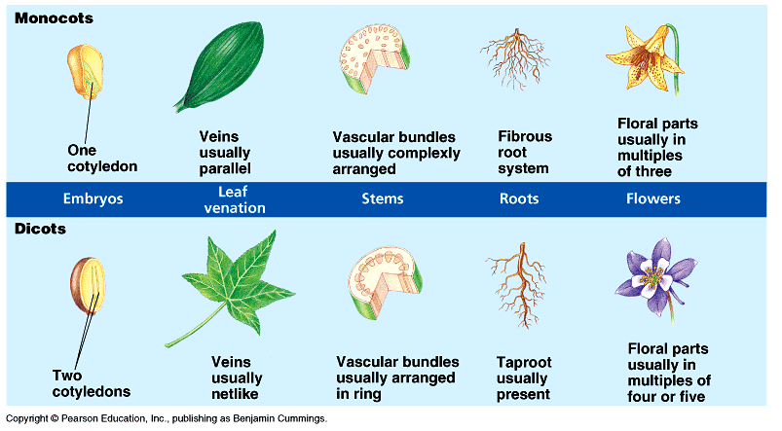

Plant nutrition and transport:
- What nutrients do plants need?

- Why does it take oxygen up through the roots?

- How does water get from the outside to the center where the vascular tissue is?

- Why does the vascular tissue move to the outside of the stem?

- How does water get into the roots in the first place?

- Apoplastic route travels through the:

- Symplastic route travels through the:

- What is the function of the Casparian strip?

- Is xylem dead or alive?

- Xylem flow work because of which of water’s properties?

- Is phloem alive or dead?

- Sugar is _______________ from the source to the __________________.

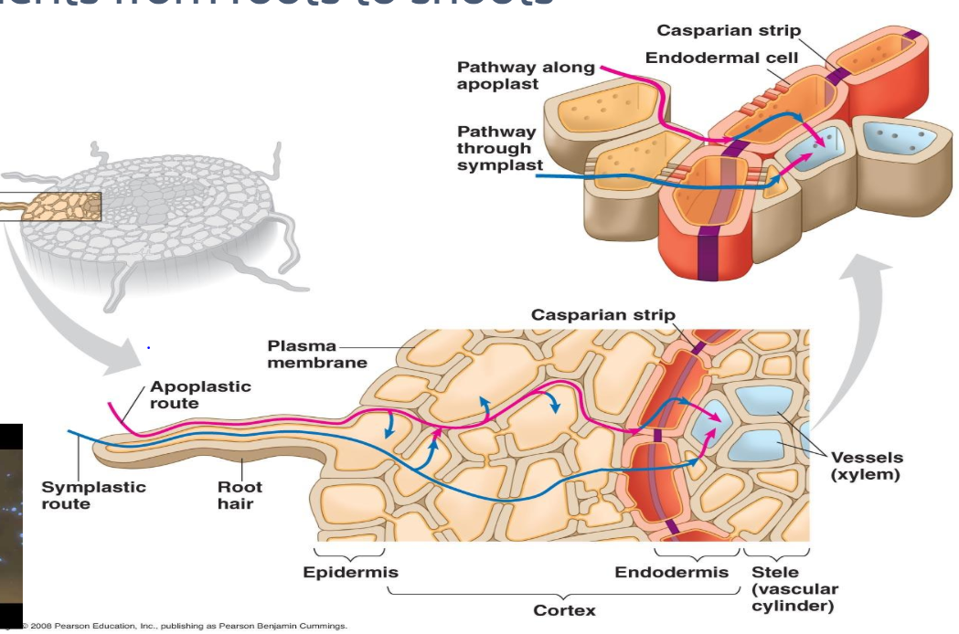

Let’s take what you know about passive and active transport and see how it applies in plants.
Plasmolysis an effect of osmosis, which is an example of passive transport

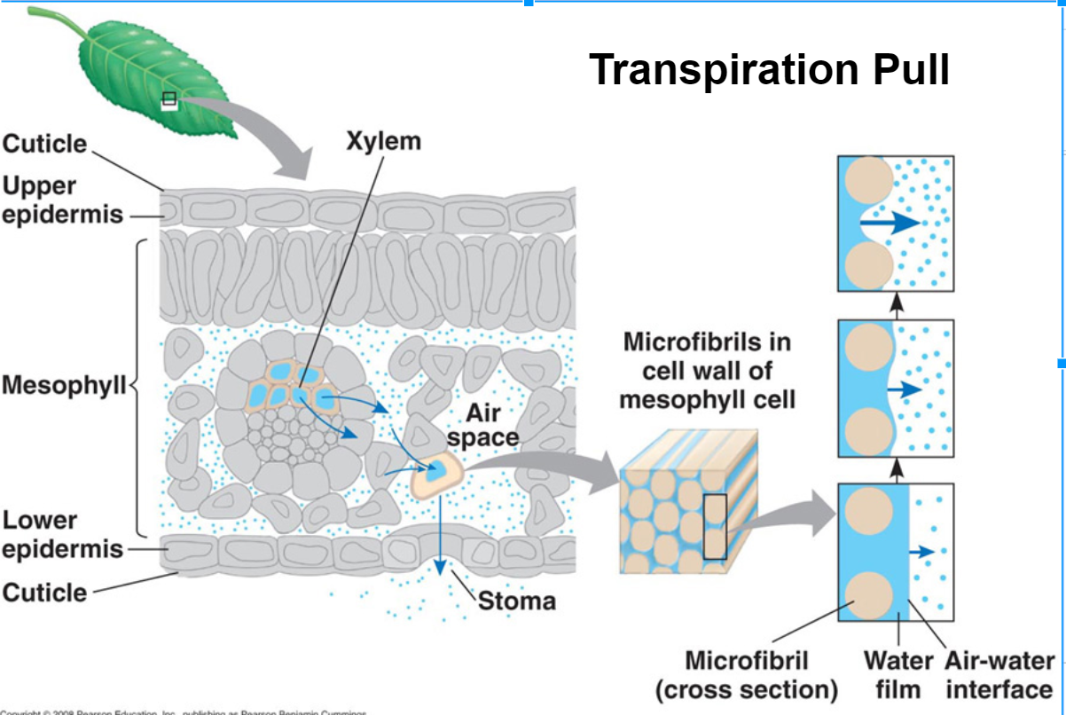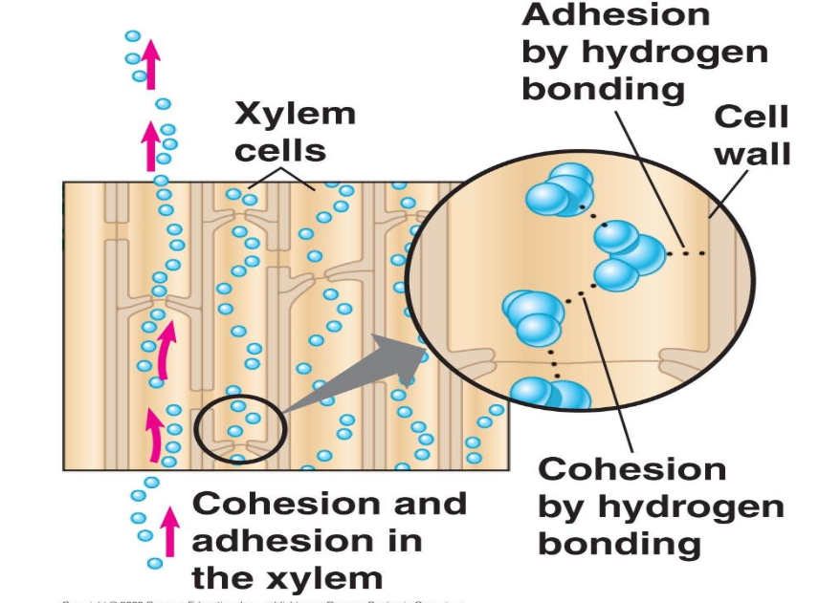

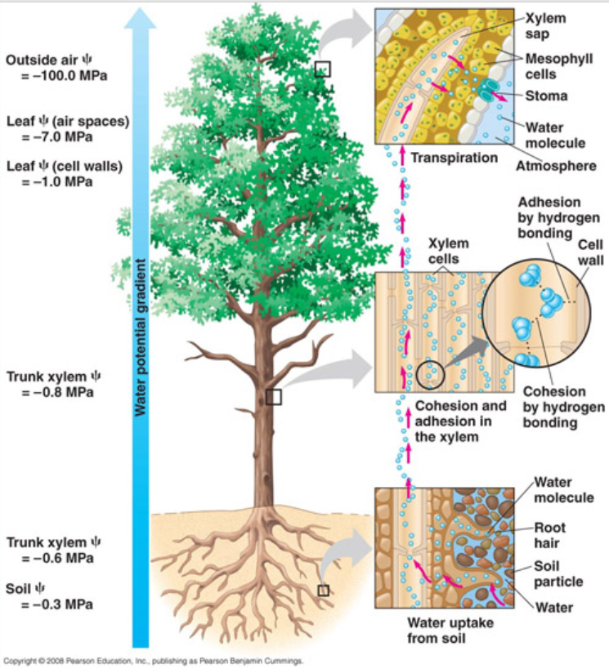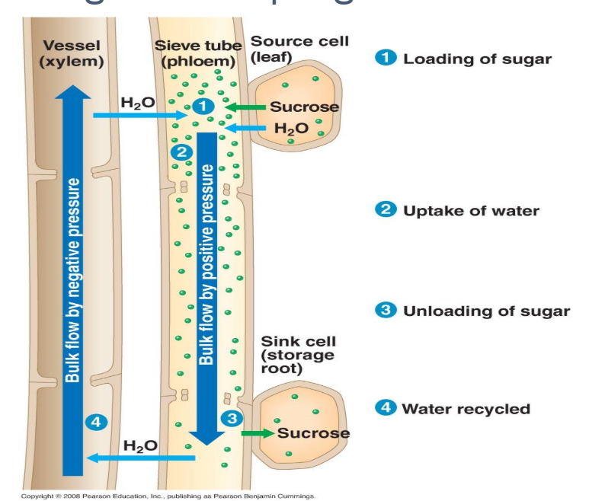
- Bulk Flow: the movement of water through a plant from regions of high pressure to regions of low pressure. Water and solute move through both xylem and phloem tissue by way of bulk flow
Water Potential:
The value for Ψ in root tissue was found to be -3.3 bars. If you place the root tissue in a 0.1 M solution of sucrose at 20°C in an open beaker, what is the Ψ of the solution, and in which direction would the net flow of water be?

