Concept 3: Analyzing cell metabolism and enzyme function
Chapter 8, AP Investigation 12

An Introduction to Energy Metabolism
- The key role of ATP in energy coupling.
- That enzymes work by lowering the energy of activation.
- The catalytic cycle of an enzyme that results in the production of a final product.
- The factors that influence the efficiency of enzymes.

Lab 2: Enzyme Catalysis
- The factors that affect the rate of an enzyme reaction such as temperature, pH, enzyme concentration.
- How the structure of an enzyme can be altered, and how pH and temperature affect enzyme function.
- How to name an enzyme, its substrate and products, and then design a controlled experiment to measure the activity of a specific enzyme under varying conditions.
- How to calculate the rate of reaction.

METABOLISM

Metabolism is the ___________________of an organism’s chemical reactions
- Catabolic pathways __________energy by breaking down complex molecules into simpler compounds
Example:

- Anabolic pathways ____________energy to build complex molecules from simpler ones
Example:

A metabolic pathway begins with a specific ____________and ends with a _____________. Each step is catalyzed by a specific enzyme.
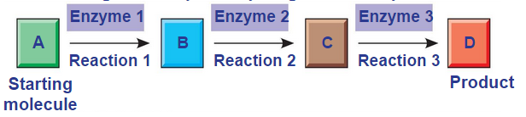

In order to have these reactions occur, you need ___________________.

ENERGY: Energy is the capacity to cause _____________. Energy exists in various forms, some of which can perform ___________.

Kinetic energy is energy associated….

Heat (thermal energy) is kinetic energy associated with …

Potential energy is energy that matter possesses because of its…

Chemical energy is potential energy available for release in a …..

Energy can be converted from one form to another.

THE LAWS OF ENERGY TRANSFORMATION

Thermodynamics is the study of energy _________________. Organisms are energy _______________.
THE FIRST LAW OF THERMODYNAMICS

According to the first law of thermodynamics, the energy of the universe is ______________:

For example, BC Hydro does NOT create energy… they transform it to a form that we use in our homes.

THE SECOND LAW OF THERMODYNAMICS

During every energy transfer or transformation, some energy is unusable, and is often lost as ________.
According to the second law of thermodynamics:

Every energy transfer increases the __________________of the universe. Therefore, the universe is unstoppable in its increasing randomness.

BIOLOGICAL ORDER AND DISORDER

- Cells create ________________ structures from less ordered materials
- Organisms also replace ordered forms of matter and energy with ___________ ordered forms.
- Energy flows into an ecosystem in the form of _________and exits in the form of _________.

FREE-ENERGY CHANGE, ΔG

A living system’s free energy is energy that can do ___________when temperature and pressure are ___________, as in a living cell. It can be thought of as a measure of _________________.

For example…

EXERGONIC AND ENDERGONIC REACTIONS IN METABOLISM

An exergonic reaction proceeds with a net release of free energy
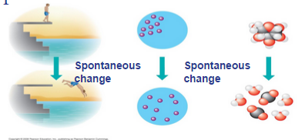
and is ______________________.
An endergonic reaction absorbs free energy from its surroundings
and is ______________________.

HOW DOES A CELL DO WORK?

A cell does three main kinds of work:
- Chemical. Example….

- Transport. Example….

- Mechanical. Example…

To do work, cells manage energy resources by__________________, the use of an exergonic process to drive an endergonic one. Most energy coupling in cells is mediated by ____________– a molecule with a very high free energy

The bonds between the phosphate groups of ATP’s tail can be broken by ____________. Energy is released from ATP when the terminal phosphate bond is broken. This release of energy comes from the chemical change to a state of__________________________, not from the phosphate bonds themselves.

THE REGENERATION OF ATP

ATP is a renewable resource that is regenerated by addition of a ____________ group to ADP. The rate of renewal is VERY fast.

- 10 million ATP molecules are turned over every second in every one of your cells… if this didn’t happen you would use up your body weight in molecules in one day.

ENZYMES

A catalyst is a chemical agent that speeds up a reaction without _______________________.

An enzyme is a _______________________.

- Hydrolysis of sucrose by the enzyme sucrase is an example of an enzyme-catalyzed reaction
Even though the reaction is “spontaneous”/exergonic/releases free energy, it would happen WAY to slow (years) without help from the enzyme due to its very high energy of activation. With the enzyme, the reaction takes seconds.

THE ACTIVATION ENERGY BARRIER

Every chemical reaction between molecules involves bond breaking and bond forming
The initial energy needed to start a chemical reaction is called the free energy of activation, or _______________________ (to contort the bonds)
Activation energy is often supplied in the form of heat from the surroundings

HOW ENZYMES LOWER THE E_{A} BARRIER?

SUBSTRATE SPECIFICITY OF ENZYMES

The reactant that an enzyme acts on is called the enzyme’s _____________

The enzyme binds to its substrate, forming an__________________

The _______________is the region on the enzyme where the substrate binds.

_________________of a substrate brings chemical groups of the active site into positions that enhance their ability to catalyze the reaction. Most enzymes are capable of 1000 substrate actions per second!

CATALYSIS IN THE ENZYME’S ACTIVE SITE

In an enzymatic reaction, the substrate binds to the active site of the enzyme.
Think of four mechanisms which allow the active site to lower an E_{A} barrier…

- Orienting substrates correctly – providing a place for _____________ to find each other

- Straining substrate bonds – _________________reactants towards transition state through weak H and ionic interactions from the R groups in the protein

- Providing a favorable microenvironment – ex) acidic conditions via acidic R-groups

- Covalently bonding to the substrate – this covalent bonding is temporary… it is released in subsequent reactions

EFFECTS OF LOCAL CONDITIONS ON ENZYME ACTIVITY

An enzyme’s activity can be affected by:

- Substrate concentration activity increases with increasing substrate concentration until the _________________point is reached (where all active sites are occupied)

- General environmental factors, such as_________________

- Chemicals that specifically influence the enzyme.
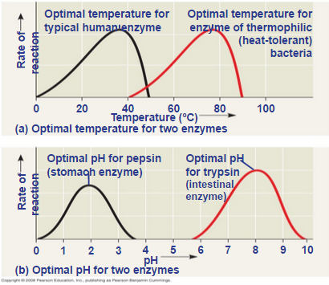

EFFECTS OF TEMPERATURE AND PH

Each enzyme has an optimal temperature in which it can function.
Each enzyme has an optimal pH in which it can function.

COFACTORS

- Cofactors are ____________enzyme helpers
- Cofactors may be inorganicvv(such as a metal in ionic form) or organic
- An organic cofactor is called a coenzyme
- Coenzymes include ___________

ENZYME INHIBITORS

Competitive inhibitors bind to the ____________ of an enzyme, competing with the substrate.

Noncompetitive inhibitors bind to another part of an enzyme, causing the enzyme to _________________and making the active site less effective.

Examples of inhibitors include toxins, poisons, pesticides, and antibiotics.
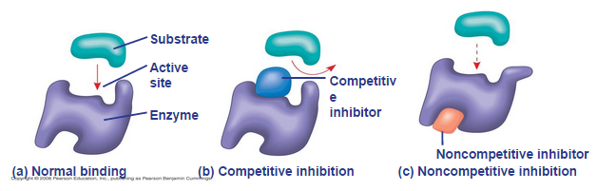

REGULATION OF ENZYME ACTIVITY HELPS CONTROL METABOLISM

Chemical chaos would result if a cell’s metabolic pathways were not tightly ________________.
A cell does this by switching on or off the ____________ that encode specific enzymes or by regulating the activity of enzymes.

ALLOSTERIC REGULATION OF ENZYMES

Allosteric regulation may either ______________________________________________________________.

Allosteric regulation occurs when a regulatory molecule binds to a protein at one site and affects the protein’s function at another site
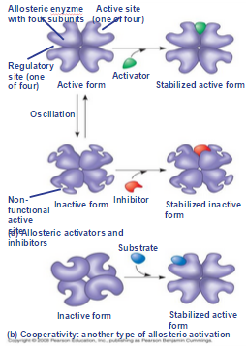

ALLOSTERIC ACTIVATION AND INHIBITION

Most allosterically regulated enzymes are made from polypeptide subunits.
Each enzyme has ______________ and ____________ forms. The binding of an
activator _____________the active form of the enzyme. The binding of an
inhibitor stabilizes the inactive form of the enzyme.

Cooperativity is a form of allosteric regulation that can ____________________.

In cooperativity, binding by a substrate to one active site stabilizes favorable conformational changes at all other subunits.

Allosteric regulators are attractive drug candidates for enzyme regulation
Inhibition of proteolytic enzymes called caspases may help management of inappropriate inflammatory responses.
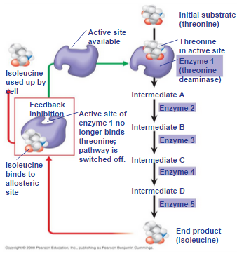
In feedback inhibition, the end product of a metabolic pathway _________
_____________ the pathway.

Feedback inhibition prevents a cell from wasting chemical resources by
synthesizing more product than is needed.

SPECIFIC LOCALIZATION OF ENZYMES WITHIN THE CELL

Structures within the cell help bring order to metabolic pathways. Some enzymes act as structural components of membranes. In eukaryotic cells, some enzymes _______________specific organelles; for example, enzymes for cellular respiration are located in mitochondria.

