Concept 1:
Analyzing the diversity of animals
(Ch 26, 32, 33, 34) Holtzclaw: pg. 186-197
Developmental Biology

What DEFINES an animal? (Metazoa):

Cell Structure and Specialization

Unique to Animals:

  - No cells walls

  - Muscle and nervous tissue

Reproduction and Development

- Primarily sexual (but some asexual)

- Zygote grows by many mitotic divisions

  - Called _______________________

  - Zygote to blastula to gastrula (____________________)
    - Gastrulation:

    - Larva to adult by metamorphosis

- Same gene to regulate expression (____________)
Body Plans

- Useful for categorization
  - Symmetry
  - Tissues
  - Body Cavities
  - Protostome vs D

Symmetry

- “no” symmetry

- Radial Symmetry

- Bilateral Symmetry
  - Distinct anterior (head-end), posterior (tail-end), left, right, dorsal (top), ventral (bottom)
  - Some have cephilization
    - Sensory organs and central nervous system in the _________________
    - Good for _____________________movement

Types of Tissue Layers
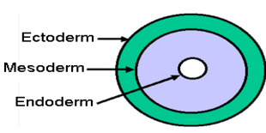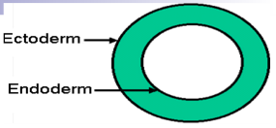

- Tissue: Group of ___________________________ cells

- Diploblastic – two layers (radial animals: )
  - Ectoderm

  - Endoderm

- Triploblastic – three layers (all bilateral animals)
- Diploblastic – two layers (radial animals: Cnideria … and Porifera… kinda)

- Diploblastic – two layers (radial animals: Cnideria … and Porifera… kinda)
Body Cavities

- Coelom – fluid filled body cavity separating the digestive tract from the outer body
  - Acoelomates – ____________________________
    - (Porifera, Cnideria,) Platyhelminthes
  - Pseudocoelomates – animals with a cavity, but not all from _________________
    - Organs held in place loosely
    - Nematoda
  - Coelomates – animals with a “true” Coelom (_______________________________)
    - Organs suspended in order
    - Annelida, Mollusca, Arthropoda, Enchinodermata, Chordata
Protostome vs Deuterostome

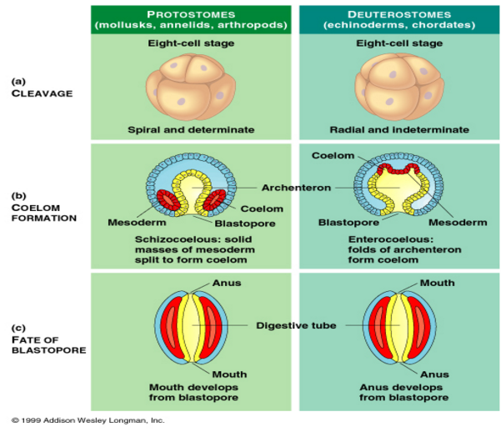
 | Protostomes | Deuterostomes
Cleavage
Coelom formation
Blastopore formation

Phyla

